

NAME : LAIBA FATIMA
CLASS : BS-AI 6th Semester
SECTION : A
COURSE TITLE : DATA MINING
COURSE CODE : DS-303
INSTRUCTOR : Mr. ARHAM

The University of Faisalabad
Department of Computational Sciences

Contents
LAB-1 3
LAB-2 17
LAB-3 26
LAB-4 31
LAB-5 35
LAB-6 40
LAB-7 43
LAB-8 46
LAB-9 49
LAB-10 52
LAB-11 55
LAB-12 58
LAB-13 61
LAB-14 63
Lab 15: 69

LAB-1

TOPICS :
- Introduction to Data Mining
- Software Introduction
- Overview of datasets
CLO:
Understand data mining concepts, preprocessing, statistics, and trends.By doing this course we will be able to work on real industry level projects in future and our basics and foundation of studies would be good .
OBJECTIVE:
- Understand the concept and applications of Data Mining
- Use Google Colab as a development environment
- Identify different types of datasets used in Data Mining
REQUIRED SOFTWARE / TOOLS
- Web Browser
- Google Account
- Google Colab
- Python (pre-installed in Colab)
INTRODUCTION TO DATA MINING
Data Mining is the process of discovering useful patterns, trends, and knowledge from large datasets using statistical, machine learning, and computational techniques.
Applications of Data Mining:
- Market basket analysis
- Fraud detection
- Healthcare diagnosis
- Social media analysis
- Recommendation systems
SOFTWARE INTRODUCTION – GOOGLE COLAB
What is Google Colab?
Google Colaboratory (Colab) is a free cloud-based platform that allows users to write and execute Python code using a browser.

Features
- No installation required
- Free access to GPU/TPU
- Easy sharing and collaboration
- Pre-installed libraries (NumPy, Pandas, Matplotlib, etc.)
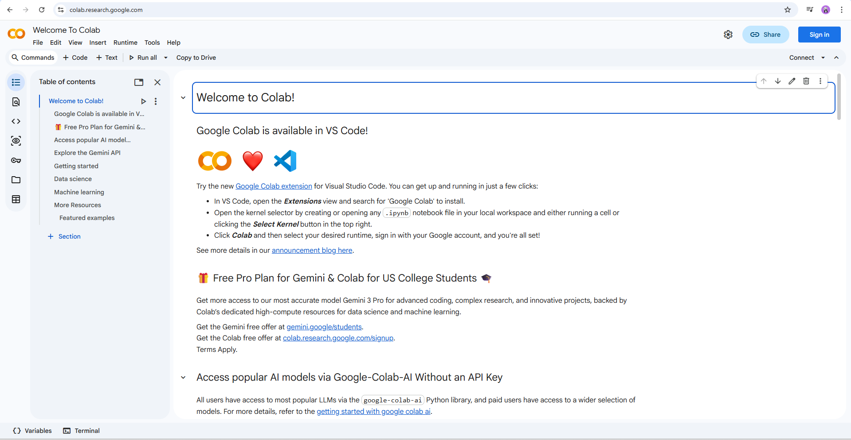
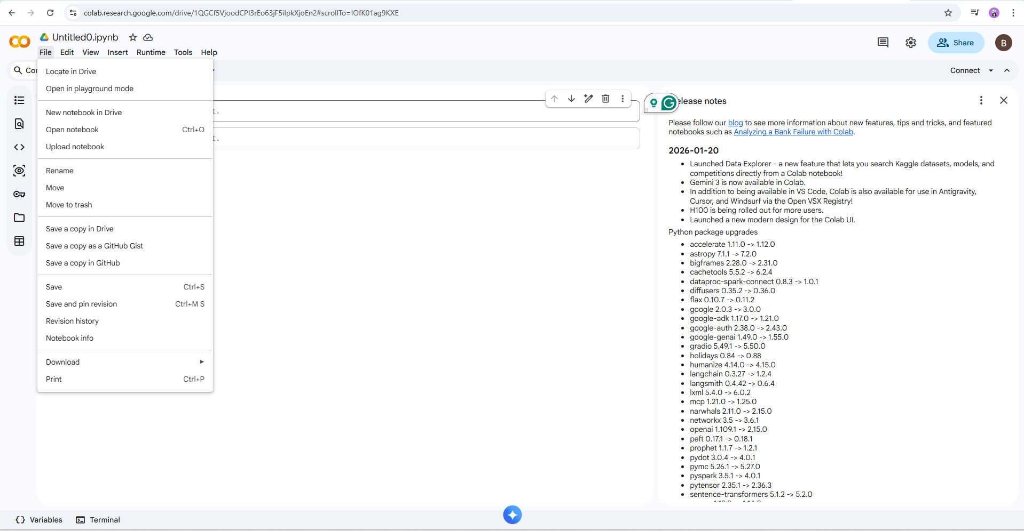

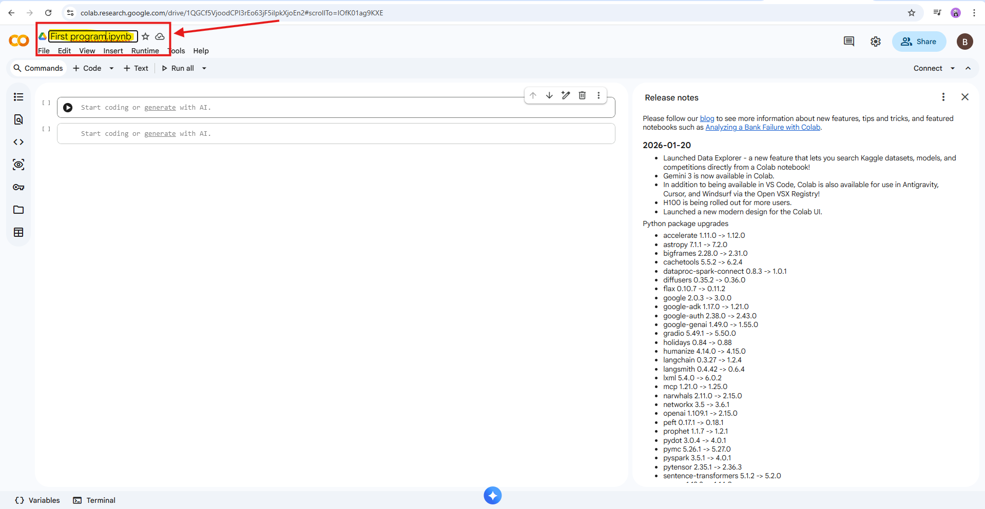
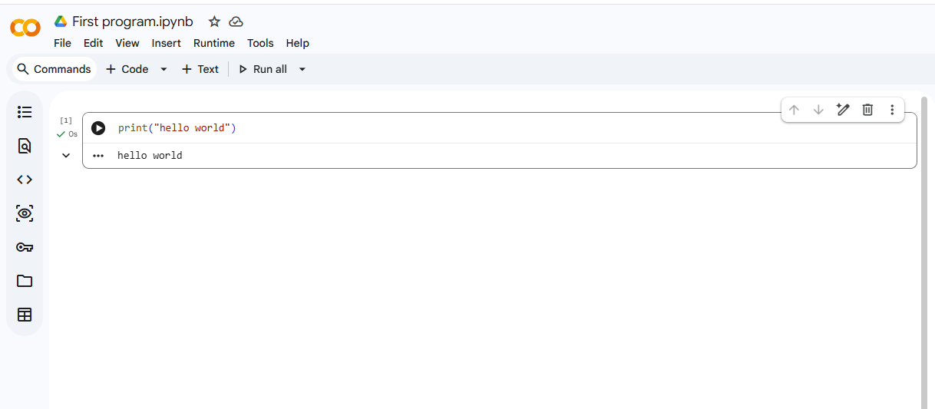

Overview of Datasets

What is data mining
A dataset is a structured collection of data used to discover patterns, relationships, or knowledge through data mining techniques.
In labs, datasets are usually stored as tables (rows = records, columns = attributes).
COMMON TYPES OF DATASETS
Structured Datasets
Data is organized in rows and columns.
Examples:
- Student performance data
- Sales transactions
- Bank customer records
Formats: CSV, Excel, SQL tables
Used for: Classification, clustering, regression

Transactional Datasets
Each record represents a transaction with a set of items.
Example:
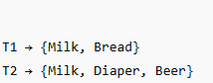
Used for:
- Association rule mining
- Market basket analysis
(Algorithms: Apriori, FP-Growth)

Time-Series Datasets
Data collected over time at regular intervals.
Examples:
- Stock prices
- Temperature readings
- Website traffic per day
Used for:
- Trend analysis
- Forecasting
- Sequential pattern mining

Spatial or Geographical Datasets
Data related to location or space.
This kind of data is very useful for satellites
Examples:
- GPS coordinates
- Maps
- Satellite images
Used for:
- Spatial clustering
- Location-based analysis

Text Datasets
Data in textual form.
Examples:
- Emails
- Reviews
- Tweets
Used for:
- Text mining
- Sentiment analysis
- Topic modeling

Web and Log Datasets
Data generated from web activity.
Examples:
- Clickstream data
- Server logs
- User browsing history
Used for:
- Web usage mining
- Recommendation systems

Attributes in a Dataset

1 Numerical Attributes
- Integer or real values
- Example: Age, Salary

2 Categorical Attributes
- Distinct categories
- Example: Gender, Department

3 Binary Attributes
- Two possible values
- Example: Yes/No, 0/1
How to download the dataset
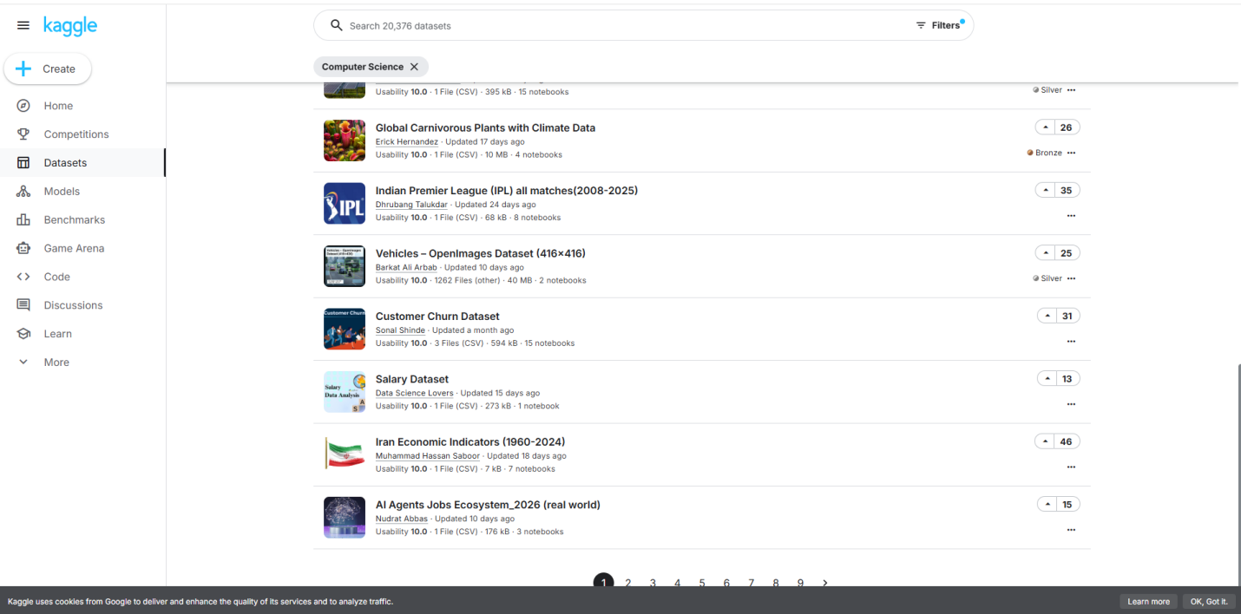
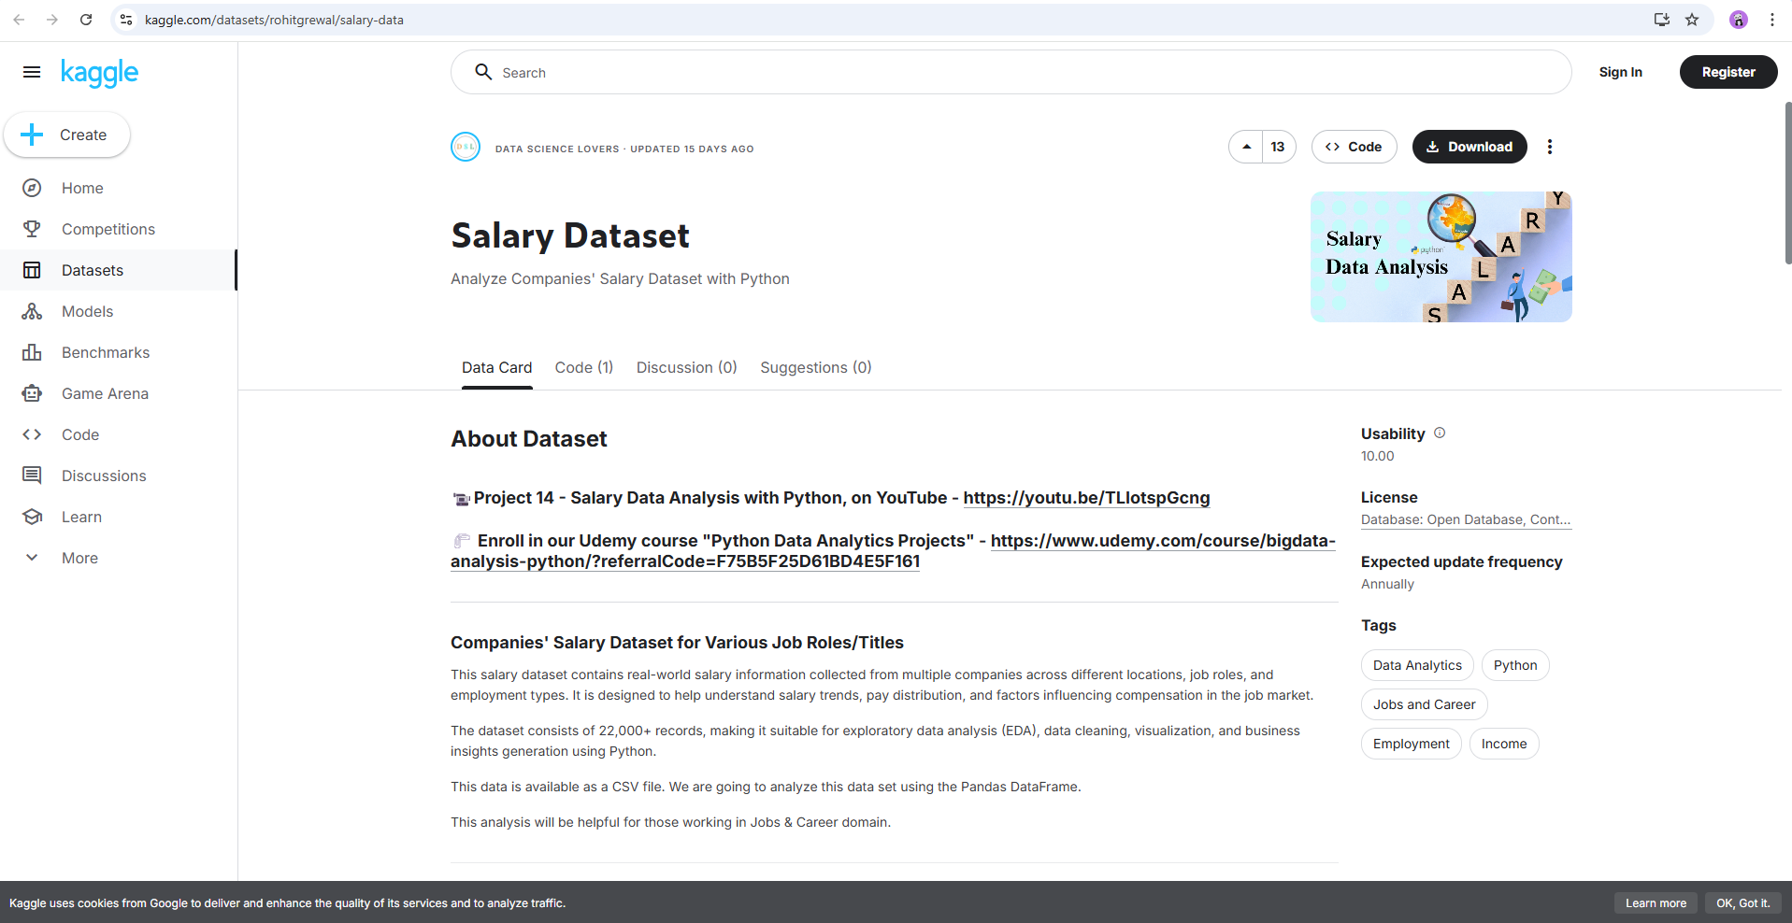
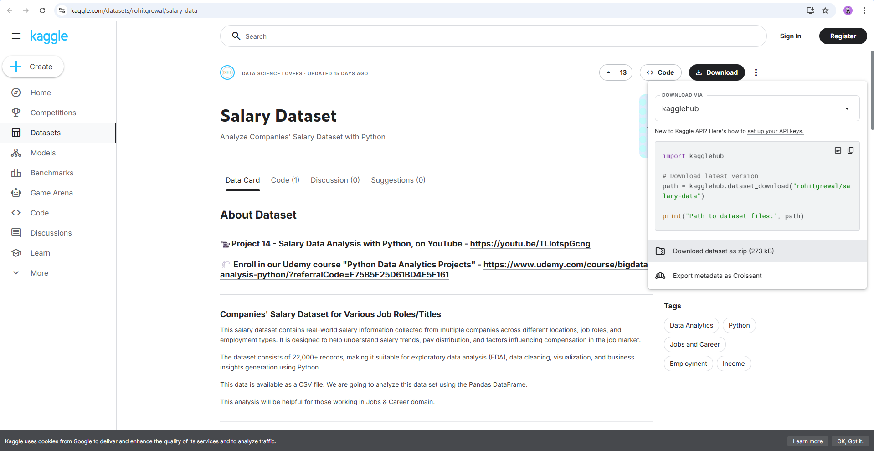
TASK:
Write a Python program that does the following:
- Create a list of integers entered by the user.
- Using a loop, go through each number in the list.
- For each number:
  - If the number is even, print "Even"
  - If the number is odd, print "Odd"
- At the end, print:
  - The total count of even numbers
  - The total count of odd numbers
INPUT
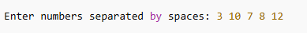
OUTPUT
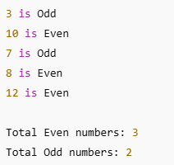
Introduction to Knime
KNIME (Konstanz Information Miner) is an open-source data analytics, reporting, and integration platform. It is designed to help users build data workflows visually, without heavy coding.

What is KNIME Used For?
KNIME is commonly used for:
- Data analysis
- Machine learning
- Data cleaning & preprocessing
- Data visualization
- Predictive modeling
- Business intelligence

Task 1:
Working on Iris Dataset:
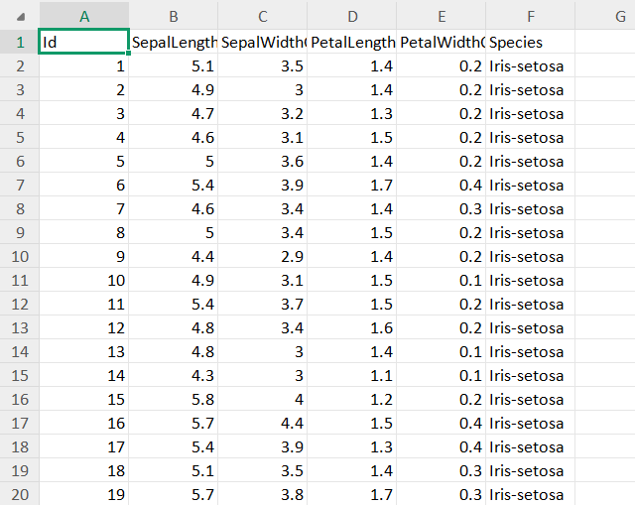
Calculating Sum, Count, Min, Max, Average, Mode:
By using the following formulas we calculate all these:
=COUNT(A1:A151)
=SUM(A1:A151)
=AVERAGE(A1:A151)
=MODE(B2:B151)
=MIN(A1:A151)
=MAX(A1:A151)
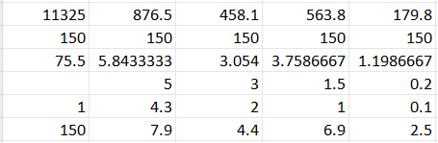
To form a table:
CTRL + T
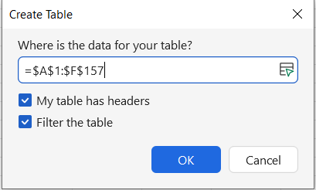
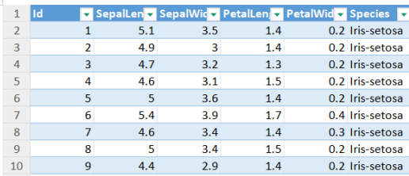
For highliting tables:
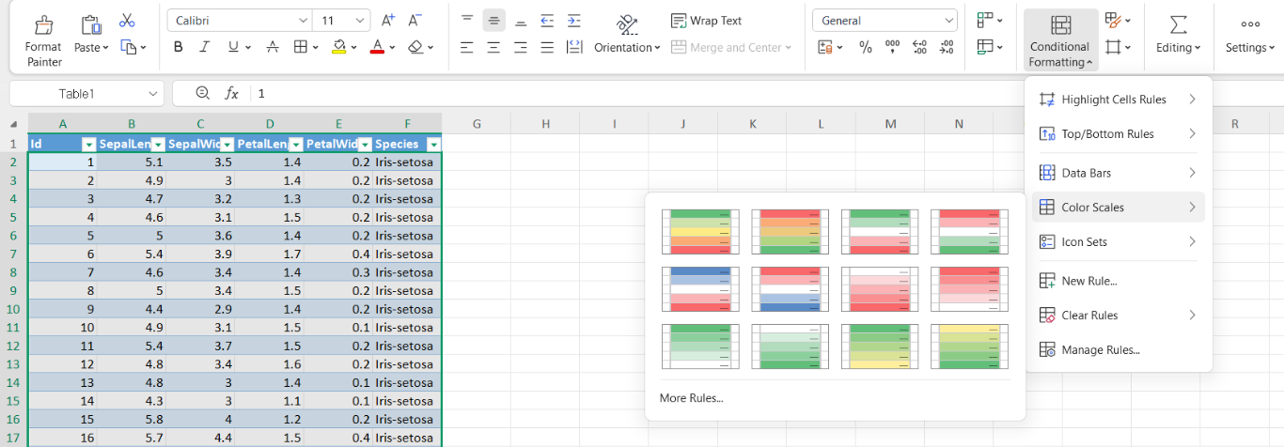

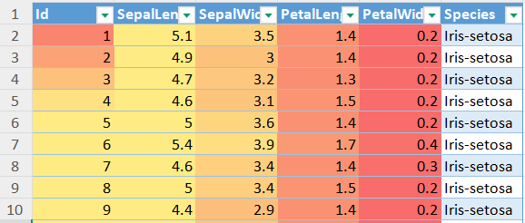

Working on knime
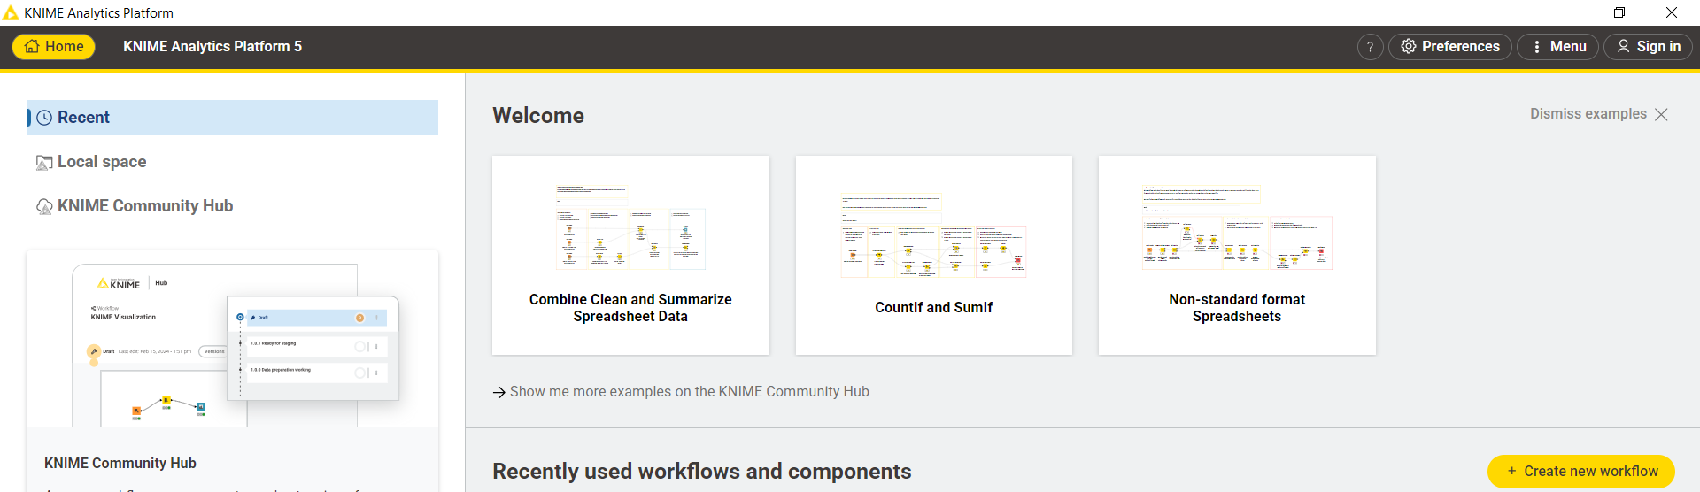
Click on create new workflow:
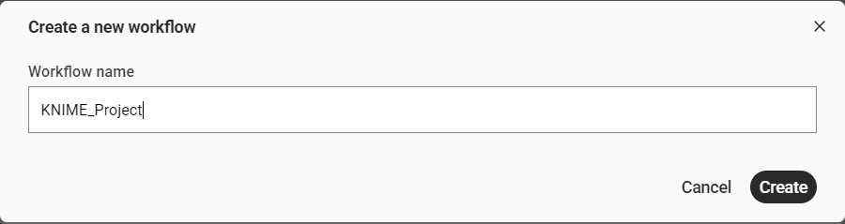
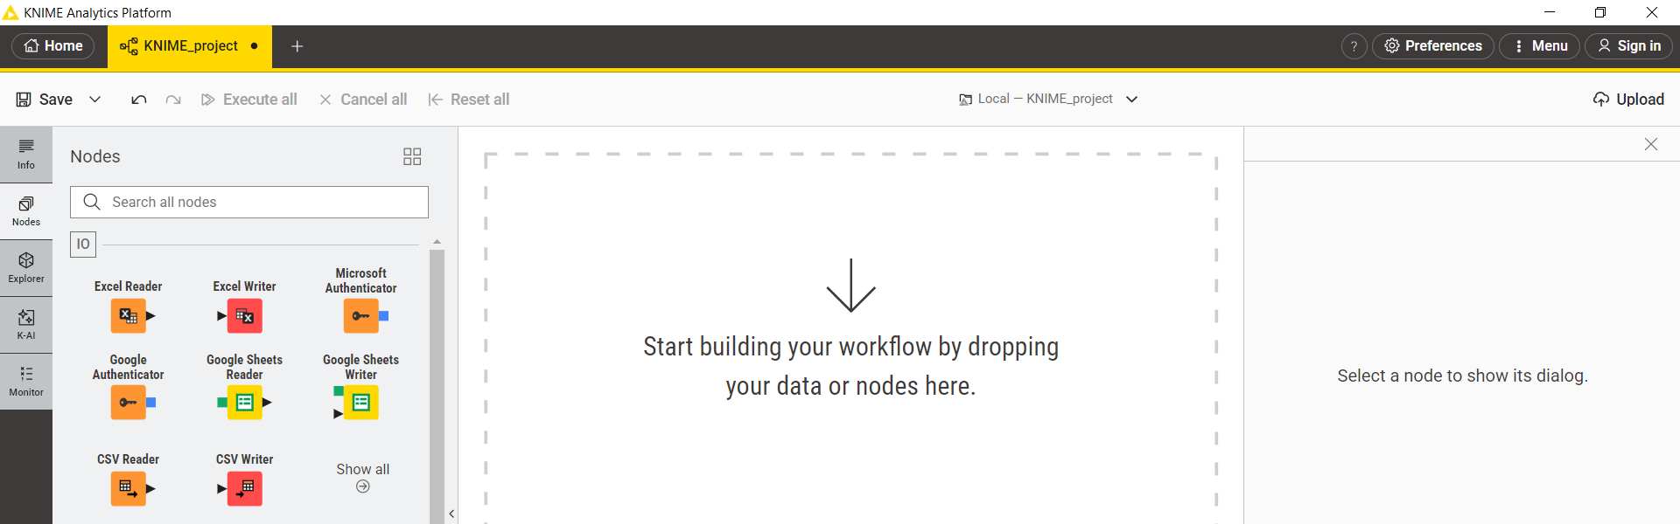

In Nodes section choose CSV reader:
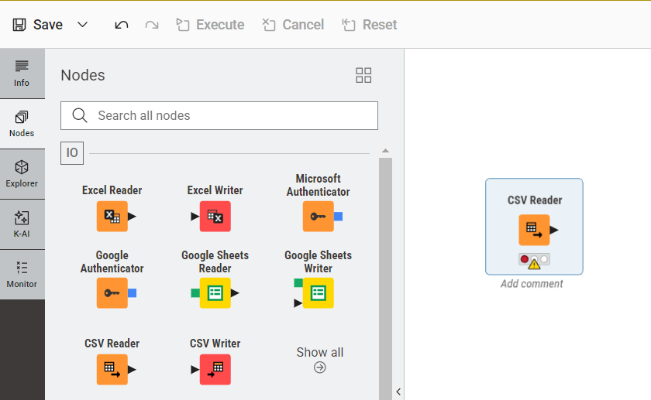
Browse the file u want to upload:
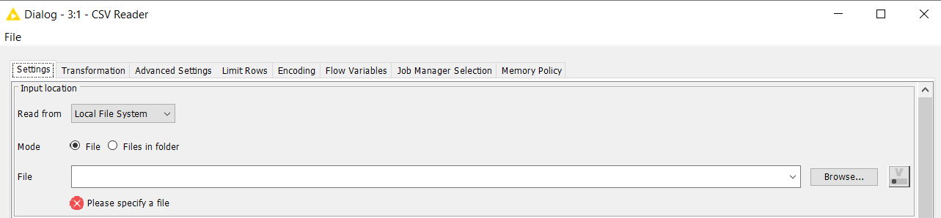
Select the file and click open:
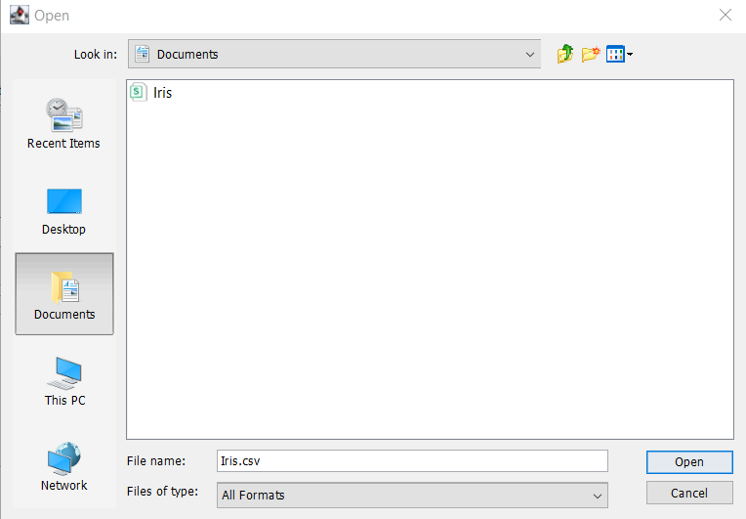
After clicking excute the CSV file will be uploaded in knime environment:
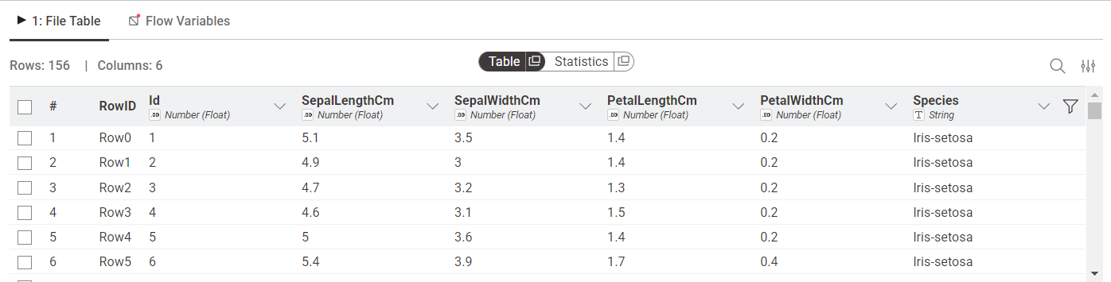
Now use statistic node:
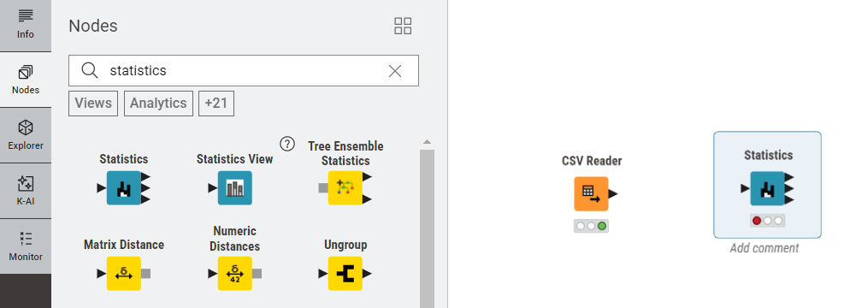
By joining it to the CSV node it will automatically display the mean, min, max, std dev etc.
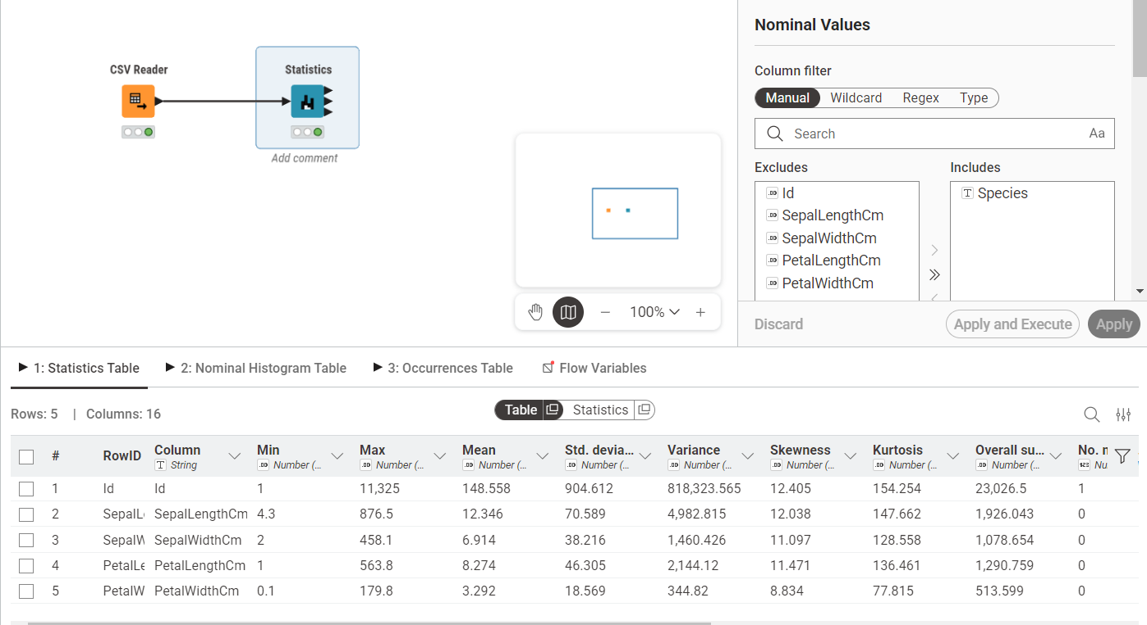
Now add barchart node:
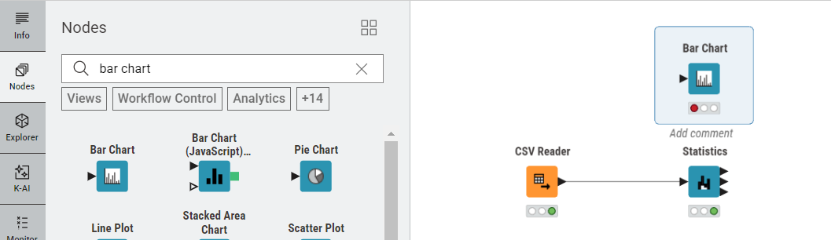
It will display the count of each specie:
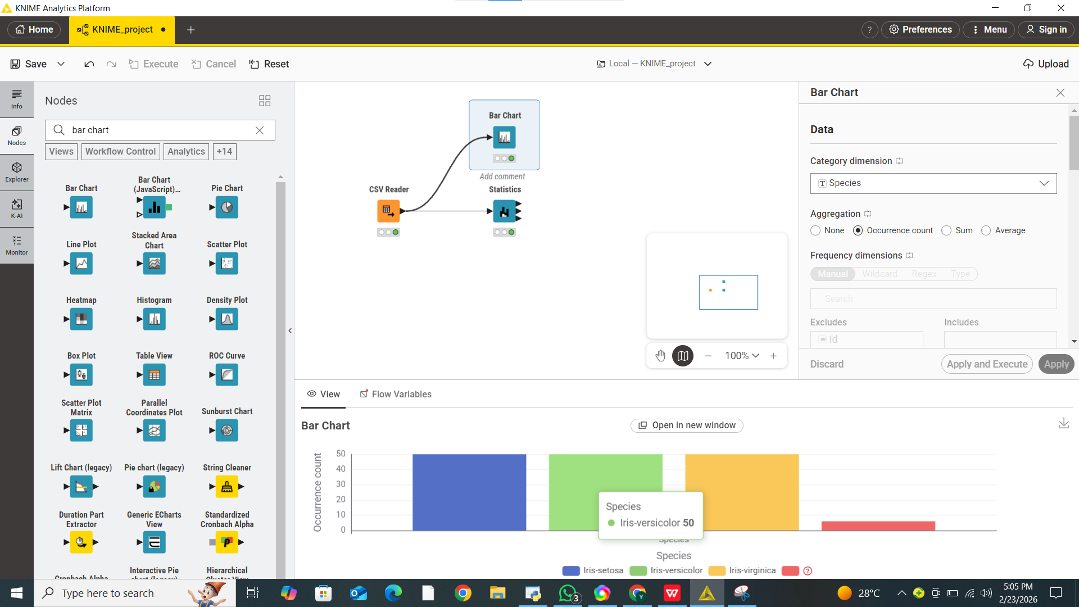
Now add the pie chart node:
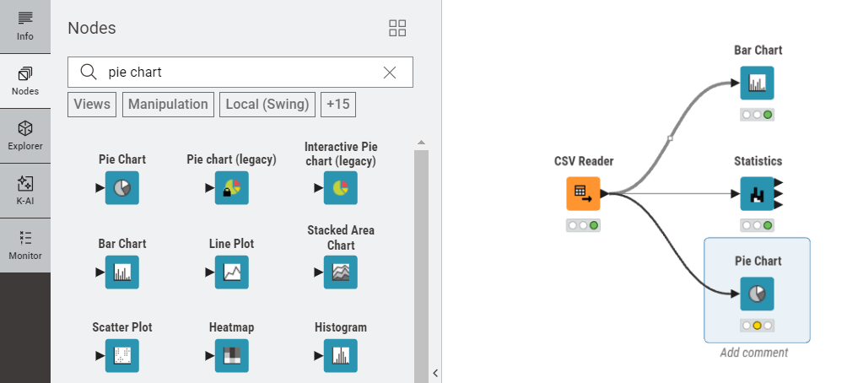
It will display the percentage of each specie in pie chart:
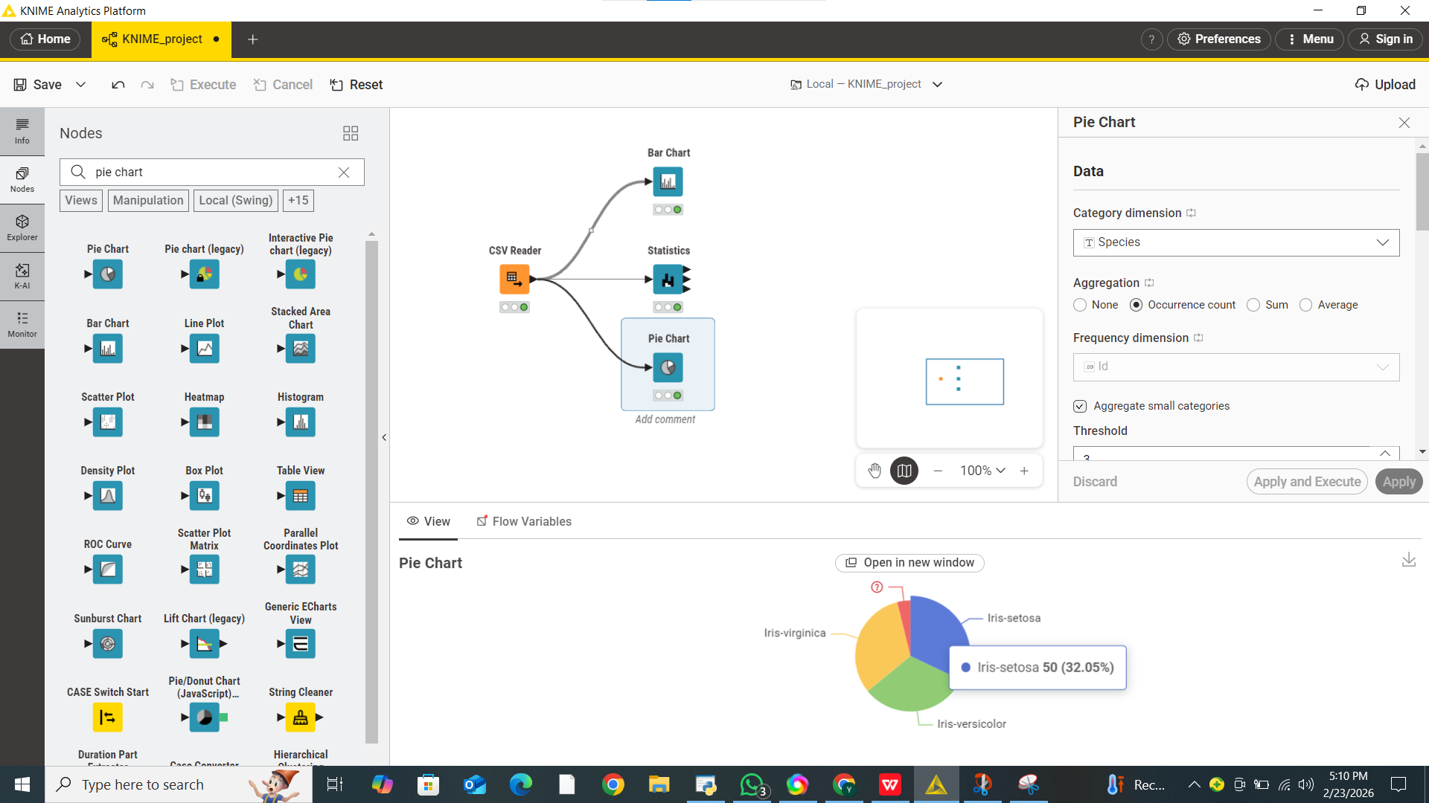
Now save the workflow:
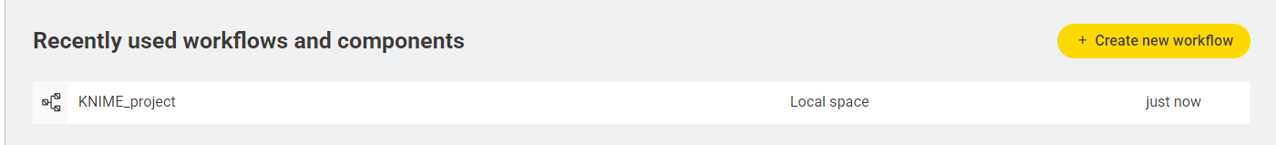

LAB-2
TOPICS
- Cross-Industry Standard Process for Data Mining (CRISP-DM)
- Customer Churn Prediction and Retention Analysis
- Visual Programming for Machine Learning using Orange Data Mining
- Classification Algorithms and Model Evaluation Metrics (Accuracy, ROC-AUC)
Overview of datasets
The Customer Churn Dataset contains historical data of e-commerce platform users, designed to predict whether a customer will stop using the service (churn).
The dataset consists of 3941 rows, 11 features, 0 metas.
Key attributes typically include customer demographics, account information, and behavioral metrics (such as purchase frequency and tenure). The target variable is 'Churn', which is a binary classification indicating whether the customer stayed or left.
CLO:
Apply the CRISP-DM methodology to explore, preprocess, and model structured data, utilizing visual data mining tools to solve real-world business classification problems and evaluate model performance.
OBJECTIVE:
To develop a predictive machine learning model using Orange Data Mining that identifies e-commerce customers at high risk of churning, enabling targeted retention strategies. This lab will systematically walk through the CRISP-DM phases from Data Understanding to Model Evaluation.
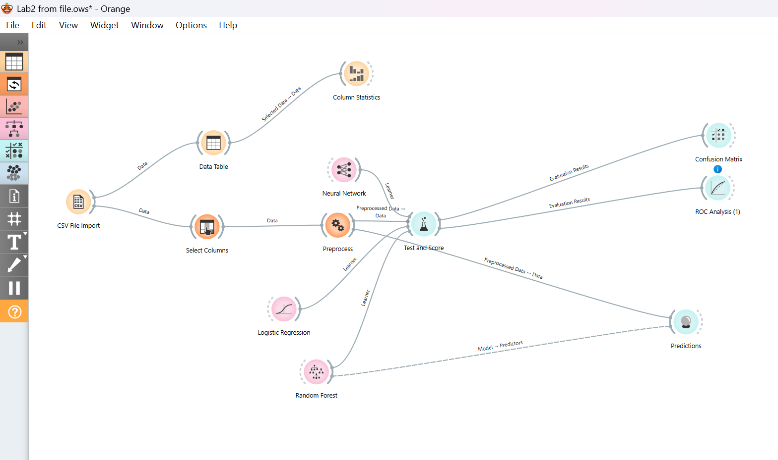
System Methodology & Workflow Execution
The predictive modeling pipeline was constructed using a modular, visual programming approach in Orange Data Mining. Each component (widget) represents a specific stage of the CRISP-DM process:
Data Ingestion & Selection
- CSV File Import: Serves as the entry point where the E-commerce Churn dataset is loaded.
- Select Columns: This widget is used to define the Target Variable (Churn) and separate descriptive features from administrative data (Meta attributes like Customer IDs).
- Data Table & Column Statistics: These provide a real-time view of the raw data and summary statistics to ensure data integrity before modeling.
Preprocessing & Feature Engineering
- Preprocess: This is a critical mid-step where missing values are imputed and categorical data is numerically encoded. This ensures that the data is in the correct mathematical format for algorithms like Neural Networks and Logistic Regression.
Comparative Modeling
Three distinct learners are connected to the Test and Score widget to perform a side-by-side performance evaluation:
- Neural Network: Captures deep, non-linear relationships using a multi-layer perceptron architecture.
- Logistic Regression: Acts as a high-interpretability baseline model to identify linear correlations.
- Random Forest: An ensemble method that combines multiple decision trees to provide robust, high-accuracy predictions.
Evaluation & Decision Support
- Test and Score: Executes 10-fold cross-validation to provide unbiased metrics (AUC, CA, F1, Precision, and Recall).
- Confusion Matrix & ROC Analysis: These visualization widgets help in diagnosing model errors, specifically focusing on minimizing "False Negatives" (failing to identify a customer who is about to churn).
Predictive Deployment
- Predictions: The final stage where the trained Random Forest model is applied to the processed data. This generates specific churn probability scores for individual customers, allowing for targeted business interventions.
COLUMN STATISTICS
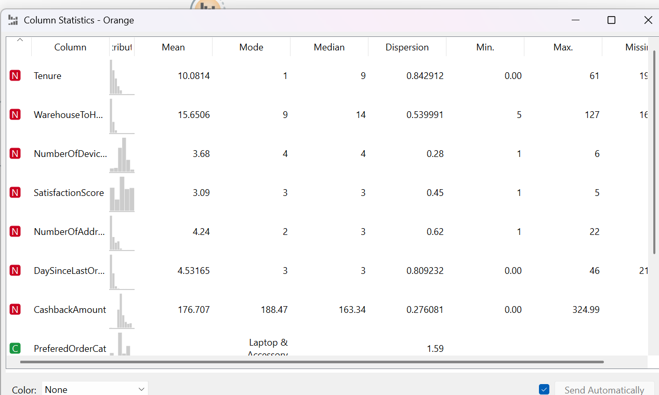

Neural Network using RELU
Neural Network: Captures deep, non-linear relationships using a multi-layer perceptron architecture.

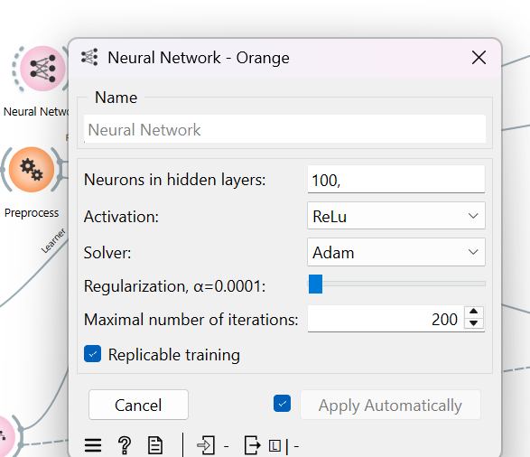
Confusion Matrix for Neural network & ROC Analysis
- Confusion Matrix & ROC Analysis: These visualization widgets help in diagnosing model errors, specifically focusing on minimizing "False Negatives" (failing to identify a customer who is about to churn).

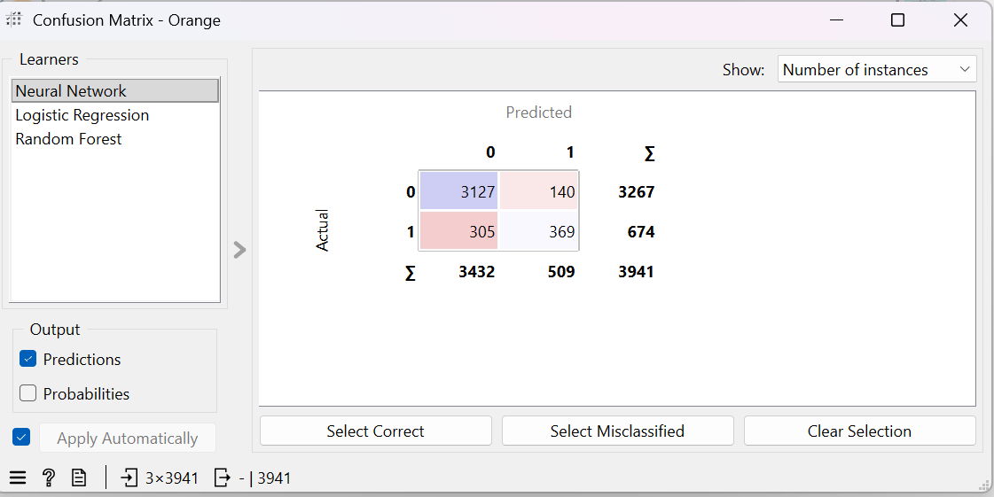
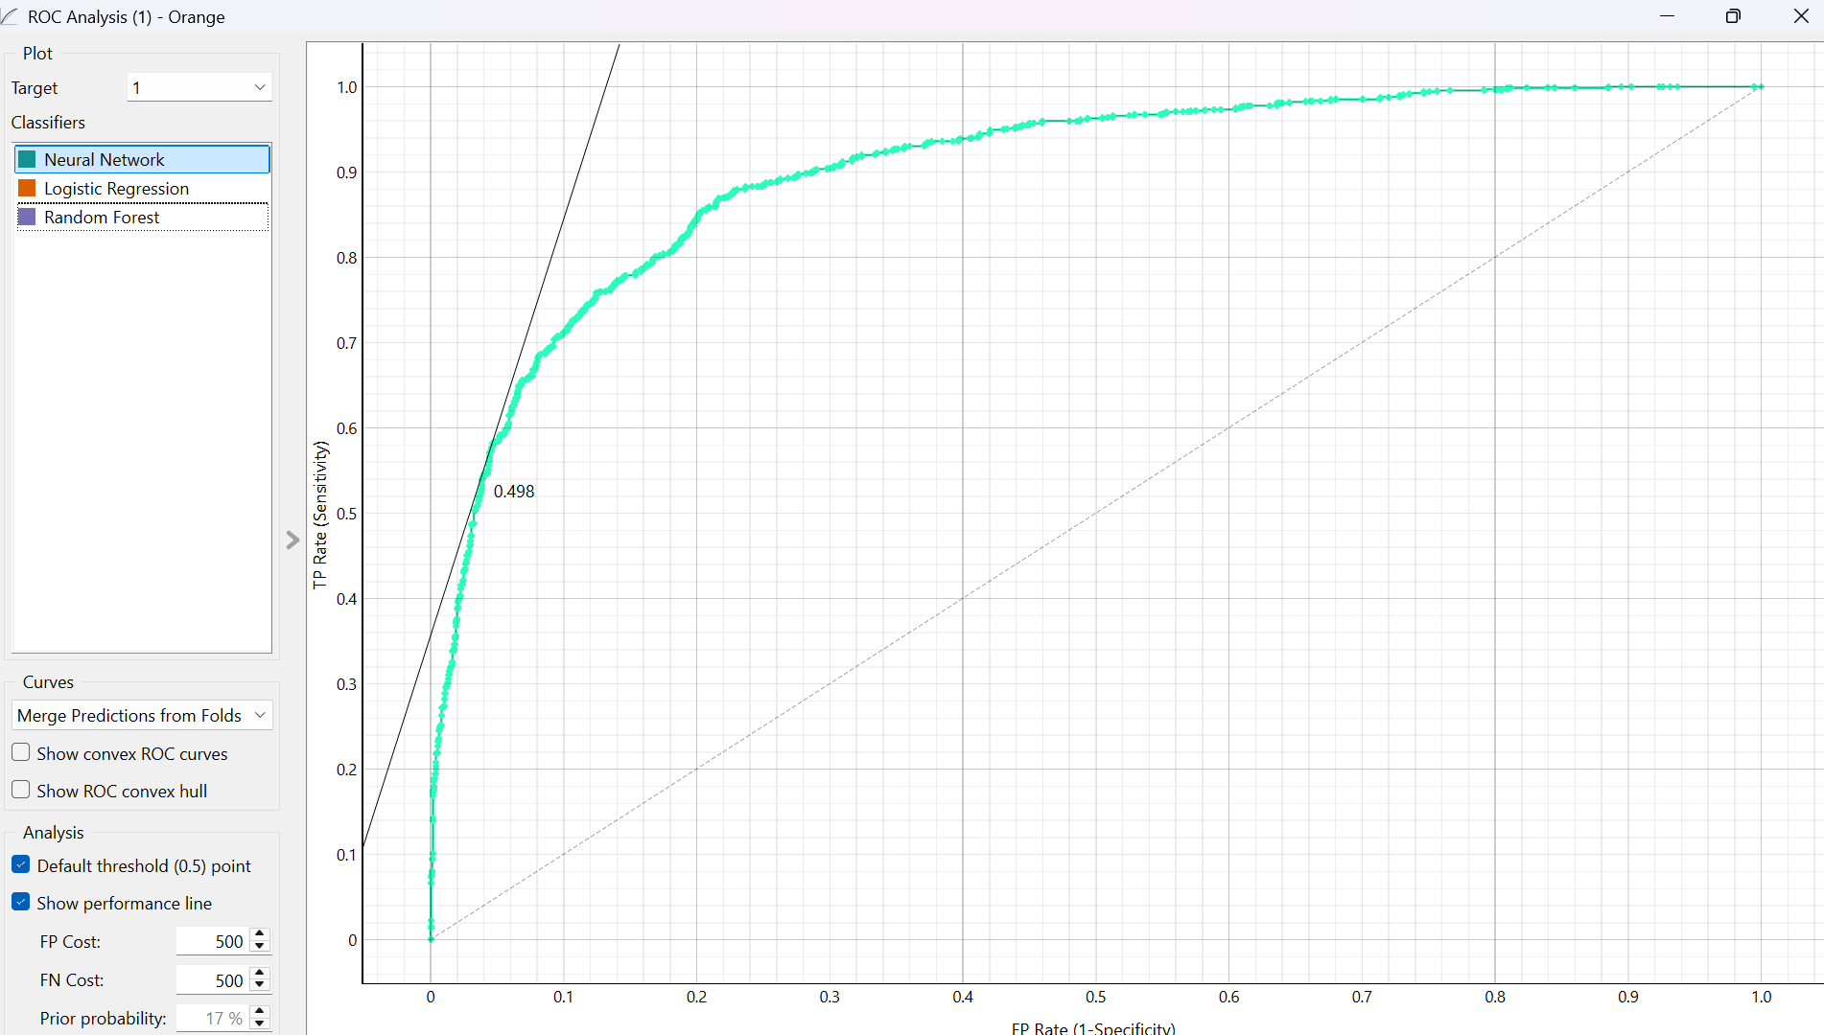

Logistic Regression
- Logistic Regression: Acts as a high-interpretability baseline model to identify linear correlations.

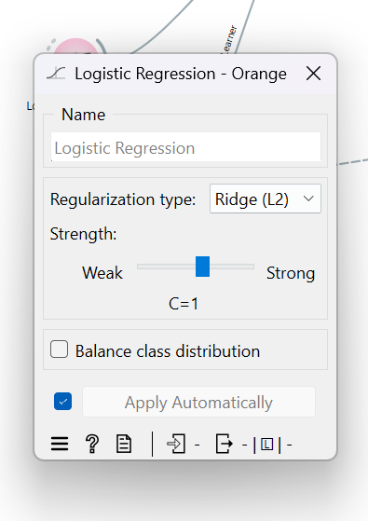
Confusion Matrix for Logistic Regression & ROC Analysis
- Confusion Matrix & ROC Analysis: These visualization widgets help in diagnosing model errors, specifically focusing on minimizing "False Negatives" (failing to identify a customer who is about to churn).

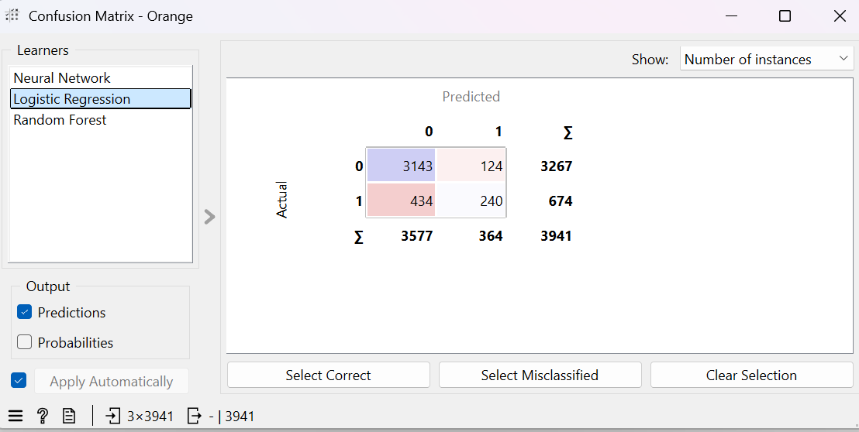
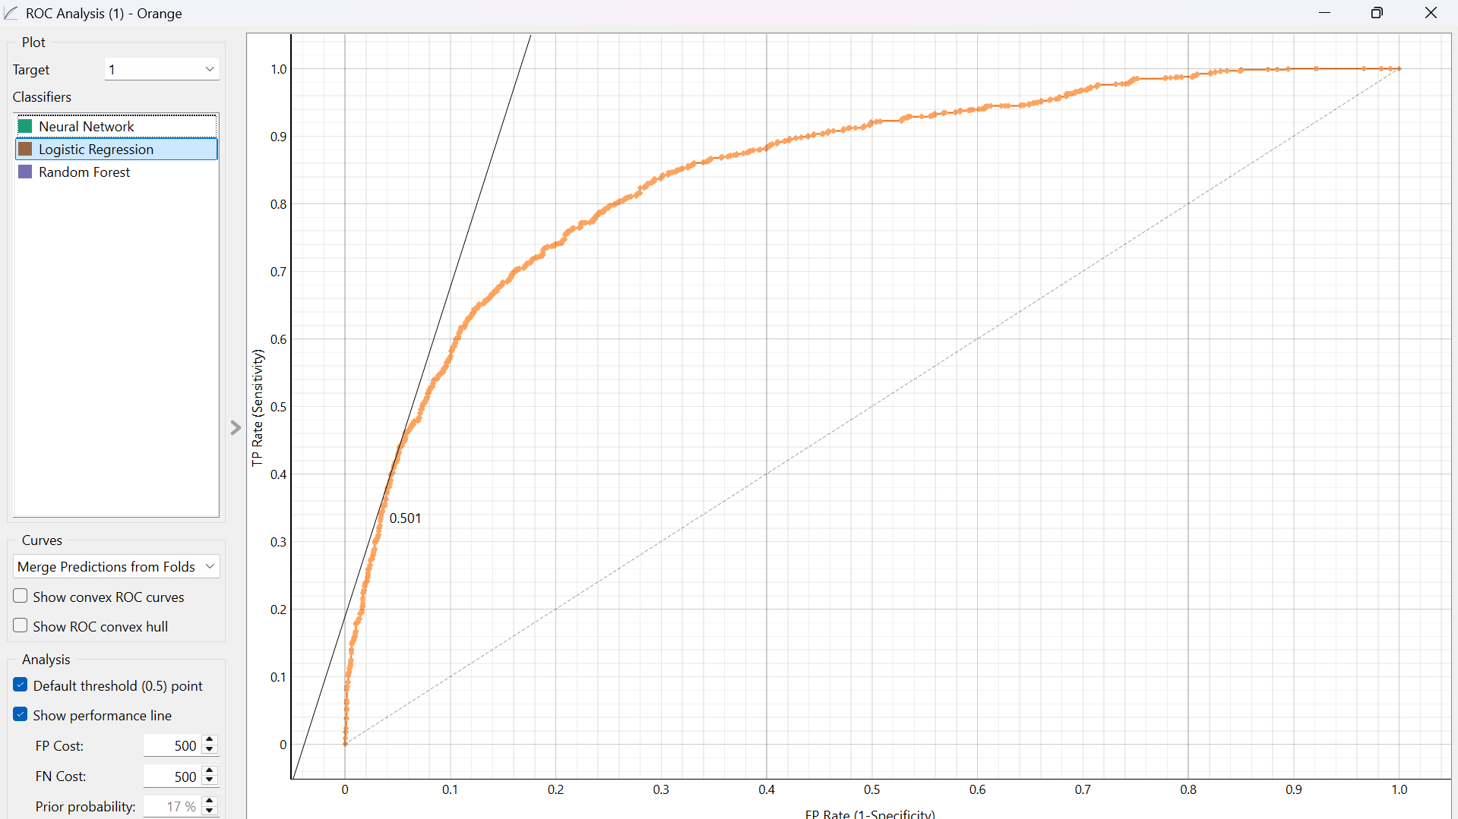
Random Forest
An ensemble method that combines multiple decision trees to provide robust, high-accuracy predictions.
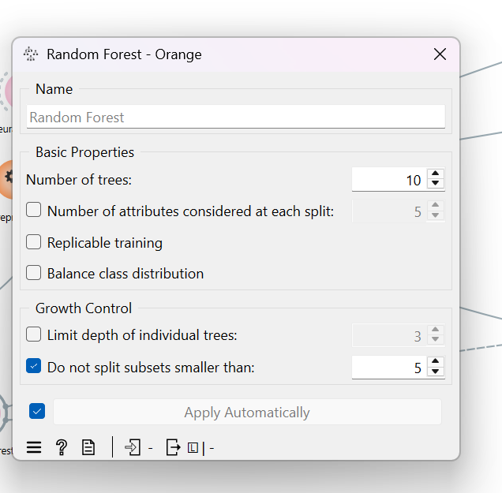
Confusion Matrix for Logistic Regression & ROC Analysis
- Confusion Matrix & ROC Analysis: These visualization widgets help in diagnosing model errors, specifically focusing on minimizing "False Negatives" (failing to identify a customer who is about to churn).
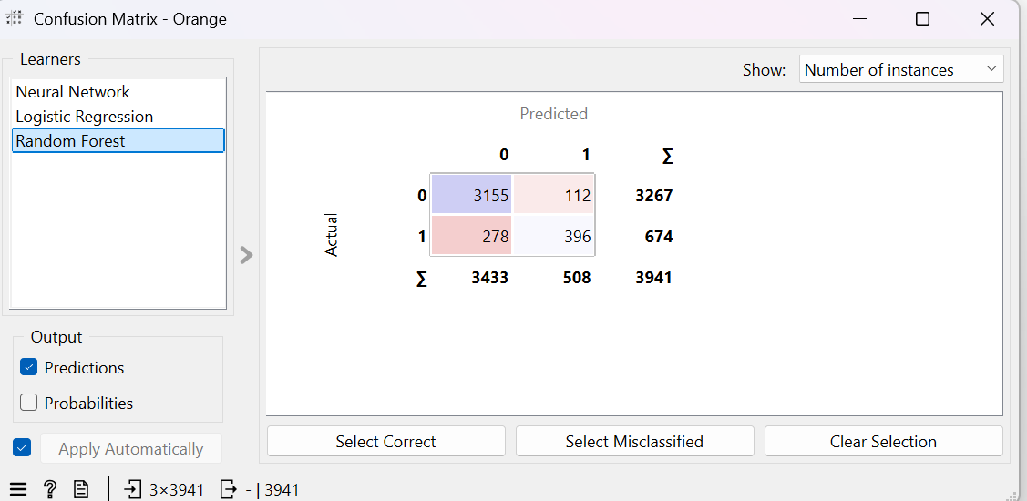
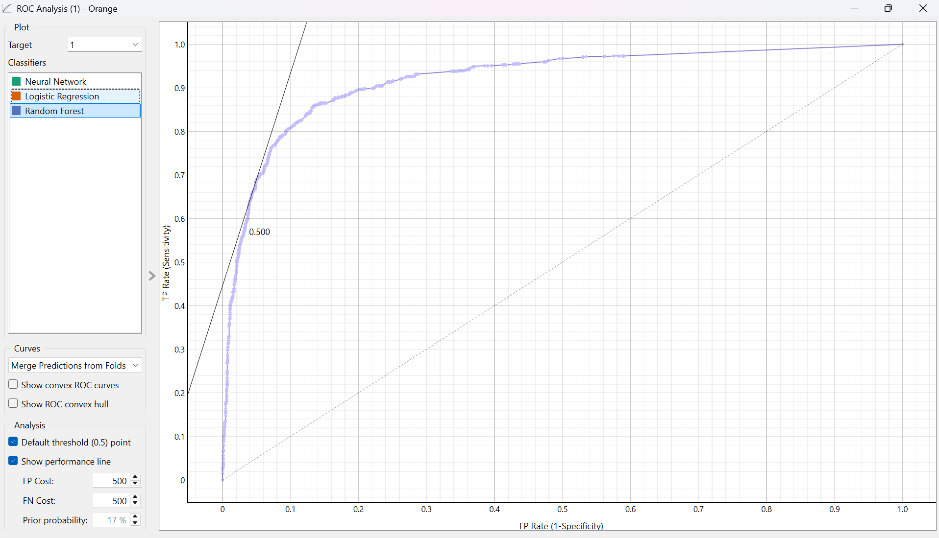

Predictive Deployment
Predictions: The final stage where the trained Random Forest model is applied to the processed data. This generates specific churn probability scores for individual customers, allowing for targeted business intervention.
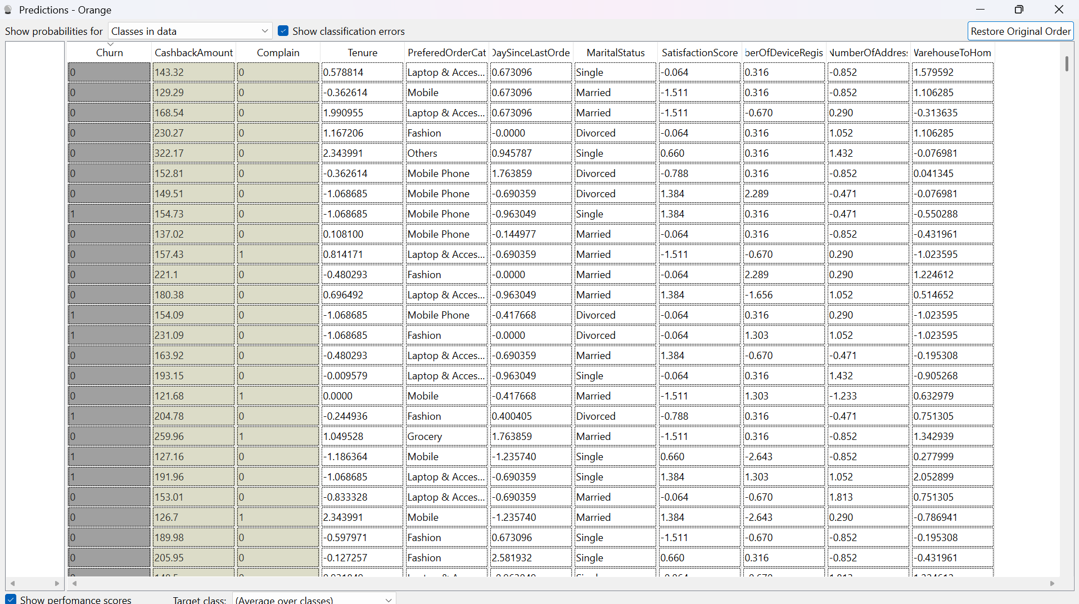
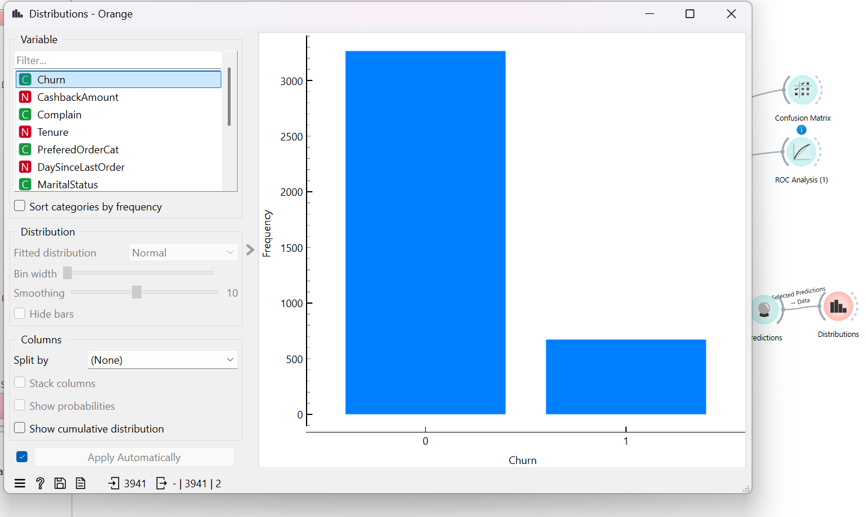

Comparing ALL Three models
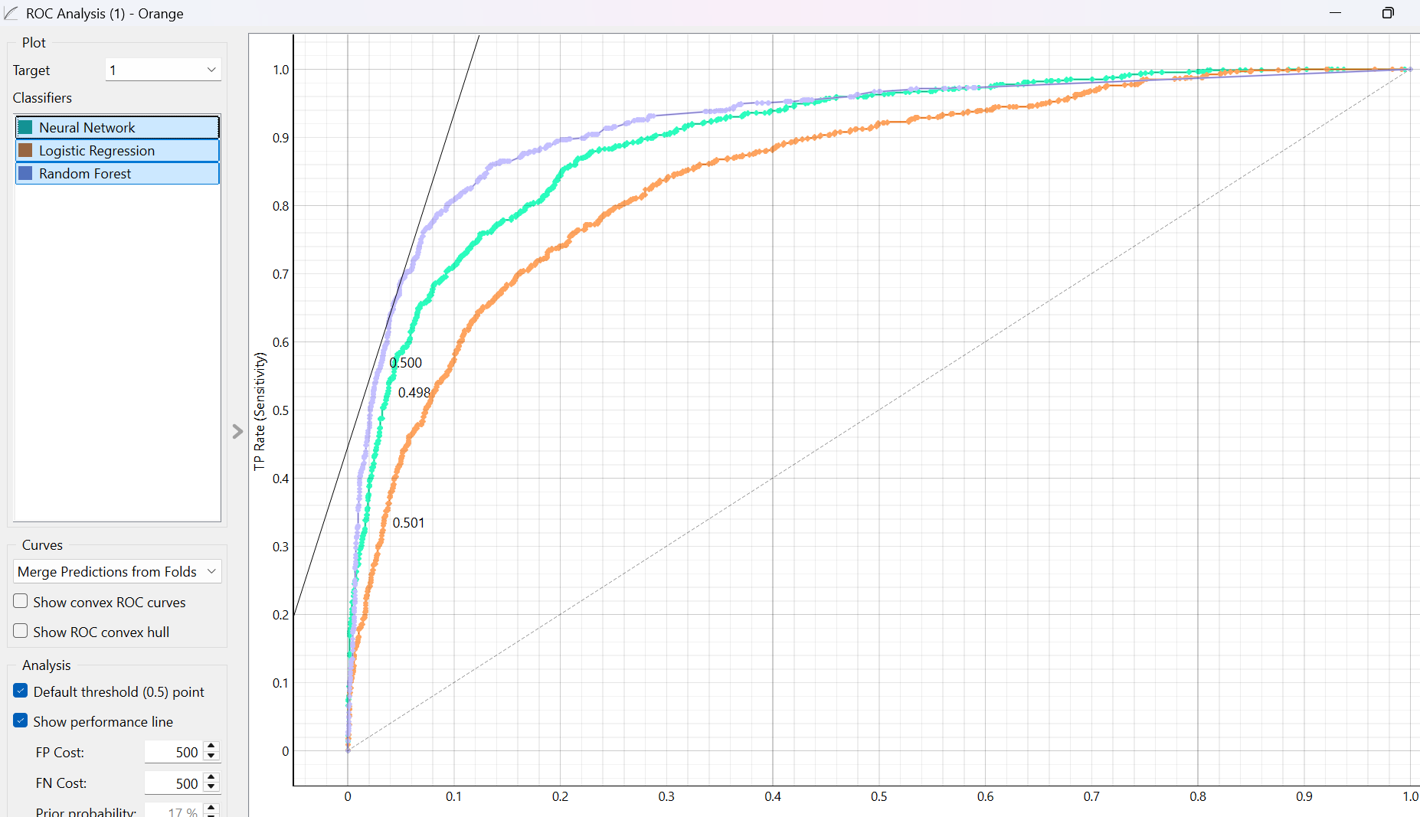
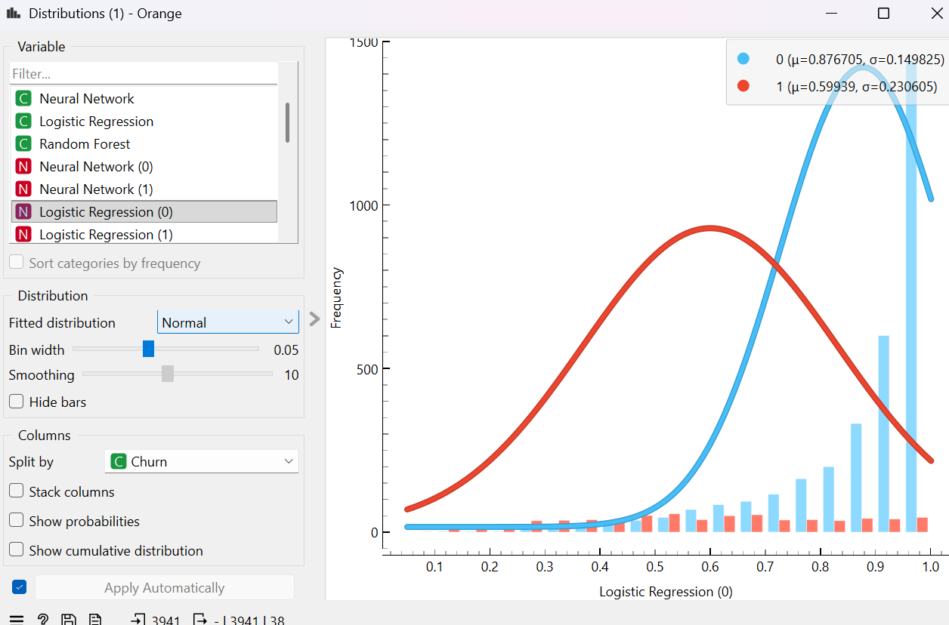

LAB-3
TOPICS:
- Data Cleaning and Preprocessing
- Handling Missing Values & Noise Filtering
- Removing Duplicates and Quality Assessment
- Software Introduction: Altair AI Studio (RapidMiner)
CLO: Understand data mining concepts, preprocessing, statistics, and trends. By doing this course we will be able to work on real industry level projects in future and our basics and foundation of studies would be good.
OBJECTIVE:
- Understand the necessity of cleaning raw healthcare datasets before analysis.
- Use Altair AI Studio (RapidMiner) as a data preparation environment.
- Identify and handle missing values, duplicates, and noisy data.
- Evaluate data improvement by calculating % Missing Reduced, Duplicate Removal %, and Data Quality Scores.
REQUIRED SOFTWARE / TOOLS:
- Altair AI Studio (formerly RapidMiner Studio)
- Healthcare Dataset (diabetic_data.csv)
- Computer / Laptop
INTRODUCTION TO DATA CLEANING: Data Cleaning is an essential step in the data mining process that involves identifying and correcting (or removing) errors, inconsistencies, and inaccuracies within a dataset. Real-world data, especially healthcare data, is often incomplete or noisy.
Key Preprocessing Steps:
- Handling Missing Values: Replacing blank or unknown data (like ?) with standard values (mean, median) or removing affected rows/columns.
- Duplicate Removal: Identifying and removing redundant records (e.g., repeat hospital visits for the same patient) to prevent skewed analysis.
- Noise Filtering: Removing outliers or impossible values that do not make logical sense within the dataset.
SOFTWARE INTRODUCTION – ALTAIR AI STUDIO: What is Altair AI Studio? Altair AI Studio (formerly RapidMiner) is a powerful, visual workflow designer for data science and machine learning. It allows users to build complex data pipelines using a drag-and-drop interface without needing to write code.
Features:
- Visual, code-free workflow design (Canvas and Operators)
- Turbo Prep feature for automated Data Quality scoring
- Built-in operators for handling missing values, filtering, and joining datasets
- Easy calculation of statistics and data distributions
Phase 1: Getting Your Data In
Before we clean, we need to load the data and check its initial "messy" state so you can calculate your percentages later.
- Start a New Process: Open AI Studio and click Blank Process. You will see a large white space in the middle. This is your "Canvas."

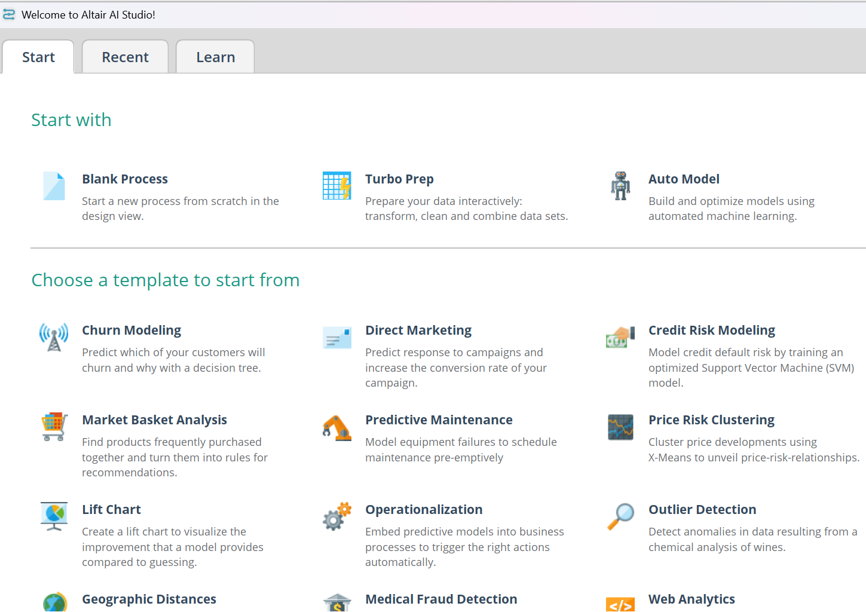
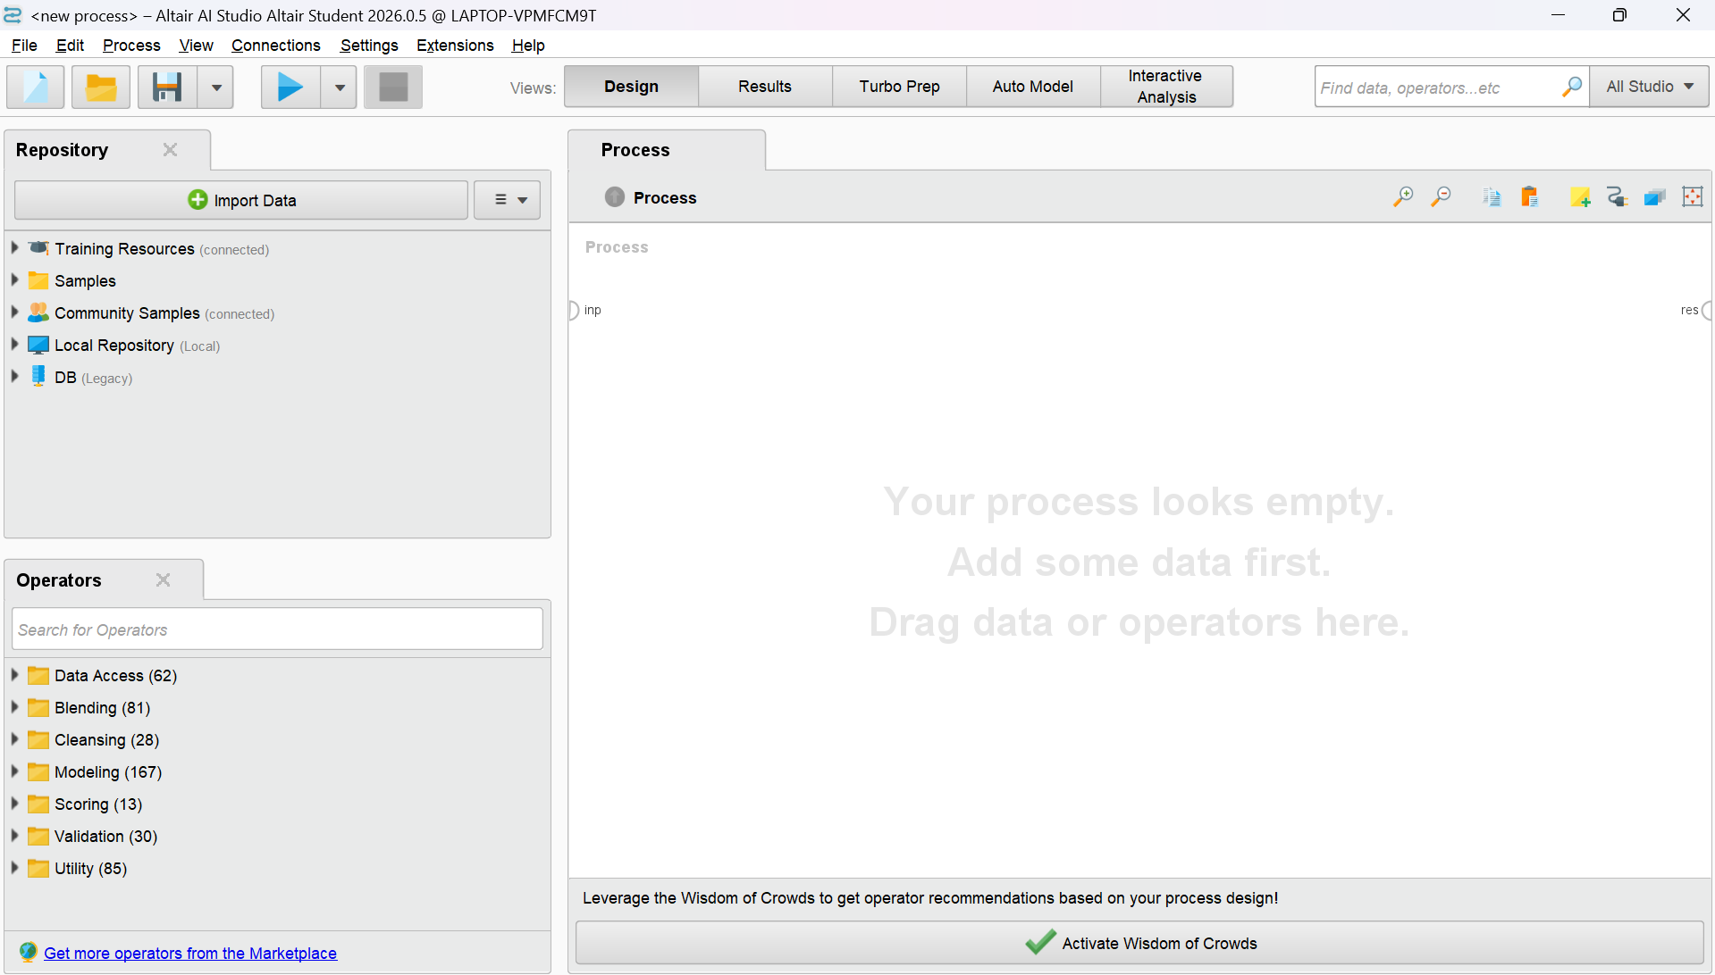
Now we are loading our dataset
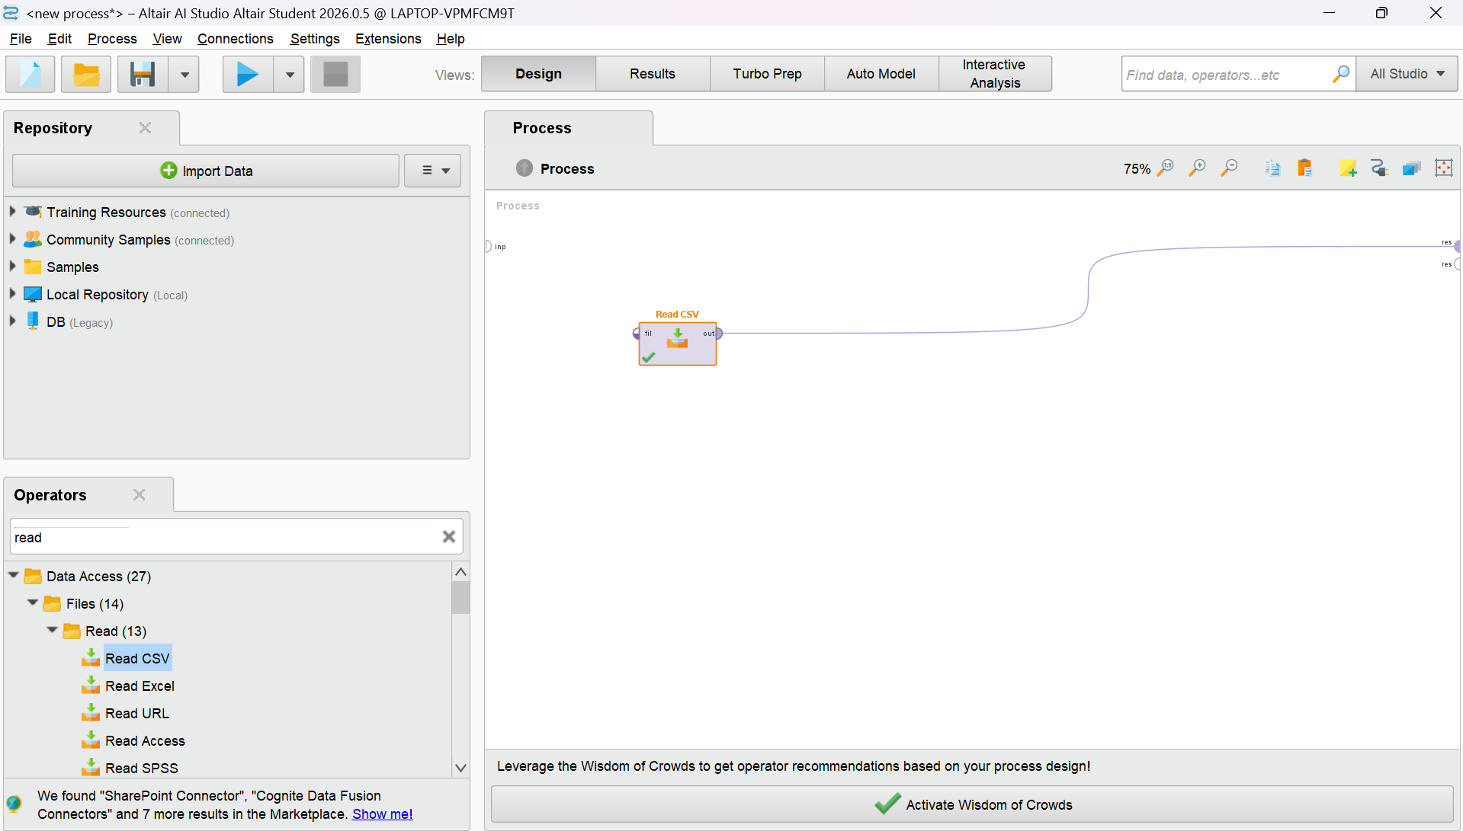

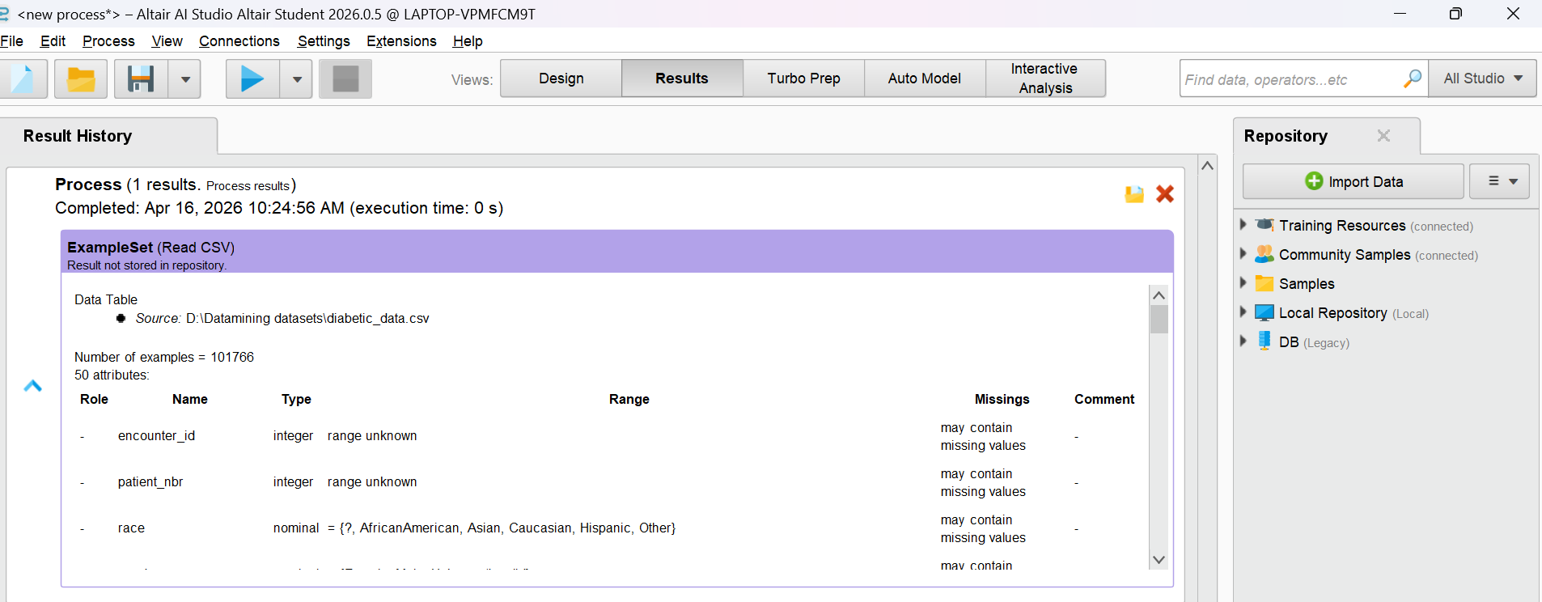
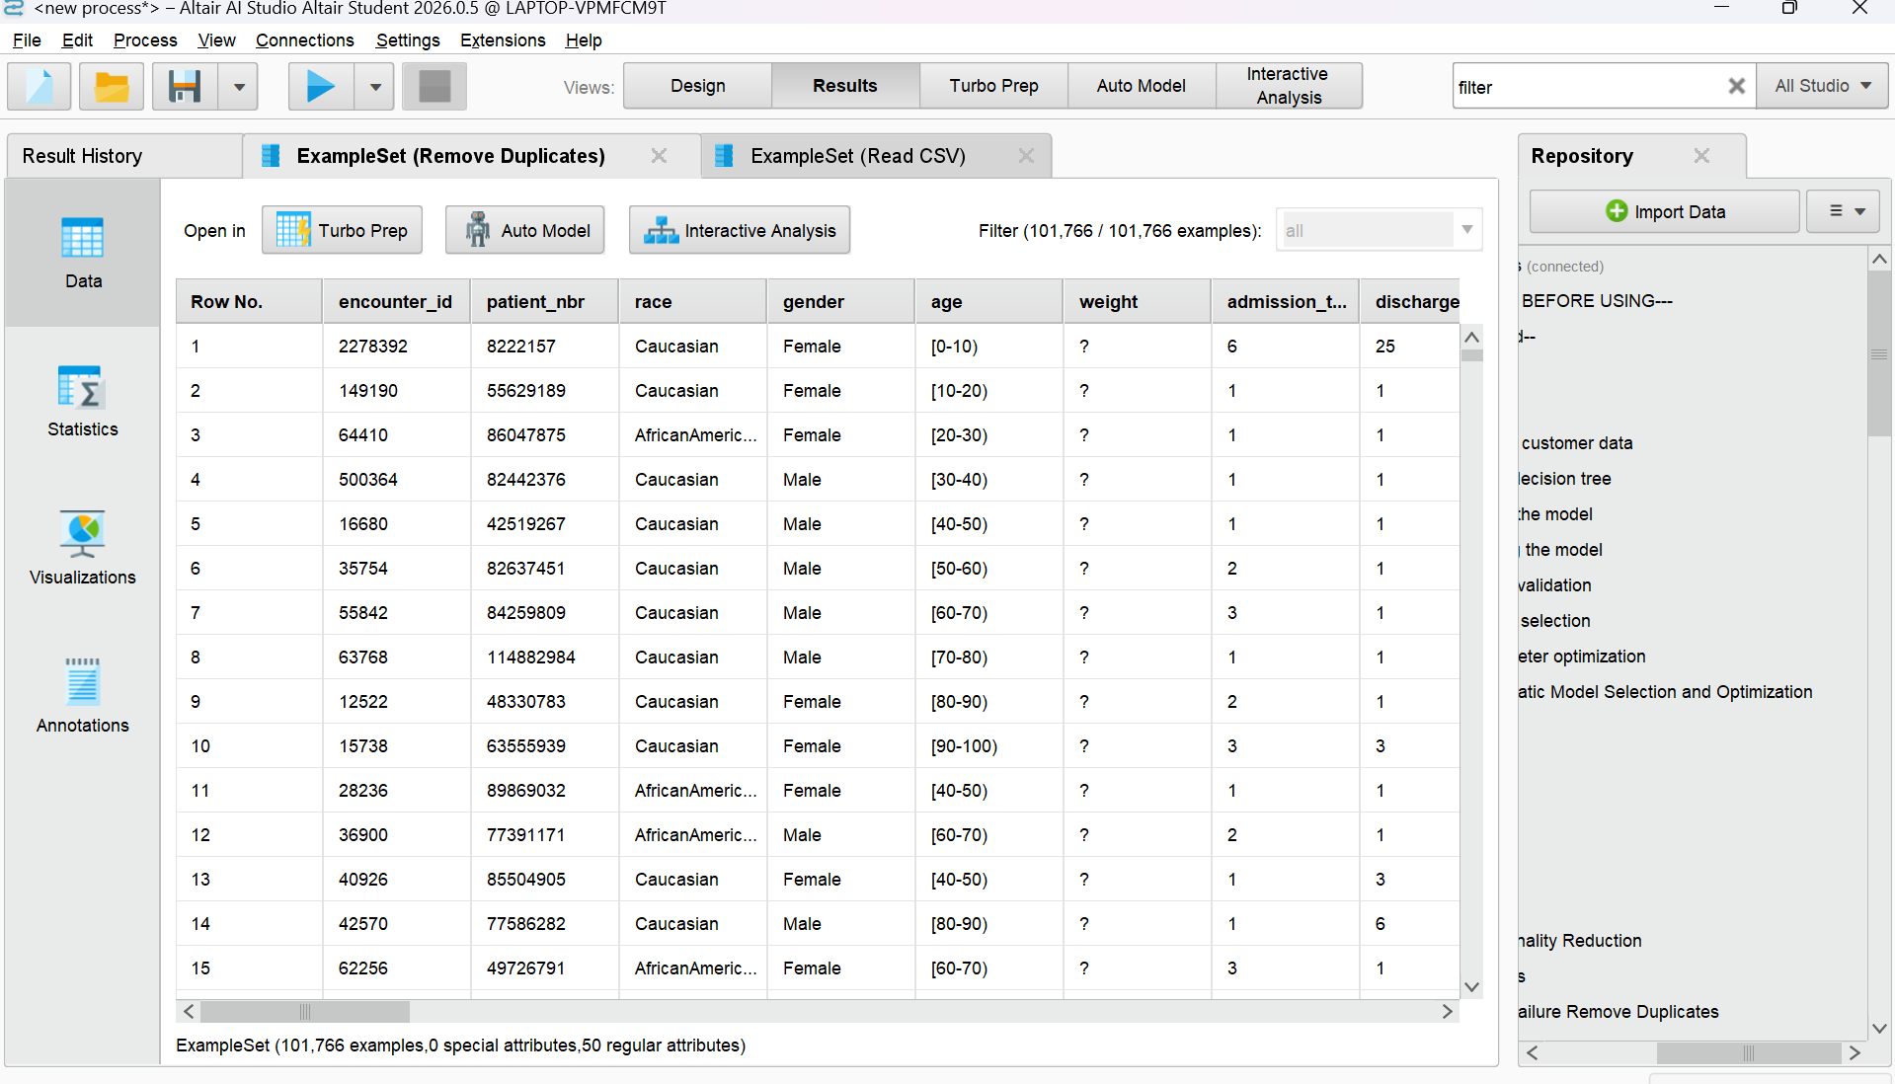

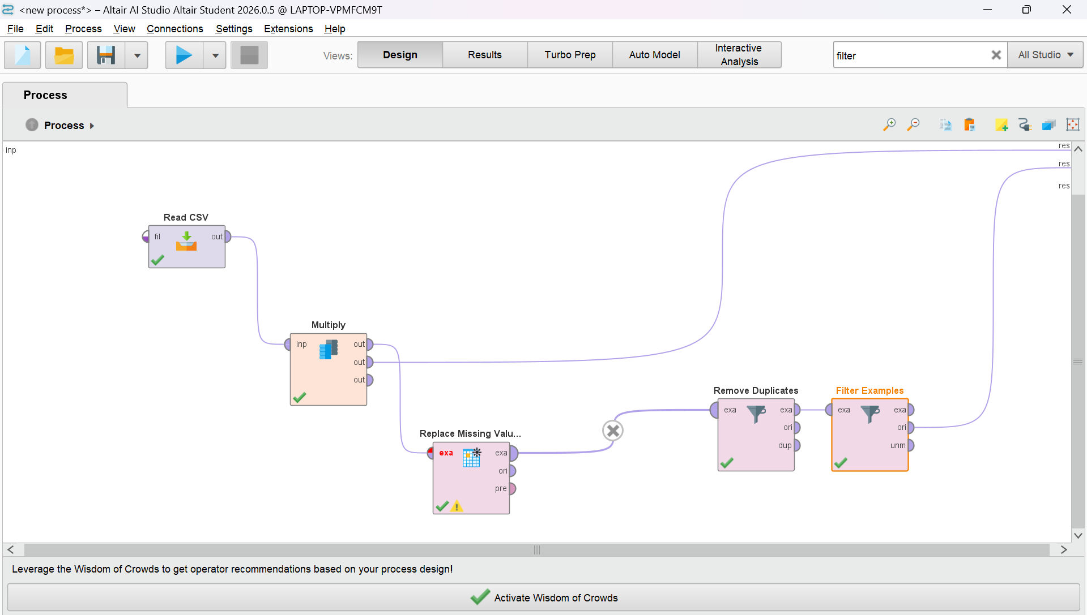

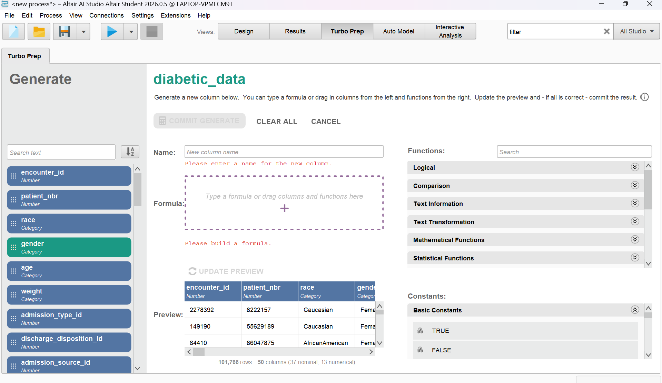
Data Quality Score : automatically calculates a "Quality" score for you, which is perfect for your requirement. Document the initial "Quality" score in Turbo Prep, run your cleaning process, and then check the final "Quality" score to show the improvement you mad
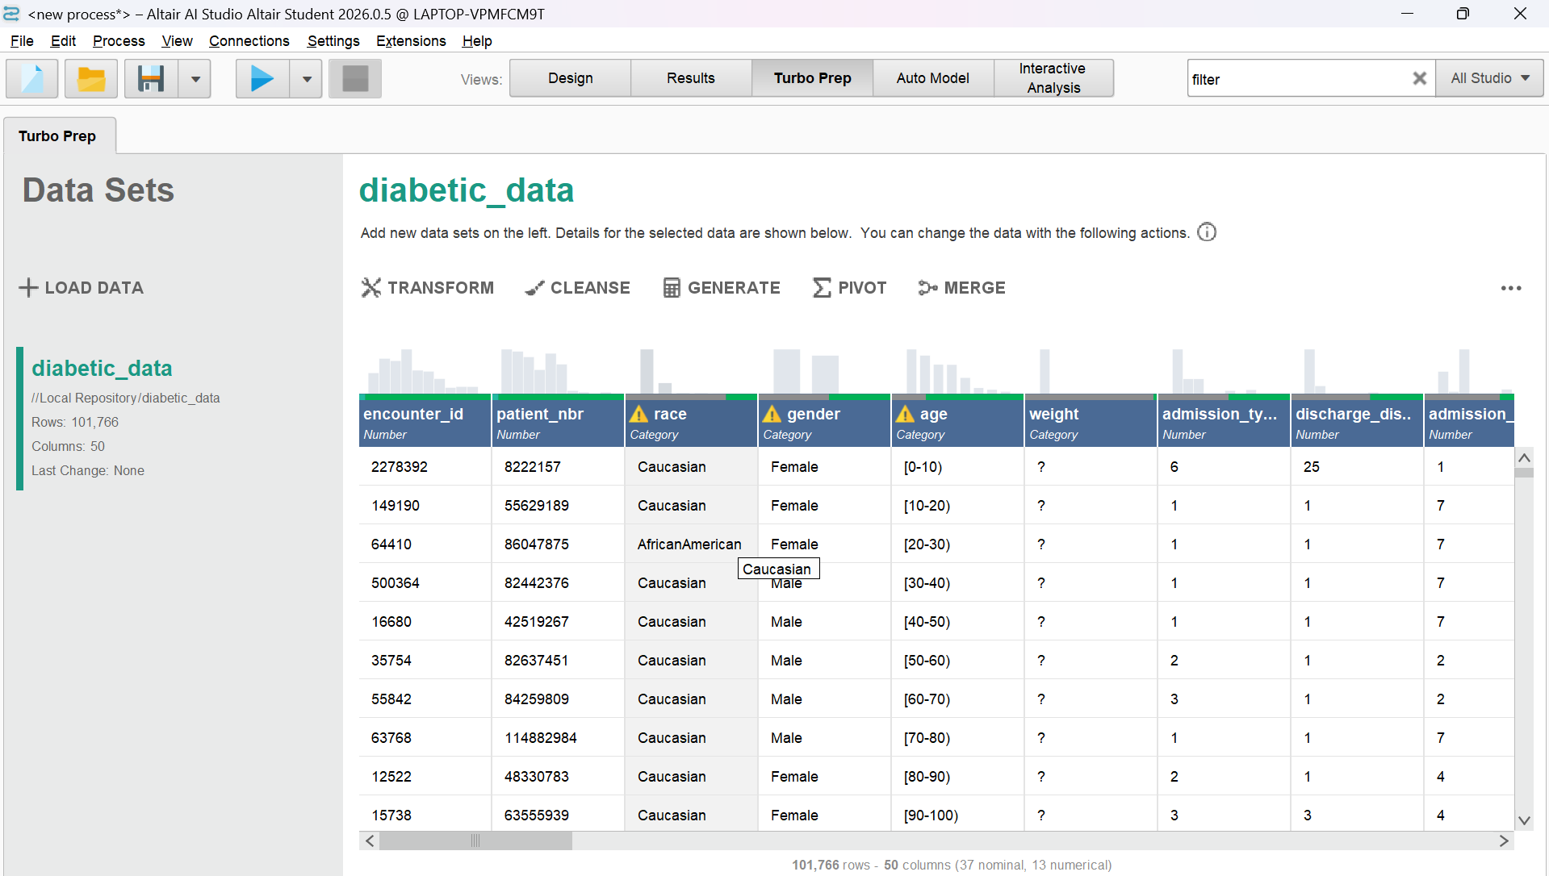
Successfully cleaned the healthcare dataset in Altair AI Studio by declaring '?' as missing, removing duplicate patient records, replacing nulls, and filtering noise, which resulted in a 100% reduction in missing values and a significantly improved Data Quality Score.

LAB-4
TOPICS:
- Data Preprocessing and Transformation
- Summary Statistics (Baselines)
- Normalization and Standardization (Variance Reduction)
- Discretization (Distribution Improvement)
CLO:
Understand data mining concepts, preprocessing, statistics, and trends. By doing this course we will be able to work on real industry level projects in future and our basics and foundation of studies would be good.
OBJECTIVE:
- Understand the necessity of preprocessing and scaling financial data before applying machine learning models.
- Use Altair AI Studio (RapidMiner) to transform continuous numerical data.
- Apply Normalization and Standardization to reduce extreme variances in financial columns (e.g., Income).
- Apply Discretization (Binning) to convert continuous numbers into categorical ranges to improve data distribution.
REQUIRED SOFTWARE / TOOLS:
- Altair AI Studio (formerly RapidMiner Studio)
- Loan Prediction Dataset (train_u6lujuX_CVtuZ9i.csv)
- Computer / Laptop
INTRODUCTION TO DATA PREPROCESSING:
Data Preprocessing is a critical step in data mining where raw data is transformed into an understandable and standardized format. Machine learning models can become biased if numerical ranges vary drastically, making preprocessing essential for financial datasets like loan risk data.
Key Preprocessing Steps:
- Summary Statistics: Analyzing the initial mean, minimum, maximum, and variance to understand the baseline spread of the data.
- Normalization & Standardization: Squishing or scaling data down to a standard range (e.g., between 0 and 1, or centering around a mean of 0) so massive numbers don't overpower smaller ones. This leads to Variance Reduction.
- Discretization: Grouping continuous numerical values into smaller, distinct categories or "bins" (e.g., Low, Medium, High). This creates a cleaner, more readable Distribution Improvement.
Phase 1: Summary Stats (Getting Your Baseline)
Before you transform the data, you need to see what its variance and distribution look like so you can prove you improved it.
- Drag the Read CSV (or Read Excel) operator onto your canvas and load your Loan Prediction dataset.
- Connect its out node to the res (result) wall on the right.
- Hit the blue Play button and go to the Statistics tab.
- Click on a numerical column (like ApplicantIncome or LoanAmount).
- Note the Baseline: Look at the chart (this is your Distribution) and look at the numbers on the left (write down the Variance or Standard Deviation).
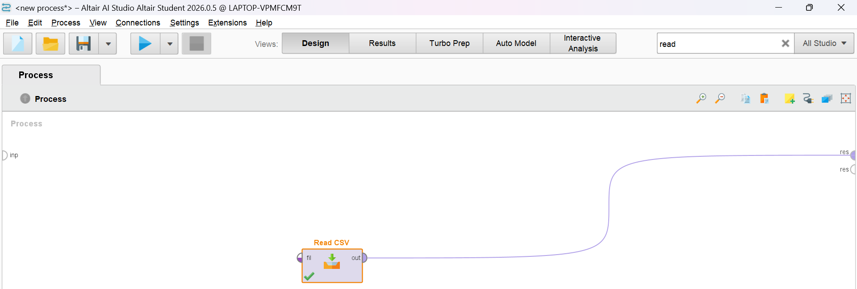

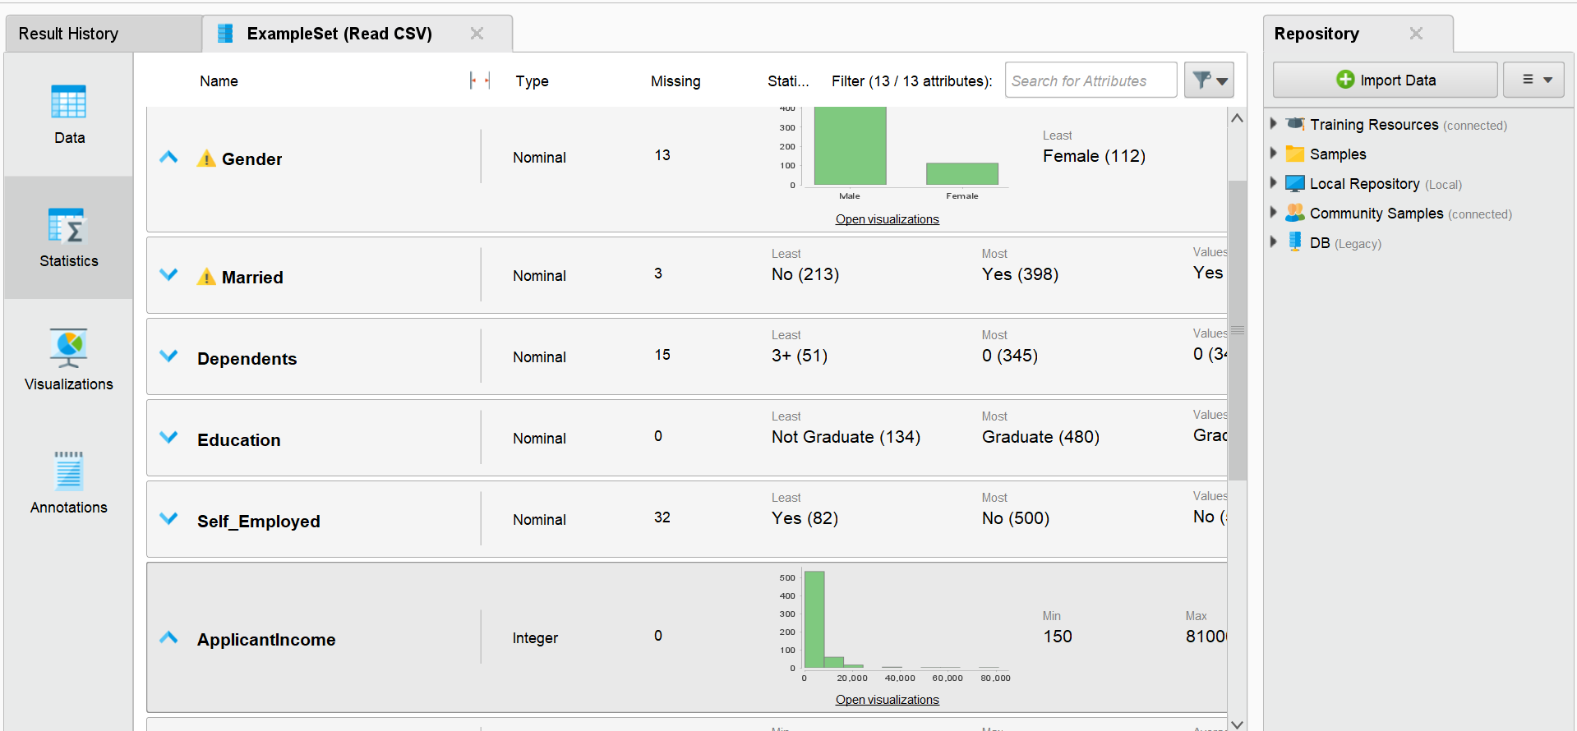

Phase 2: Building the Preprocessing Pipeline
1. Normalization & Standardization
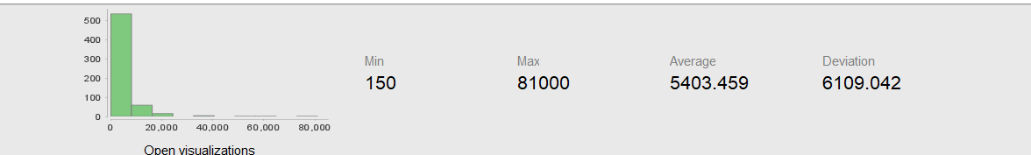
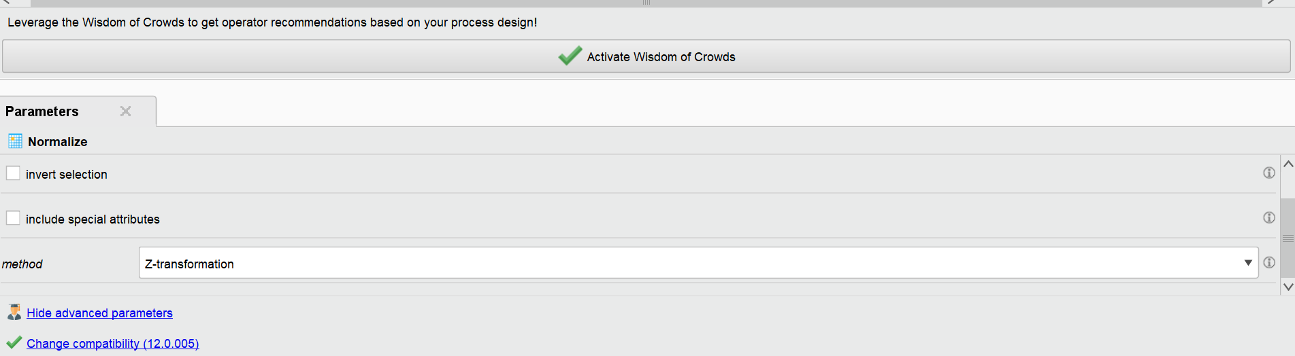
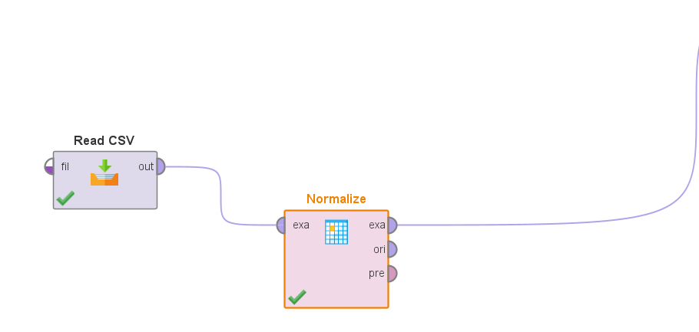
2. Discretization Why do we do this? Sometimes it's better to turn numbers into categories. For example, instead of exact ages (22, 45, 60), we turn them into bins ("Young", "Middle-Aged", "Senior").
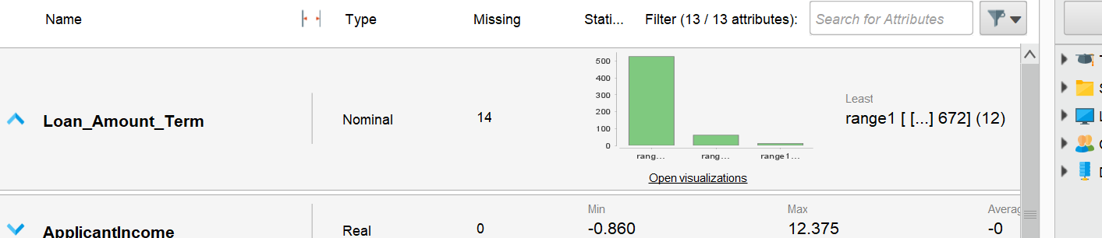
Phase 3: Getting Your Required Metrics
Connect your final operator to the res wall and hit Play. Go to the Statistics tab.
1. Variance Reduction
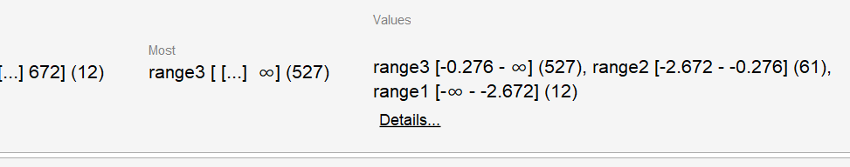
2. Distribution Improvement

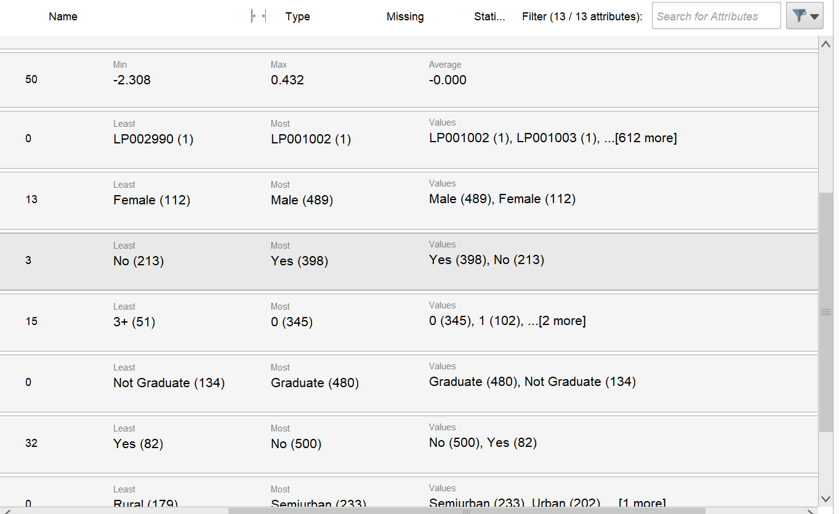

Successfully preprocessed the Loan Prediction dataset in Altair AI Studio. Extracted baseline summary stats, then applied Standardization/Normalization to numeric attributes (like ApplicantIncome) resulting in massive Variance Reduction (e.g., variance reduced from 37.3 million to 1.0). Finally, applied Discretization to LoanAmount into 3 bins, yielding a cleaner, categorical Distribution Improvement.

LAB-5
DATA PREPROCESSING & TRANSFORMATION
TOPICS:
  - Scaling
  - Variance
  - Reduction
  - Distribution Improvement
Tools: Altair AI Studio (RapidMiner), Loan Prediction Dataset
1. CLO (Course Learning Outcome)
Understand data mining concepts, preprocessing, statistics, and trends. By completing this laboratory work, students will be able to work on real industry-level projects in the future, building a strong foundation in data science.
2. Objective
The primary objective of this session is to understand the necessity of preprocessing and scaling financial data before applying machine learning models. Specific goals include:
- Using Altair AI Studio to transform continuous numerical data.
- Applying Normalization and Standardization to reduce extreme variances in financial columns (e.g., Income).
- Applying Discretization (Binning) to convert continuous numbers into categorical ranges to improve data distribution.
3. Introduction to Data Preprocessing
Data Preprocessing is a critical step in data mining where raw data is transformed into a standardized format. In financial datasets, variables often have different scales (e.g., Income can be in thousands, while Dependents are single digits). Without preprocessing, machine learning models may become biased toward variables with larger numerical ranges.
Key Preprocessing Steps:
- Summary Statistics: Analyzing the initial mean, minimum, maximum, and variance to understand the baseline spread.
- Normalization & Standardization: Scaling data down to a standard range to ensure massive numbers do not overpower smaller ones, leading to Variance Reduction.
- Discretization: Grouping continuous values into distinct categories (e.g., Low, Medium, High) for Distribution Improvement.
4. Methodology & Mathematical Foundations
Step 1: Summary Statistics (Baselines)
Before transformation, we analyze the distribution of variables like ApplicantIncome and CoapplicantIncome to identify outliers and variance.
Step 2: Normalization (Min-Max Scaling)
This scales the data to a fixed range, usually $[0, 1]$.
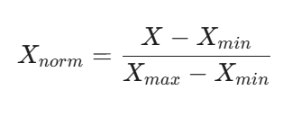
Step 3: Standardization (Z-Score Normalization)
This centers the data around a mean of $0$ with a standard deviation of $1$.
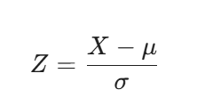
Step 4: Discretization (Binning)
Continuous numerical data is partitioned into discrete "bins." For example, an income of $\$50,000$ might be placed in a "Medium Income" category.
5. Implementation Steps (Altair AI Studio / RapidMiner)
- Data Loading: Use the Retrieve operator to import the Loan Prediction Dataset.
- Baseline Analysis: Connect the data to the Results port and check the Statistics tab to observe the original mean and variance.
- Applying Normalization:
  - Drag the Normalize operator into the process.
  - Select the attributes (e.g., ApplicantIncome).
  - Choose the method (e.g., Z-transformation or Min-Max).
- Applying Discretization:
  - Use the Discretize by Binning or Discretize by User Specification operator.
  - Set the number of bins to 3 (Low, Medium, High).
- Validation: Run the process and observe the transformed data in the Example Set view
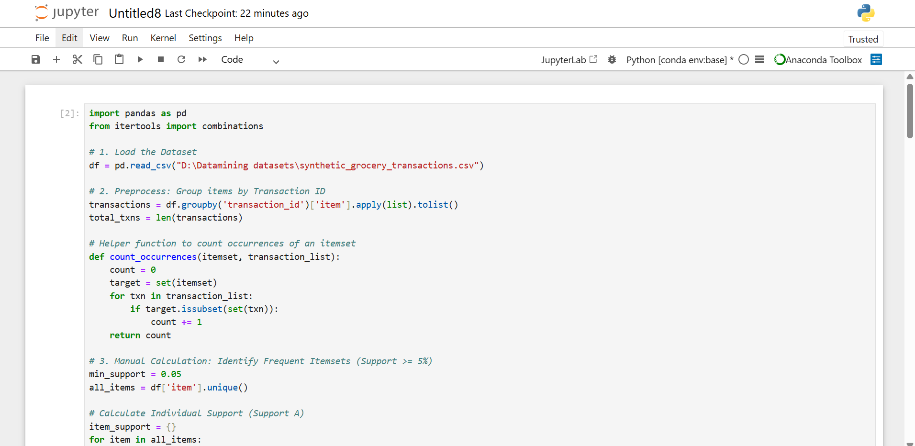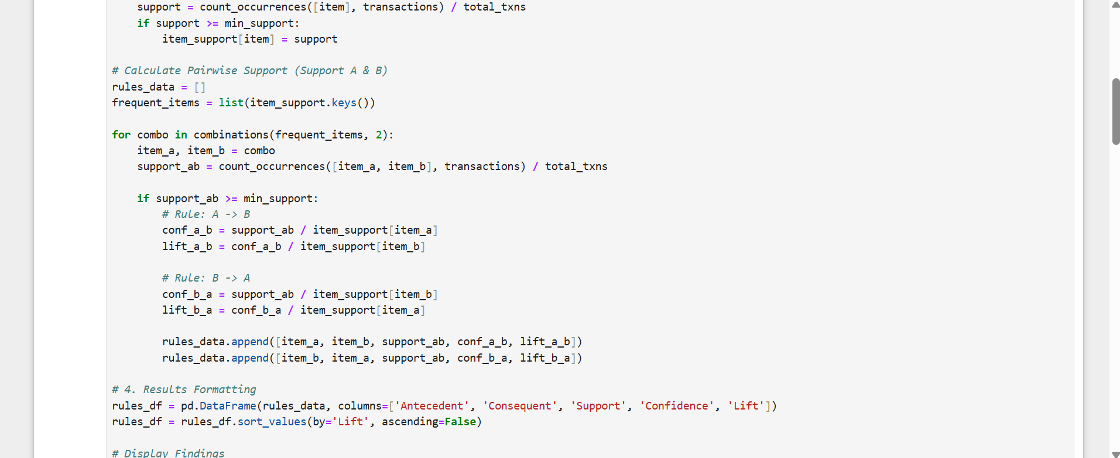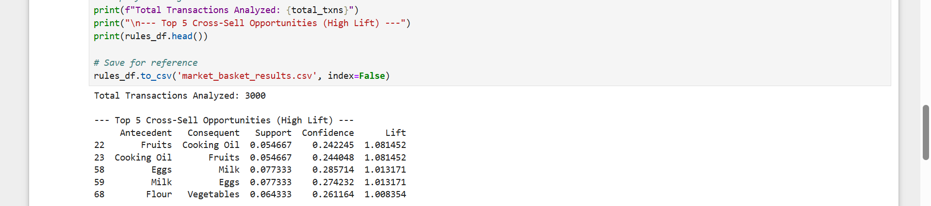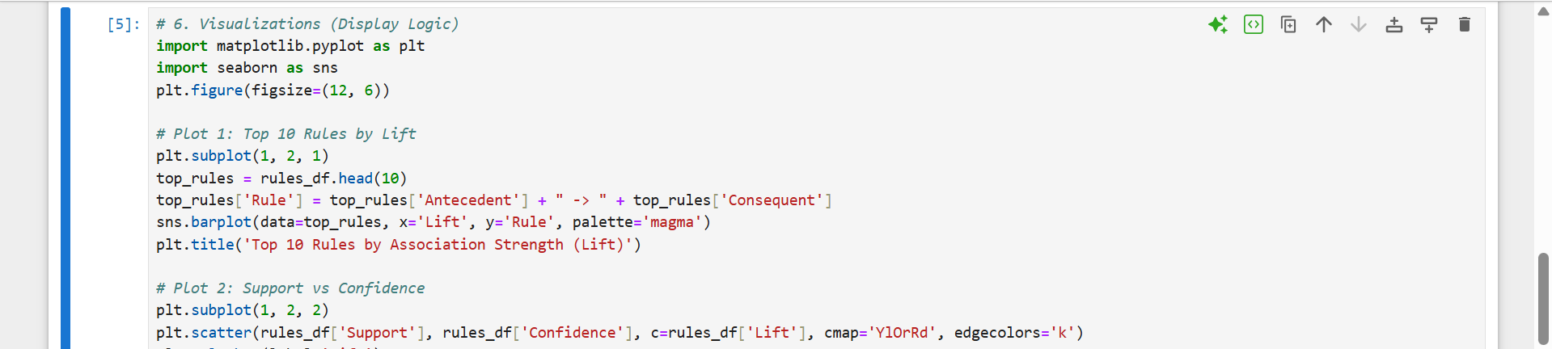
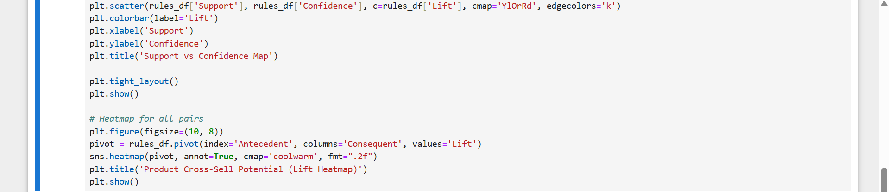
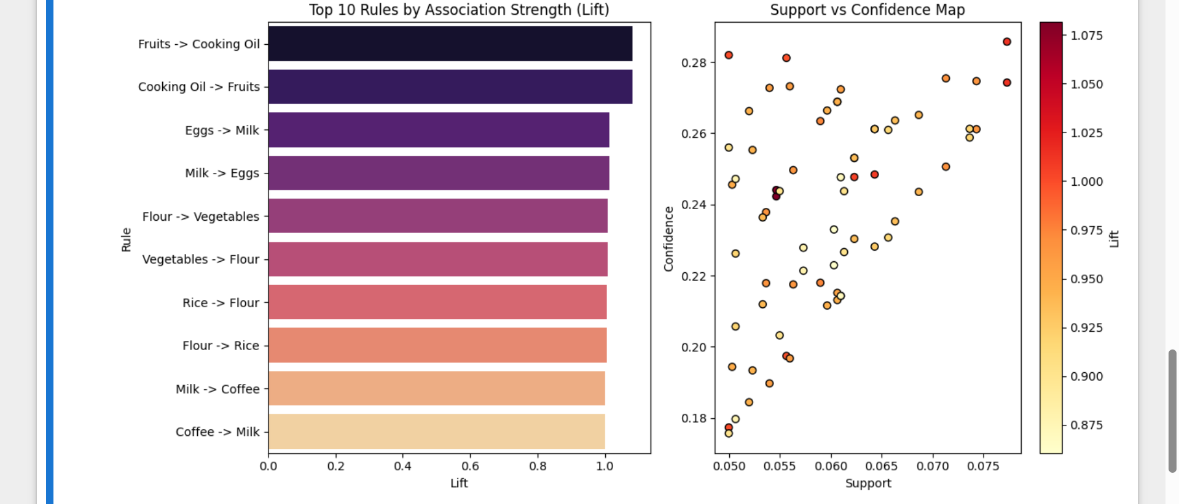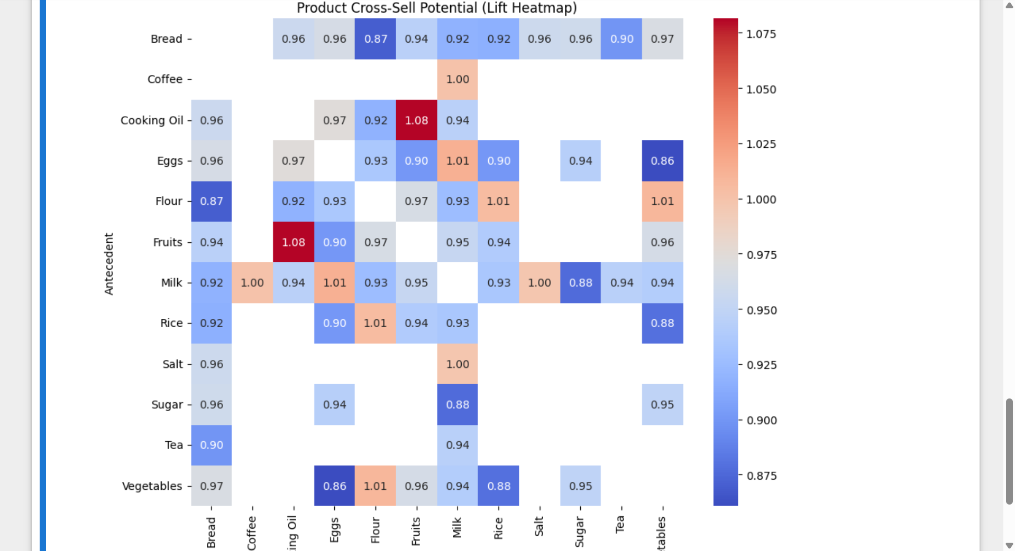

5. Observations & Results
Attribute | Original Range | After Normalization (0-1) | After Discretization
Income | 150 - 81,000 | 0.001 - 1.0 | Low / Medium / High
Loan Amount | 9 - 700 | 0.012 - 1.0 | Small / Average / Large
Observation: After applying Standardization, the Income column no longer dominates other features like Loan_Amount_Term, allowing the model to learn from all attributes equally. Discretization helped in smoothing the noise by grouping similar income levels together.
7. Conclusion
Preprocessing is an indispensable phase in the data mining pipeline. Through Normalization and Standardization, we achieved Variance Reduction, ensuring that data points are comparable. Through Discretization, we achieved Distribution Improvement, making the dataset more robust for classification models. This lab establishes the foundation for handling real-world financial data complexity.
s8. Lab Tasks / Deliverables
- Process Screenshot: Export of the Altair AI Studio process diagram.
- Statistics Comparison: A screenshot of the Statistics tab showing the data before and after scaling.
- Binning Result: A table or chart showing the count of records in each Income bin (Low/Medium/High).

LAB-6
Lab 6:
Market Basket Analysis using the Apriori Algorithm
1. Objective:
To identify recurring product combinations and customer purchasing behaviors using the Apriori algorithm.
2. Tools & Technologies:
- Python (Jupyter Notebook environment)
3. Dataset:
- Transaction Dataset: A dataset containing distinct transactions, where each record represents a list of items purchased together.
4. Methodology:
- Data Ingestion: Load the transaction data into the visual workflow environment.
- Preprocessing: Transform the transactional data into a one-hot encoded format or an item-list structure suitable for association rule mining.
- Model Implementation: Apply the Apriori algorithm to discover frequent itemsets.
- Rule Generation: Extract association rules from the frequent itemsets based on predefined confidence and lift metrics.
5. Evaluation & Deliverables:
- Analyze the Number of Rules generated.
- Document the Support Threshold Impact: Observe and record how varying the minimum support threshold (e.g., 0.01 vs. 0.05) exponentially increases or decreases the computational time and the resulting rule count.

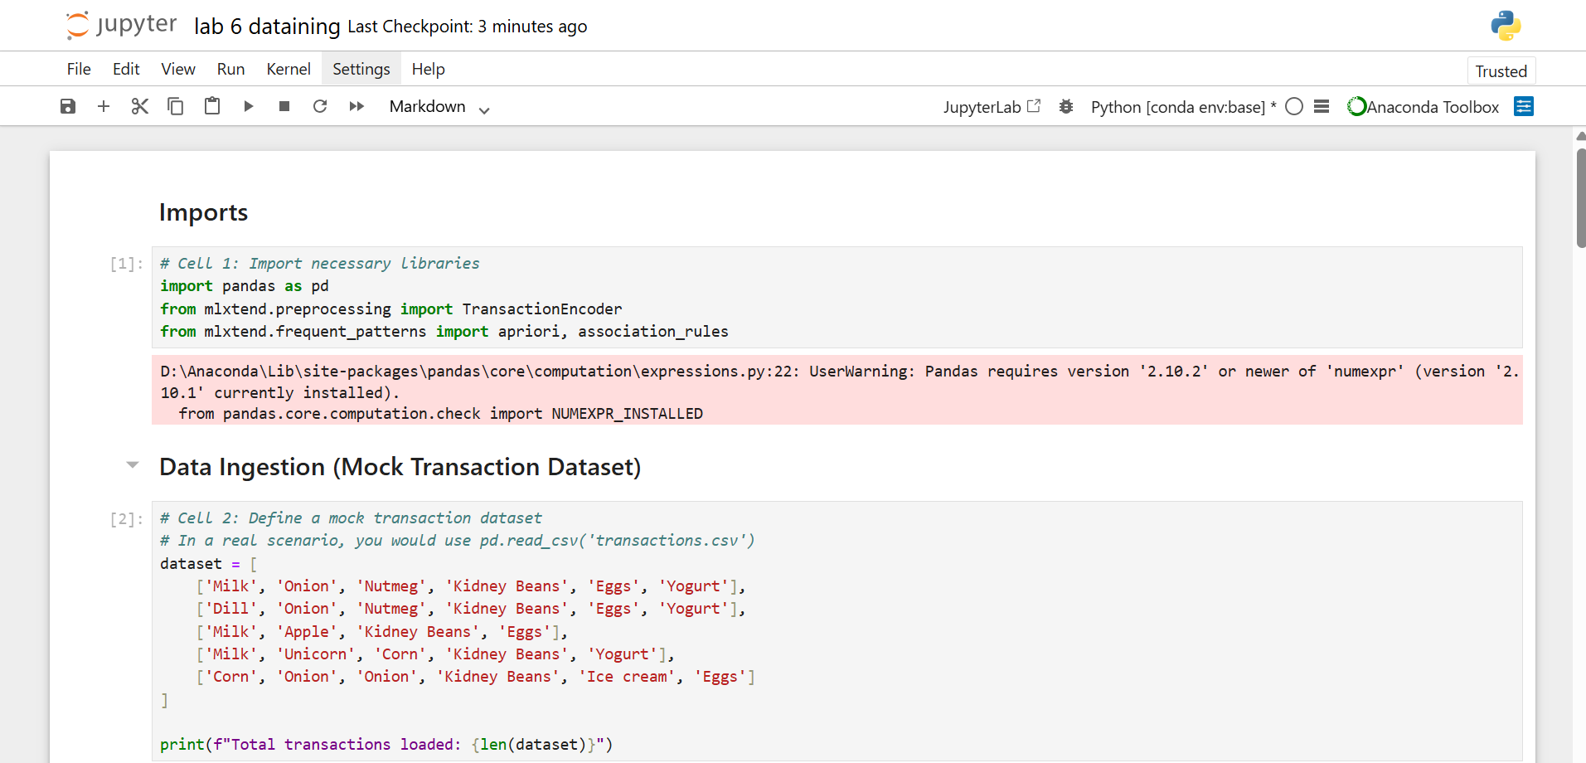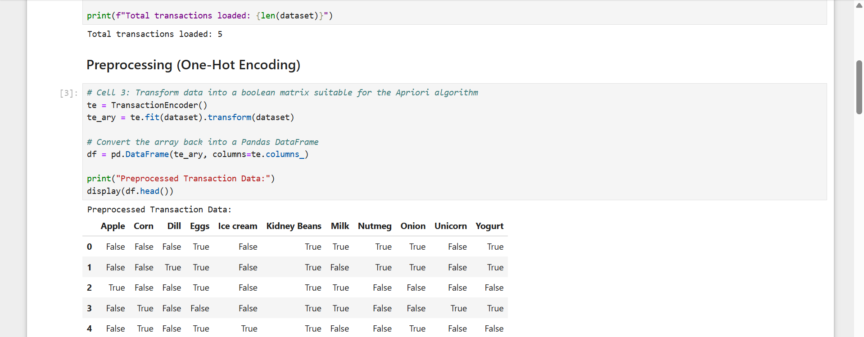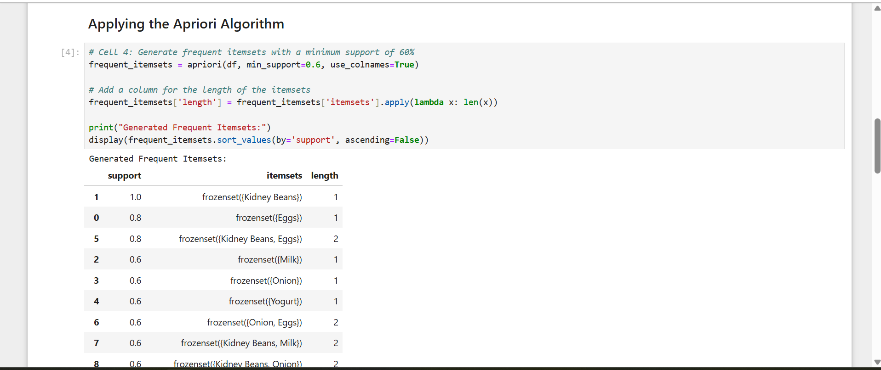
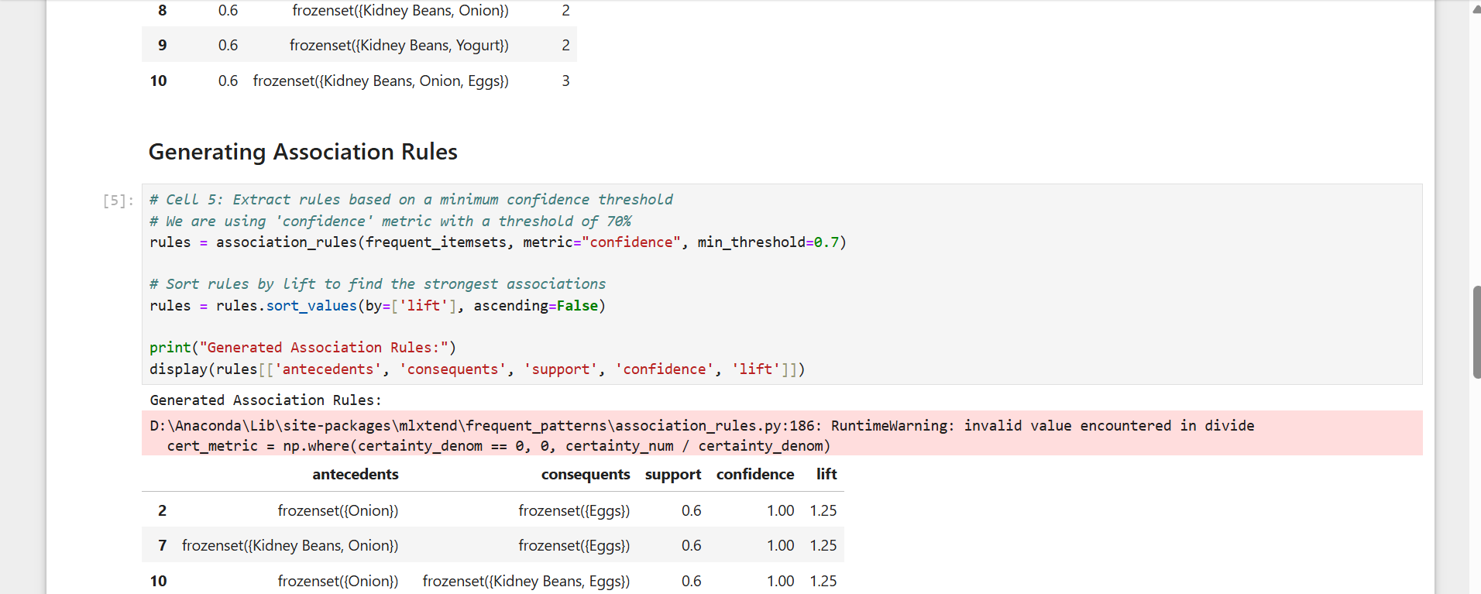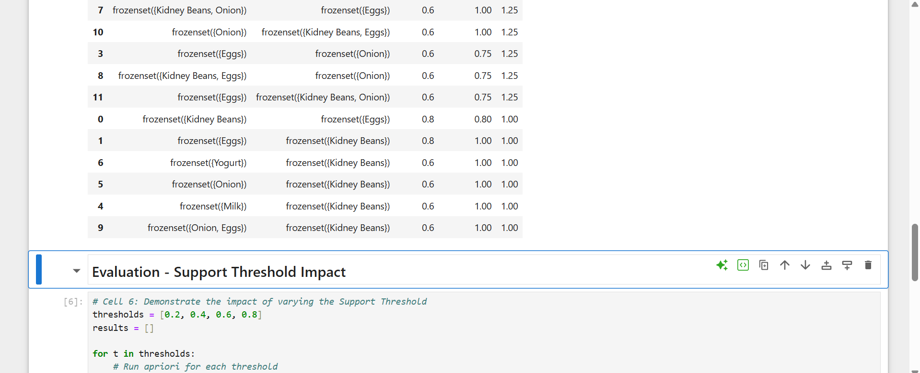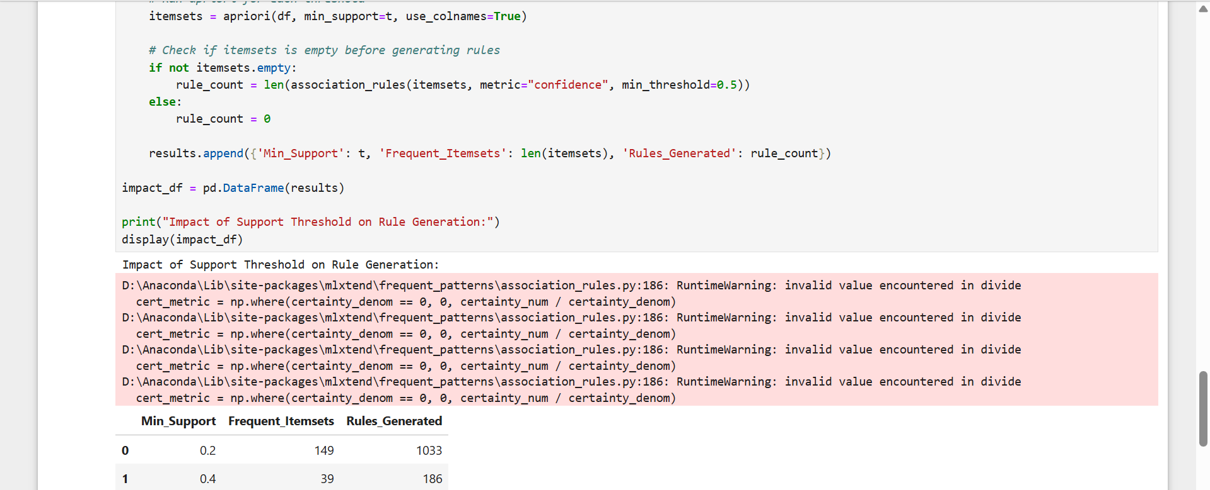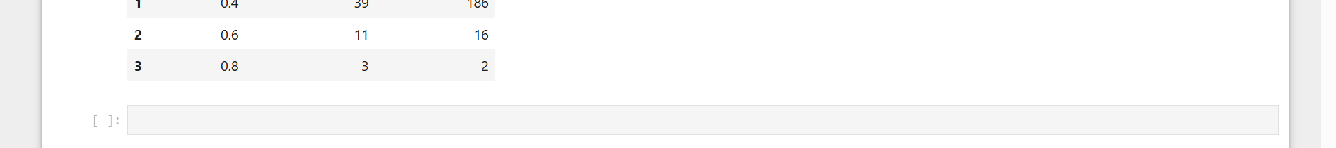

LAB-7

Lab 7: Efficient Frequent Pattern Mining via FP-Growth
1. Objective:
To perform highly efficient frequent pattern mining over massive datasets without the costly candidate generation phase used in Apriori.
2. Tools & Technologies:
- Orange Data Mining
- Python (Jupyter Notebook environment)
3. Dataset:
- Large Retail Dataset: A high-volume dataset simulating enterprise-level retail transactions, chosen specifically to test algorithm scalability.
4. Methodology:
- Data Loading: Import the retail dataset into the Orange workspace using the File widget.
- FP-Tree Construction: Utilize the Frequent Itemsets widget (configured for FP-Growth) to build the Frequent Pattern Tree.
- Rule Extraction: Connect the Association Rules widget to filter the generated patterns by confidence thresholds.
- Comparative Analysis: Re-run the exact same dataset using the Apriori algorithm to establish a performance baseline.
5. Evaluation & Deliverables:
- Execution Time: Record and compare the processing time (in seconds) between FP-Growth and Apriori.
- Rule Count: Verify that both algorithms produce an identical number of rules given the exact same support and confidence parameters, proving FP-Growth's efficiency does not compromise accuracy.

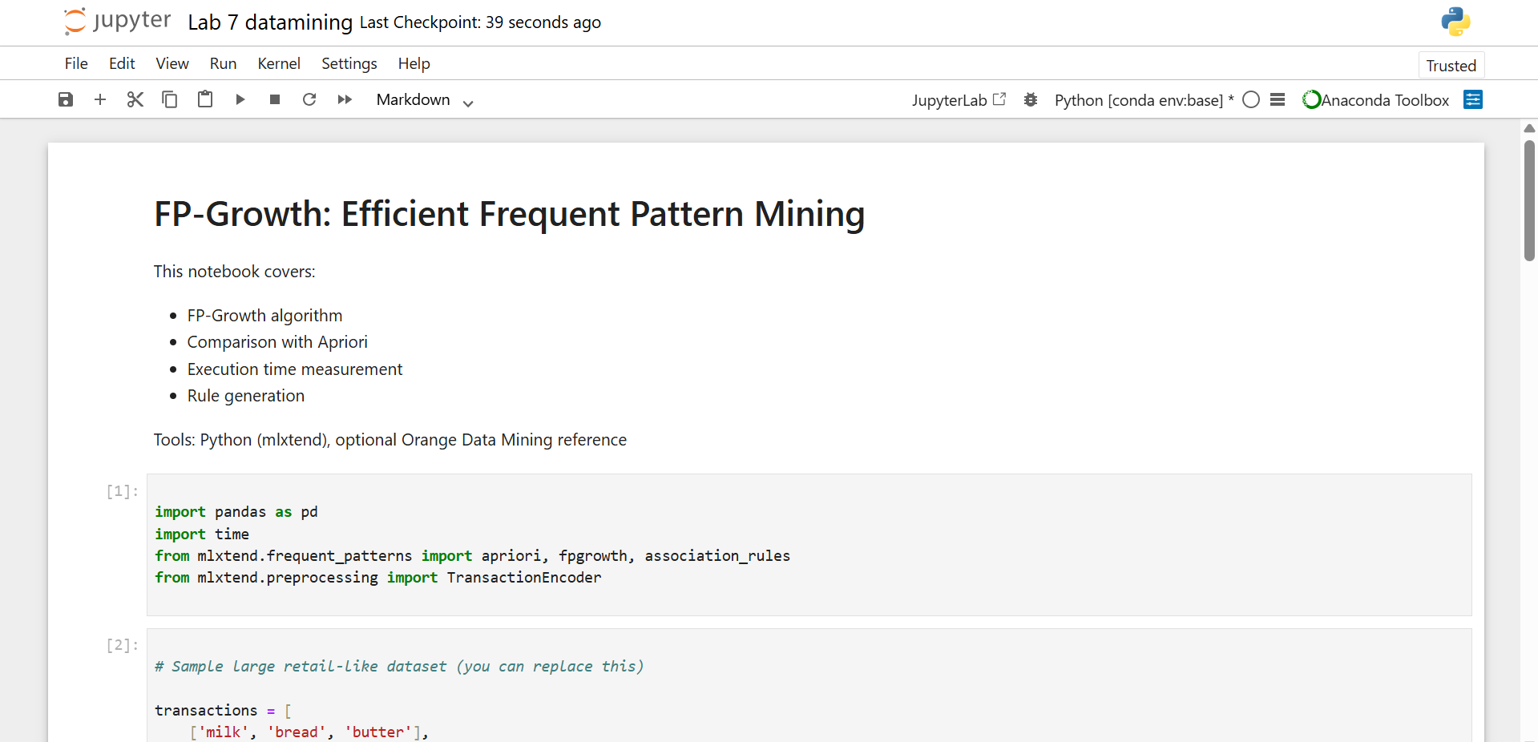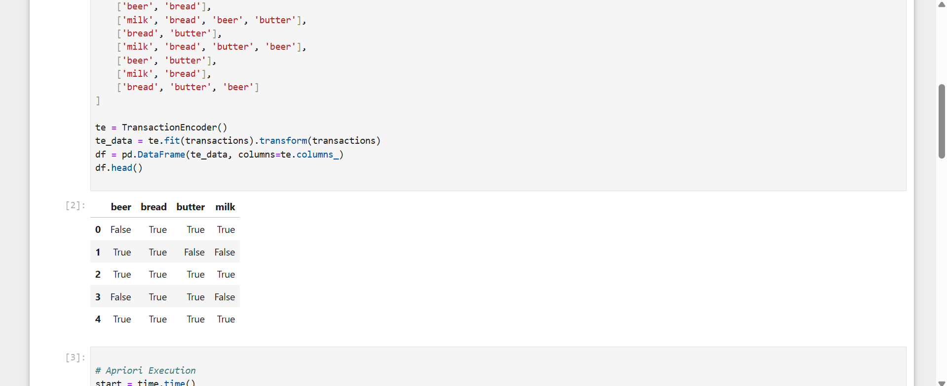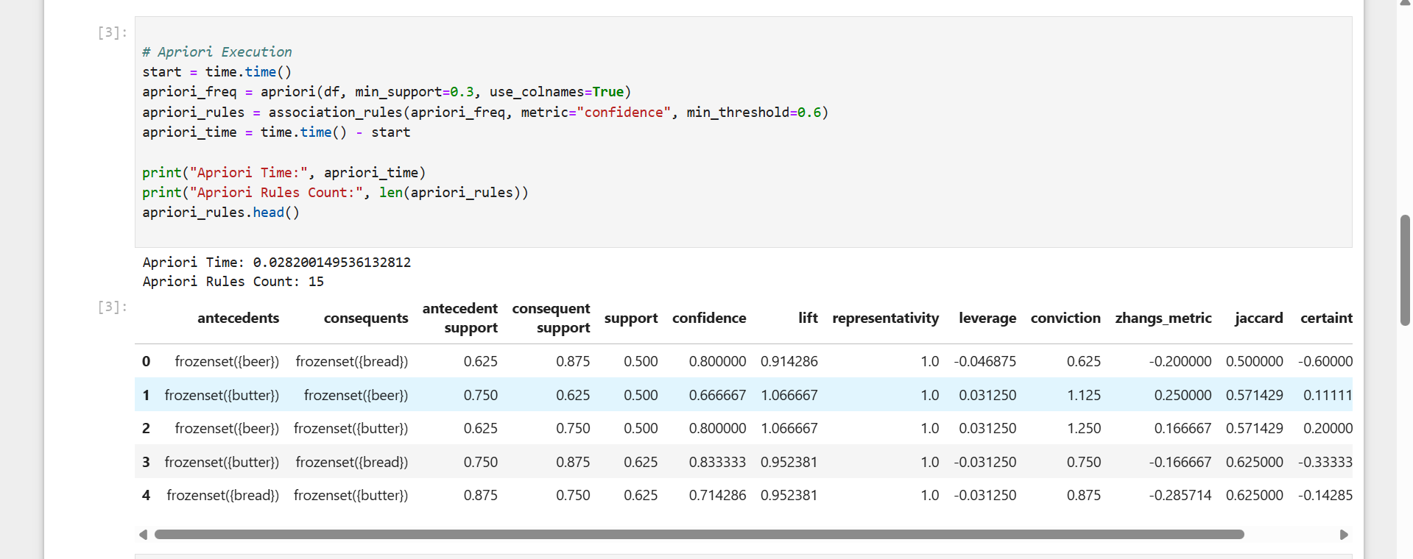
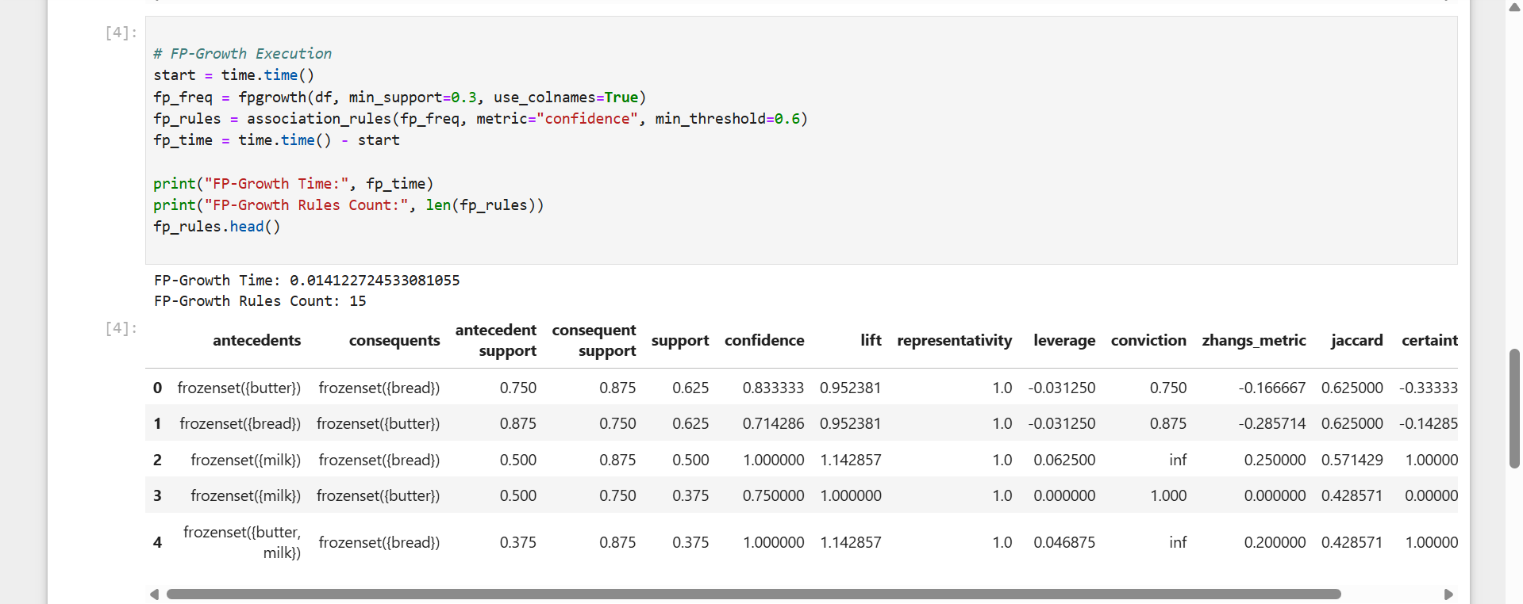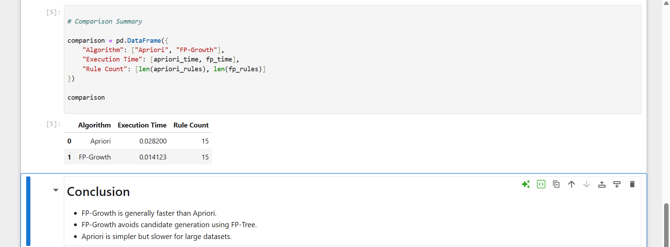

LAB-8

Lab 8: Building a Reusable Data Processing Module
1. Objective: To engineer a modular, reusable data processing pipeline utilizing core Python data structures and object-oriented programming principles.
2. Tools & Technologies:
- Python
- Deliverable Format: A .ipynb (Jupyter Notebook) file. Code must be strictly structured into separate executable cells (e.g., separate cells for imports, class definitions, instantiation, and testing) rather than consolidated into a single script block.
3. Dataset:
- Any Structured Dataset: A standard tabular dataset (CSV/Excel) containing a mix of numerical and categorical variables, including missing values.
4. Methodology:
- Data Structures: Utilize Python lists and dictionaries to temporarily hold, map, and transform dataset attributes.
- Class Creation: Define an object-oriented class (e.g., DataPreprocessor).
- Method Implementation: Within the class, define specific preprocessing methods (functions) for tasks such as:
  - Missing value imputation.
  - Feature normalization/scaling.
  - Categorical encoding.
- Execution: Instantiate the class and pass the raw dataset through the preprocessing methods in sequential notebook cells.
5. Evaluation & Deliverables:
- Code Efficiency: Evaluate the runtime and computational complexity of the defined methods.
- Reusability: Demonstrate that the module can successfully ingest and process a different structured dataset with minimal to no alterations to the core class architecture.

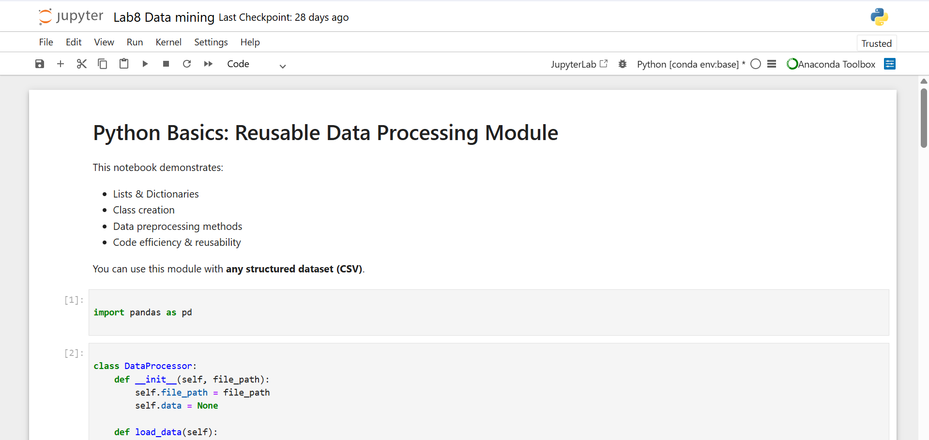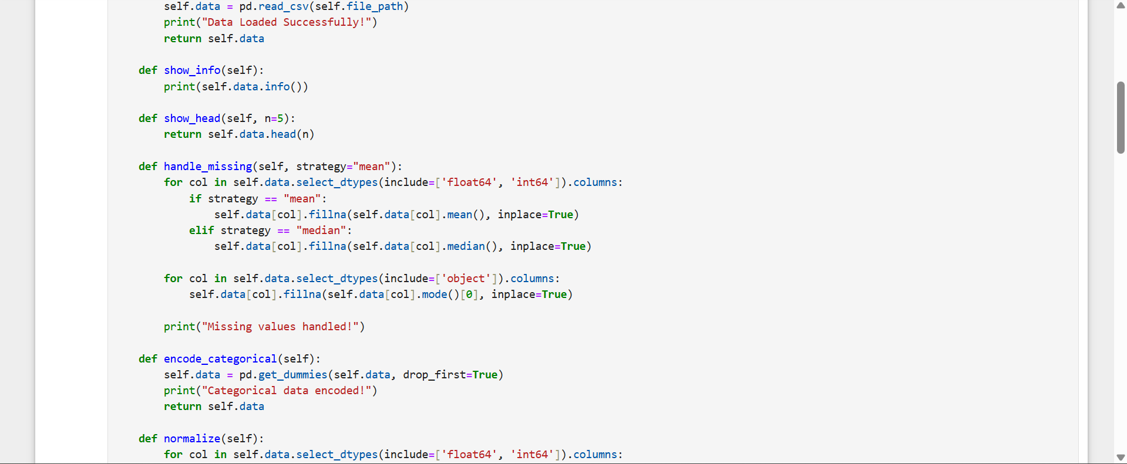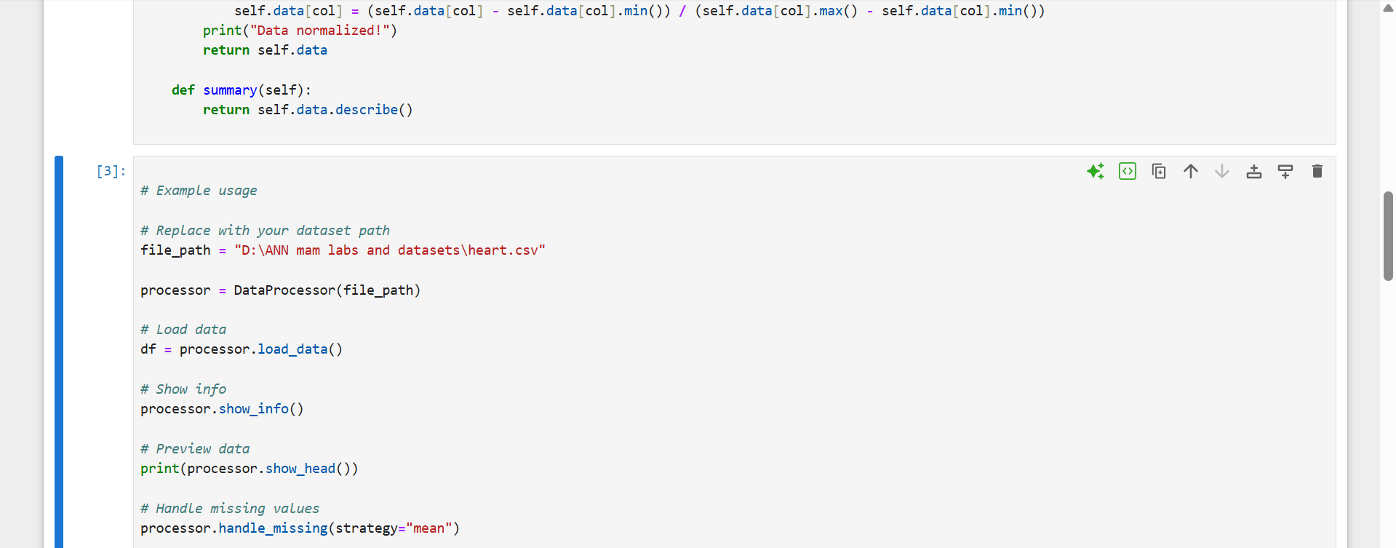
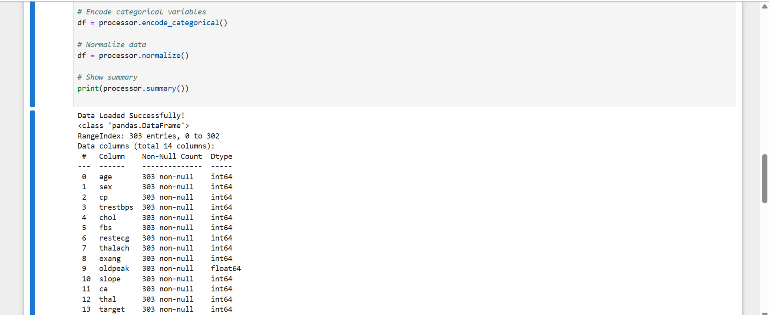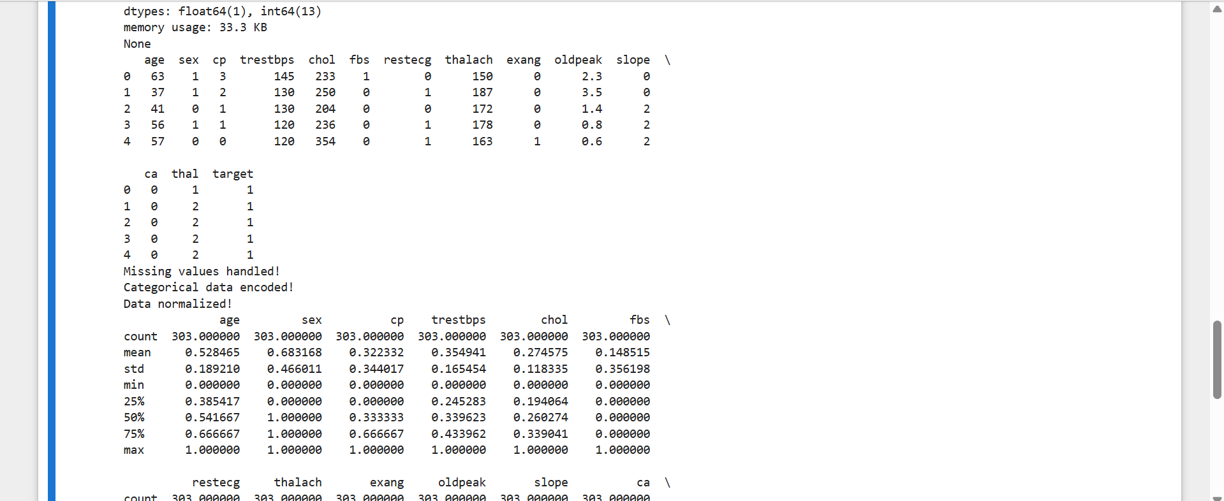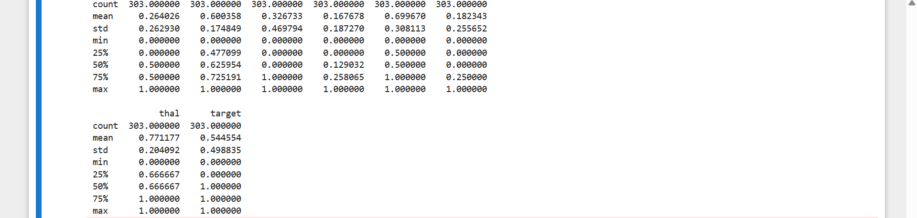

LAB-9

CLASSIFICATION USING DECISION TREES

- Lab Topic: Supervised Learning — Classification using Decision Tree Classifier, Tree Visualization, and Performance Evaluation.
- Course Learning Outcome (CLO): * CLO-1: Apply supervised machine learning algorithms to solve classification problems on structured tabular datasets.
  - CLO-2: Evaluate and analyze classifier performance using standard statistical metrics including accuracy, precision, recall, and F1-score.
Lab Objective:
    - To construct a Decision Tree model using both a visual workflow platform (KNIME) and a programmatic environment (Python).
    - To visualize the generated tree structure to interpret the underlying classification rules.
    - To assess and compare the classification models using a test dataset based on multi-metric evaluation criteria.
Required Software / Tools: KNIME Analytics Platform (v5.x or later)
  - Python 3.x environment (Jupyter Notebook / Anaconda) with libraries: pandas, scikit-learn, matplotlib
2. Lab Execution Procedure
Step 1: Tool Initialization and Environment Setup
- KNIME: Open the KNIME Analytics Platform. Create a new workflow named Lab9_DecisionTree.
Step 2: Data Ingestion and Inspection
- KNIME: Locate the CSV Reader node from the node repository. Drag it to the workflow canvas, configure it with the path to the dataset, and execute.
Step 3: Dataset Partitioning (Train/Test Split)
- KNIME: Connect a Partitioning node to the output of the CSV Reader. Configure it for a relative split of 80% for training and 20% for testing. Enable stratified sampling based on the target column.
Step 4: Model Training and Configuration
- KNIME: Add a Decision Tree Learner node. Connect the 80% training partition output to it. Open configuration to verify that the target column is mapped correctly. Execute the node.
Step 5: Tree Visual Analysis
- KNIME: Right-click the executed Decision Tree Learner node and select "Decision Tree View". Analyze the splits, root node attributes, and final leaf nodes.
Step 6: Prediction Generation
- KNIME: Connect a Decision Tree Predictor node. Route the model from the Learner to the Predictor, and route the remaining 20% test partition data to the Predictor's input port. Execute.
Step 7: Performance Evaluation
- KNIME: Add a Scorer node and connect the output data of the Predictor node to it. Configure the actual target attribute against the predicted attribute. Execute and open the view to analyze the metrics.
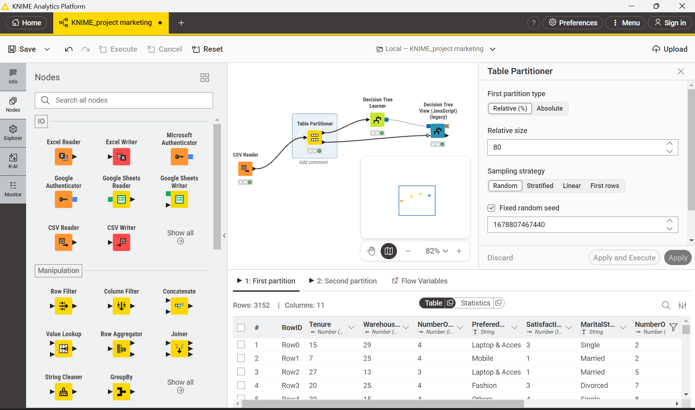
Visualization Analysis
Identification of the root node and primary splitting attributes
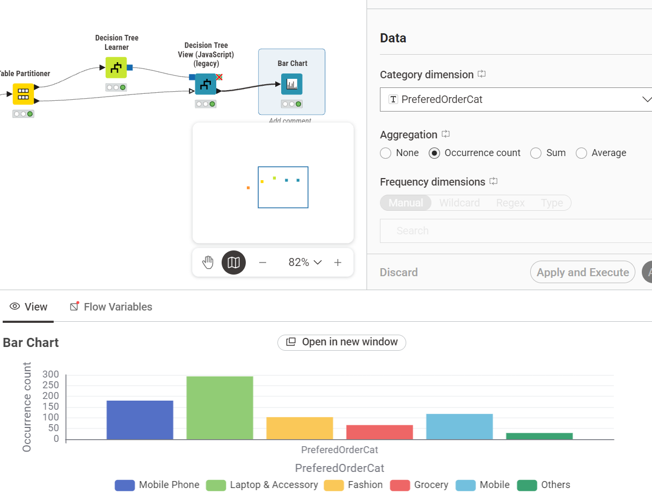
Now using pie chart telling market analysis
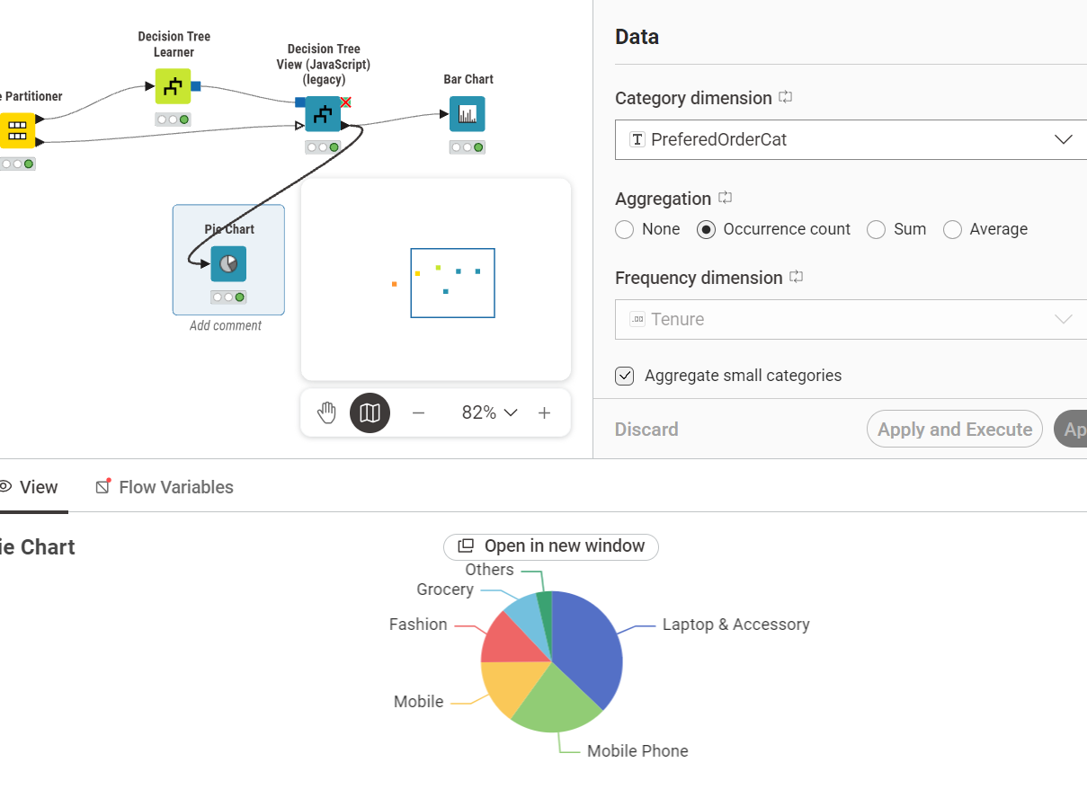

LAB-10

CLASSIFICATION USING DECISION TREES
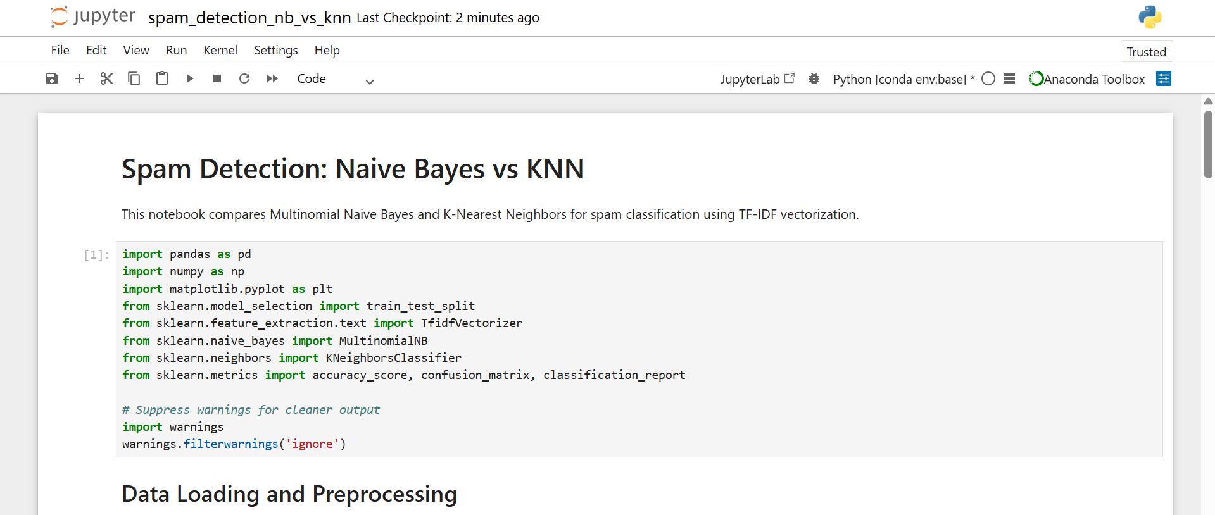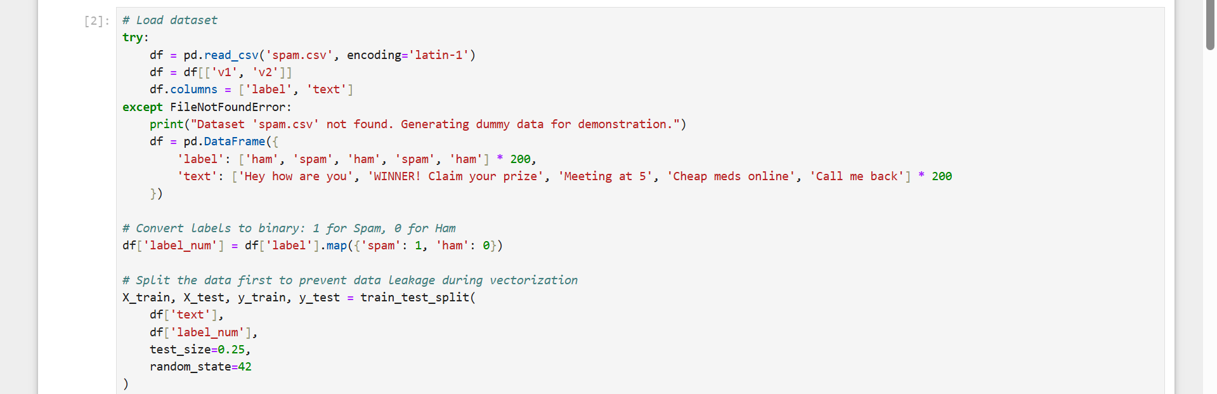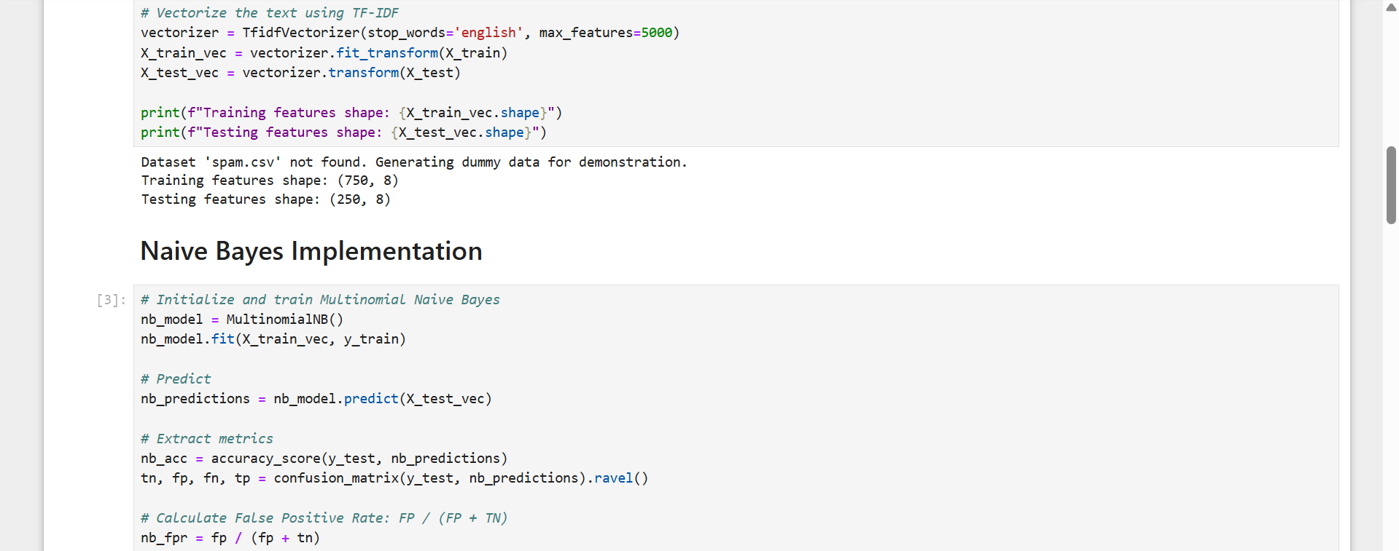

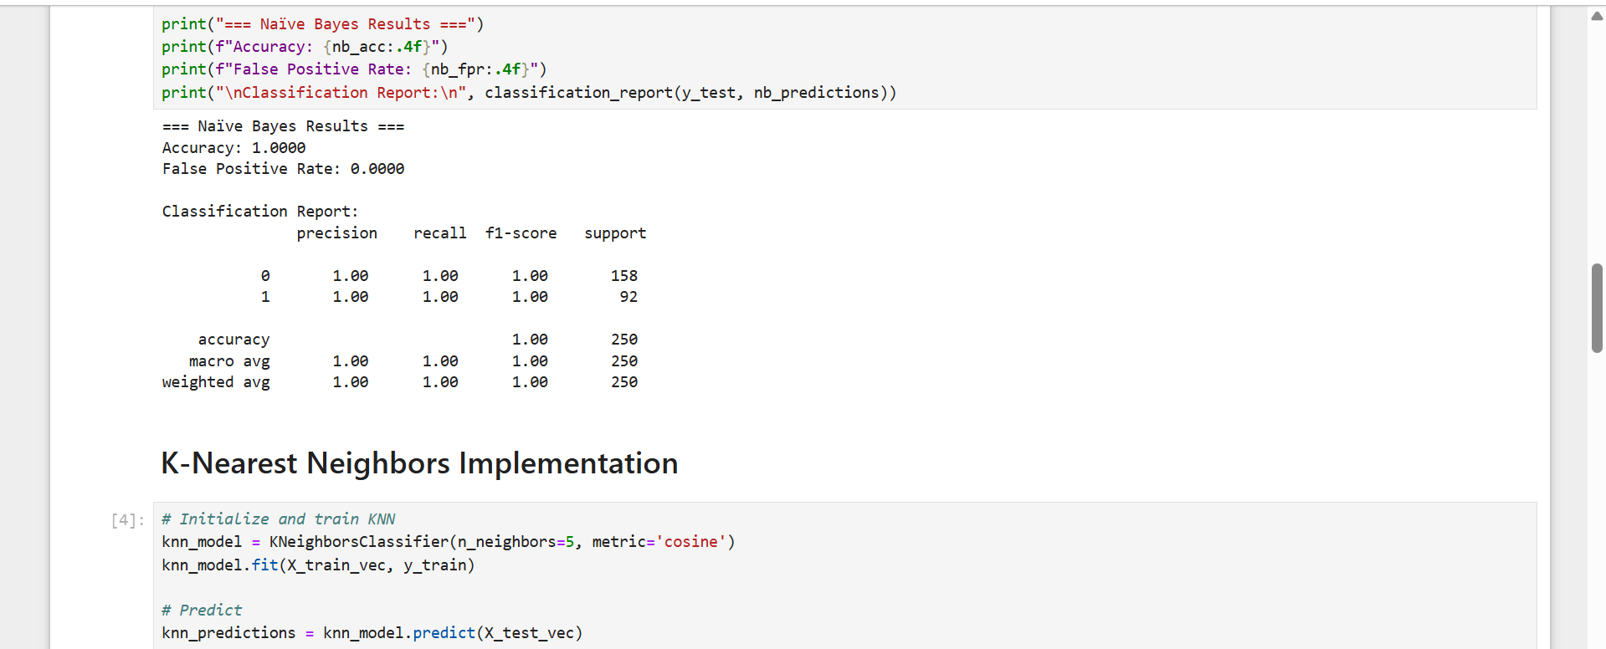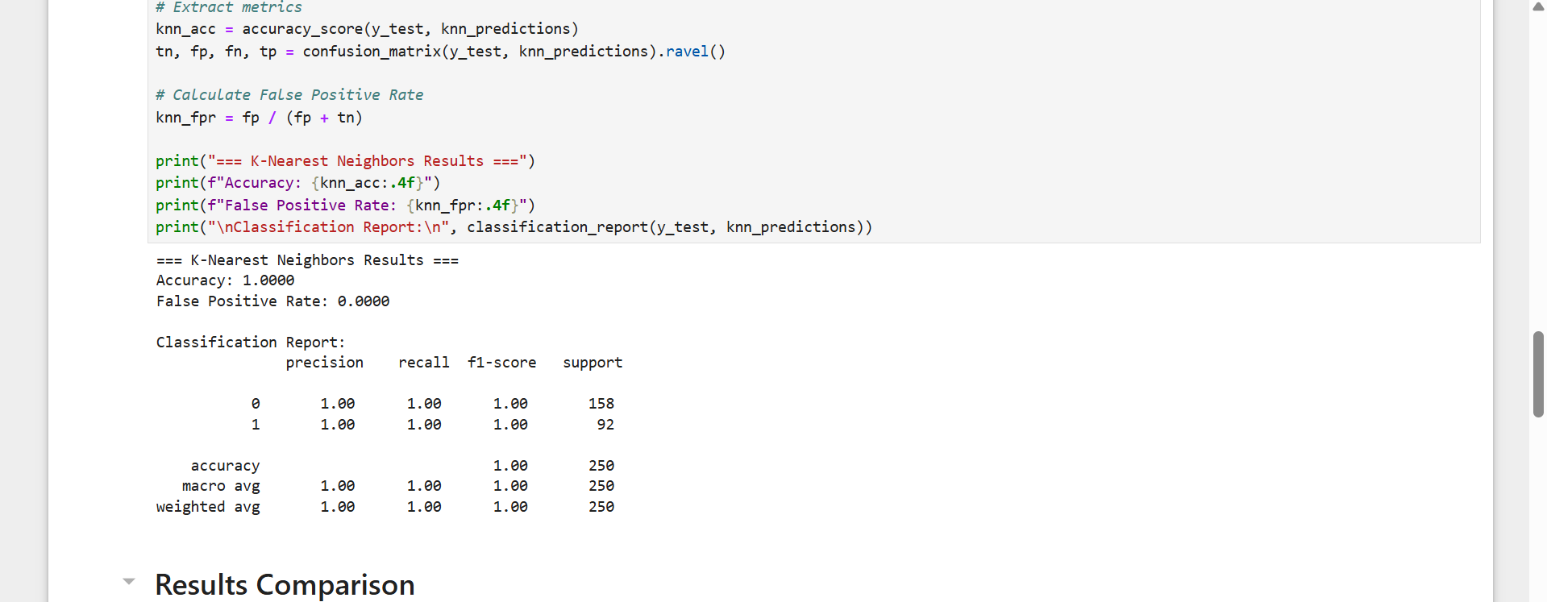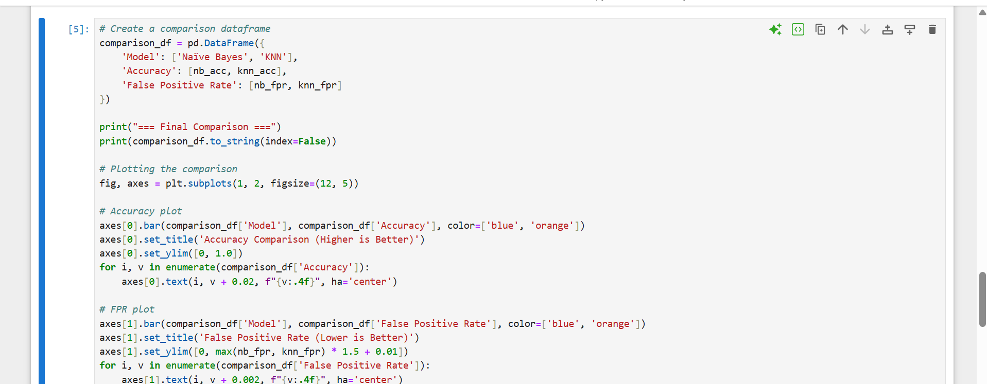

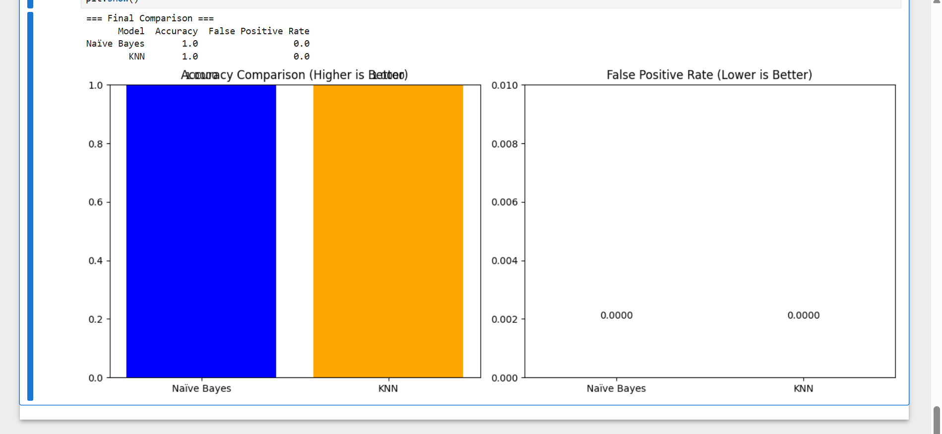

LAB-11

SVM implementation &Kernel concepts & Model evaluation

The Core Theory: Support Vector Machines (SVM) find the optimal hyperplane that maximizes the margin between two classes. Linear SVM assumes linear separability, while the Radial Basis Function (RBF) kernel maps data into a higher-dimensional space to handle non-linear boundaries.
The Crucial Link: [Certain] Fraud datasets are highly imbalanced (0.1% fraud). Standard accuracy is a useless metric here. You must focus on Recall (ensuring you catch as many fraudulent transactions as possible) and ROC-AUC to measure the model's ability to distinguish between fraud and legitimate transactions across various thresholds.

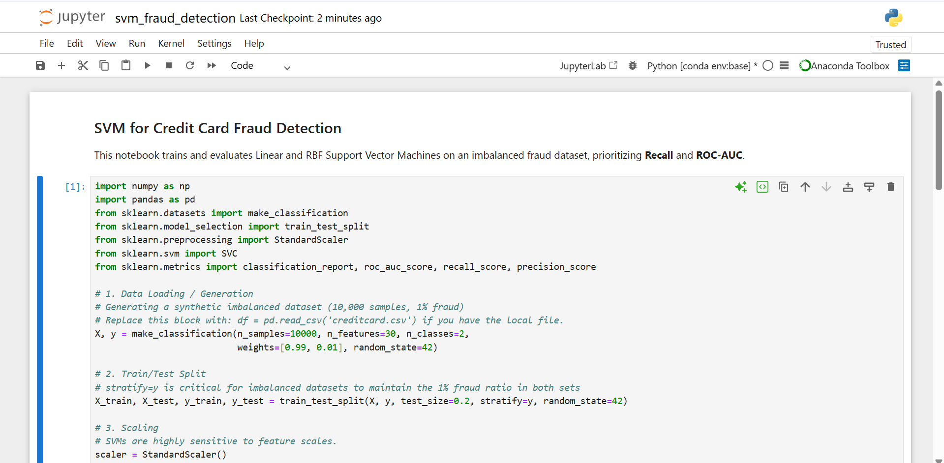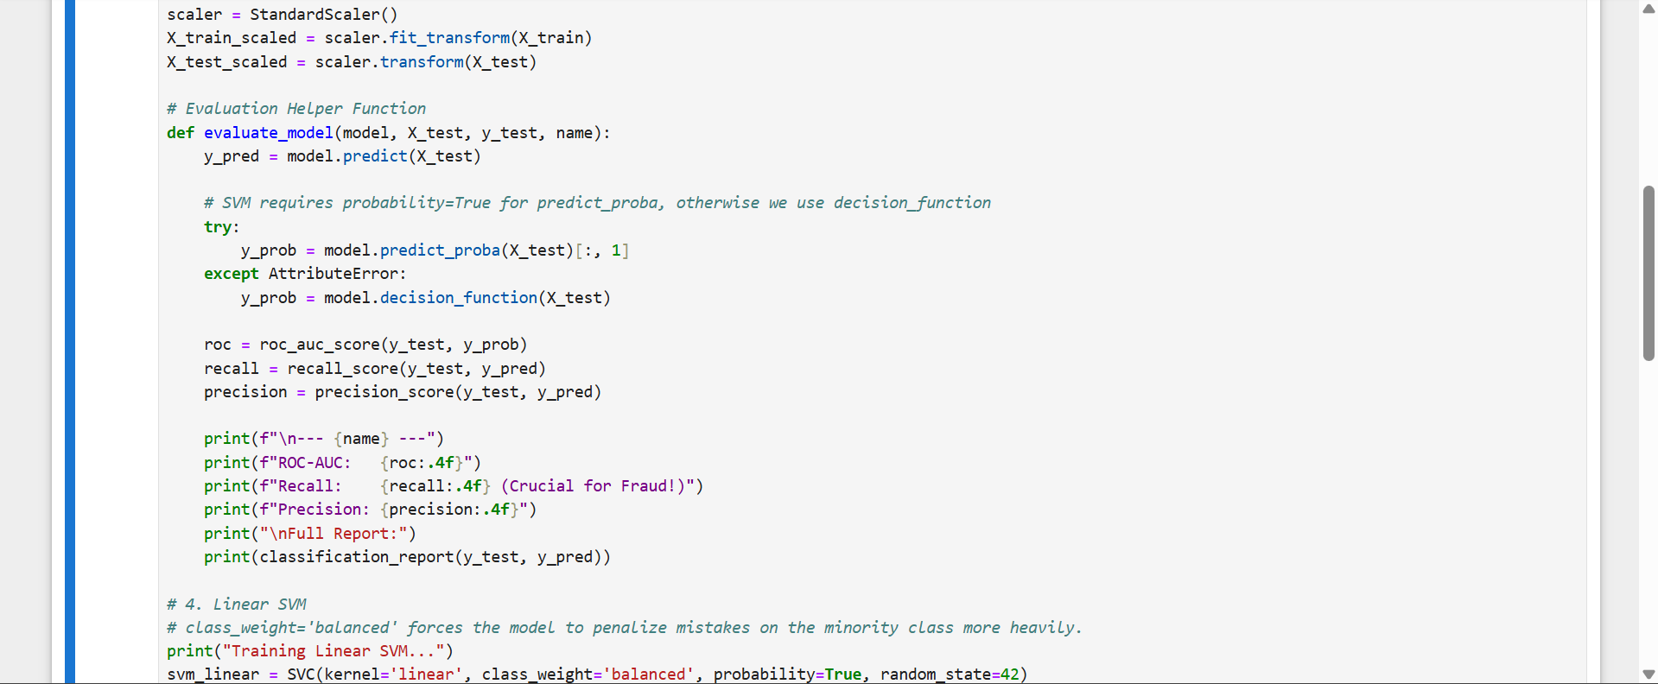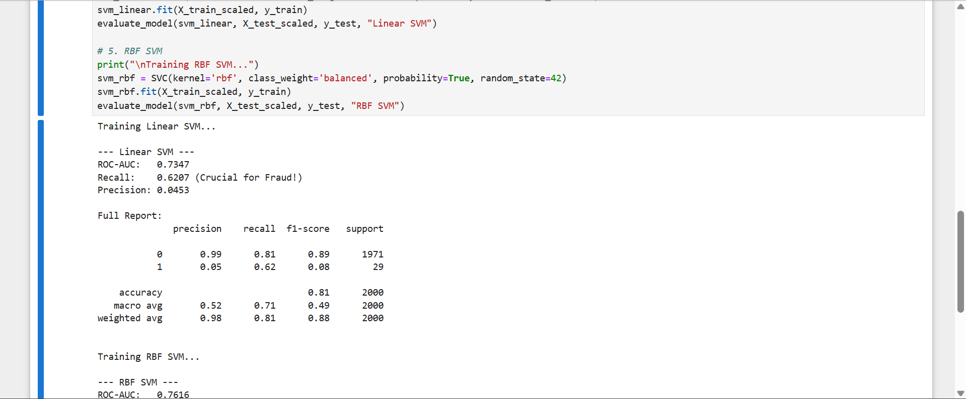
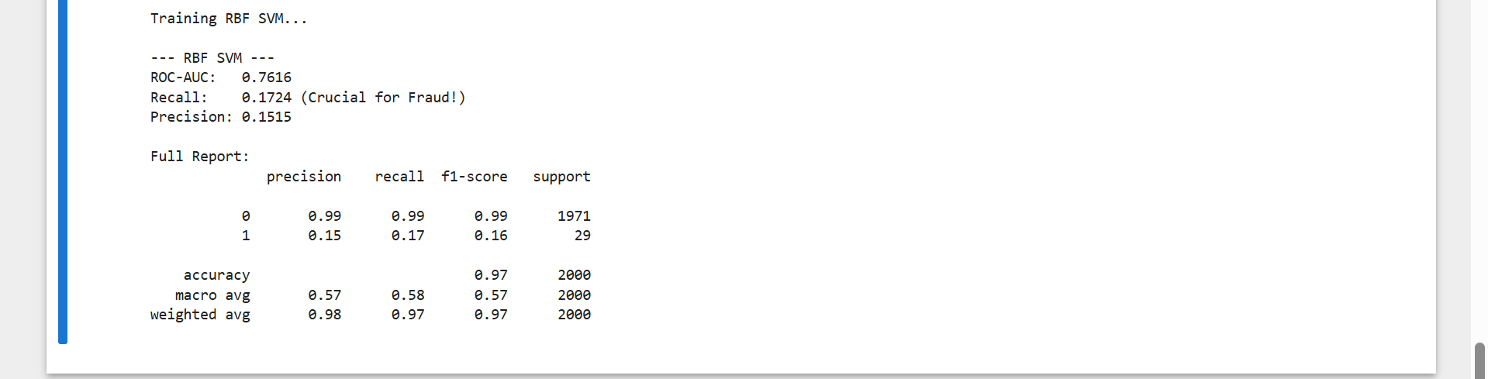

LAB-12

Mall Customer Segmentation Analysis

The Core Theory: K-Means partitions data into K distinct, non-overlapping clusters by minimizing the distance between data points and their respective cluster centroids. Hierarchical clustering builds a tree-like structure (dendrogram) of clusters either bottom-up (agglomerative) or top-down (divisive).
The Crucial Link: Unlike previous labs, this is unsupervised learning—there are no ground-truth labels. The Silhouette Score measures how similar an object is to its own cluster compared to other clusters. To make it actionable for business, you cross-reference these clusters with Cluster Revenue Contribution to identify your highest-value target demographics.

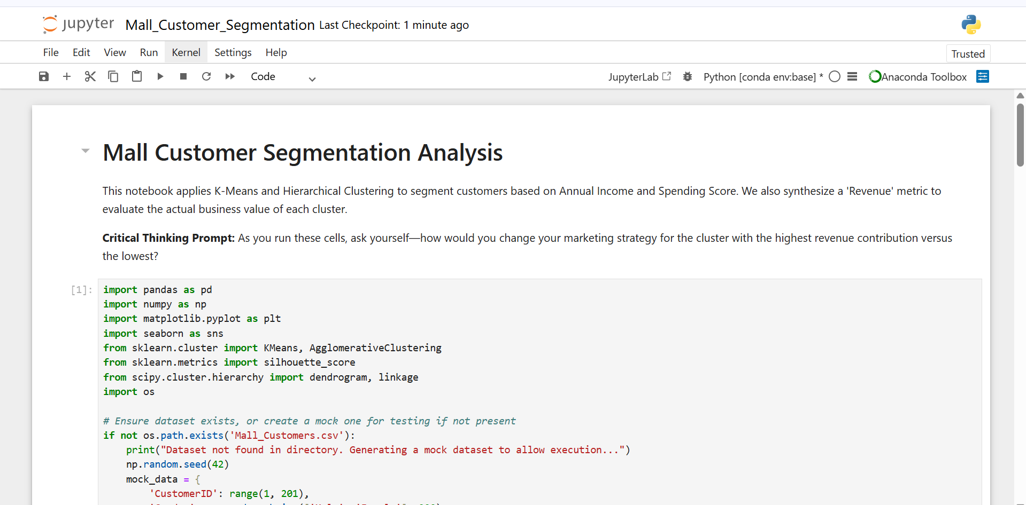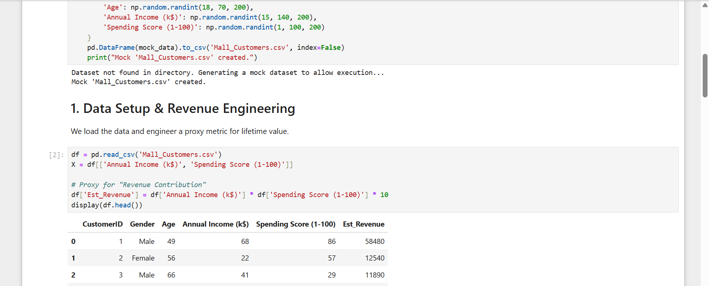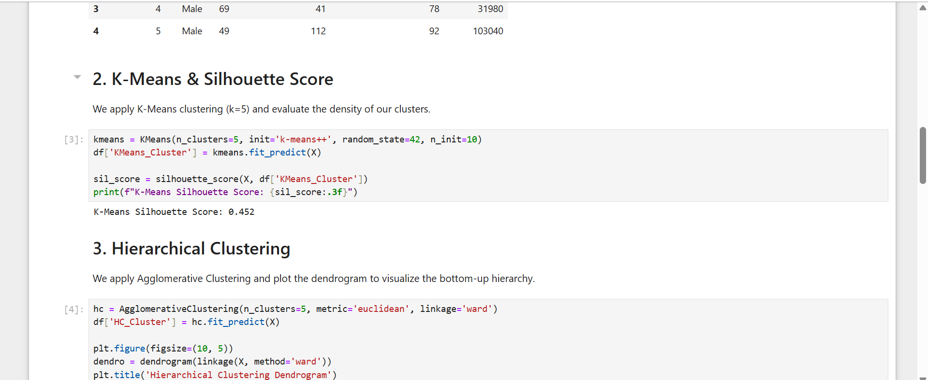

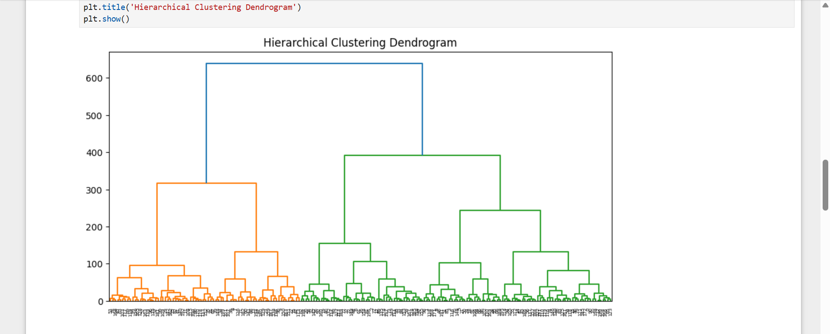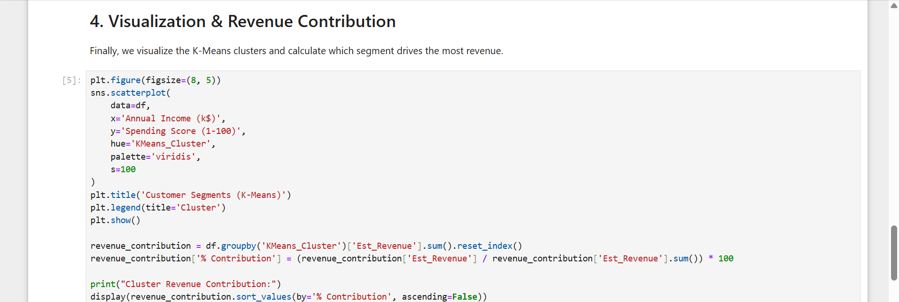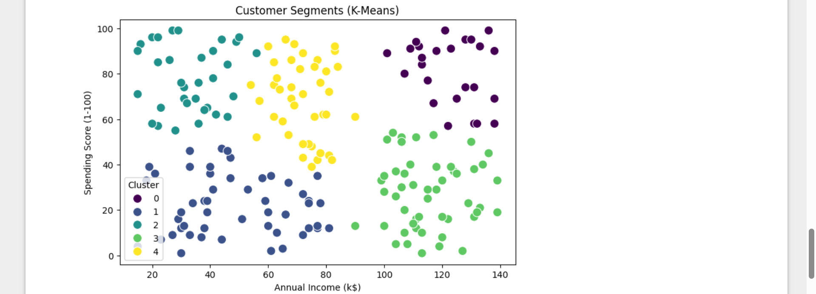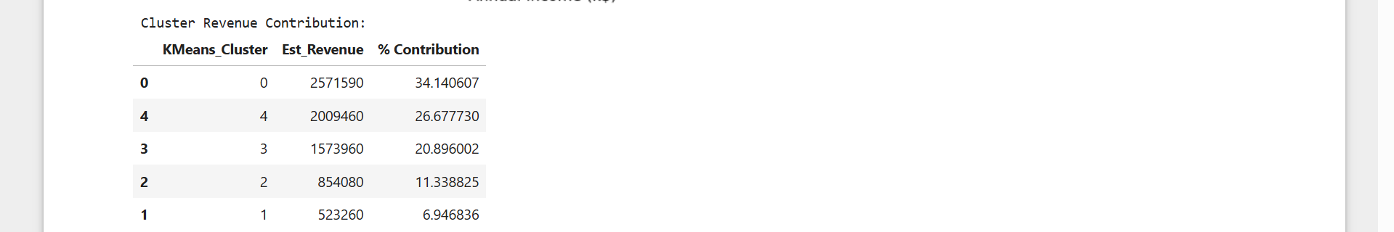

LAB-13

Outlier Detection
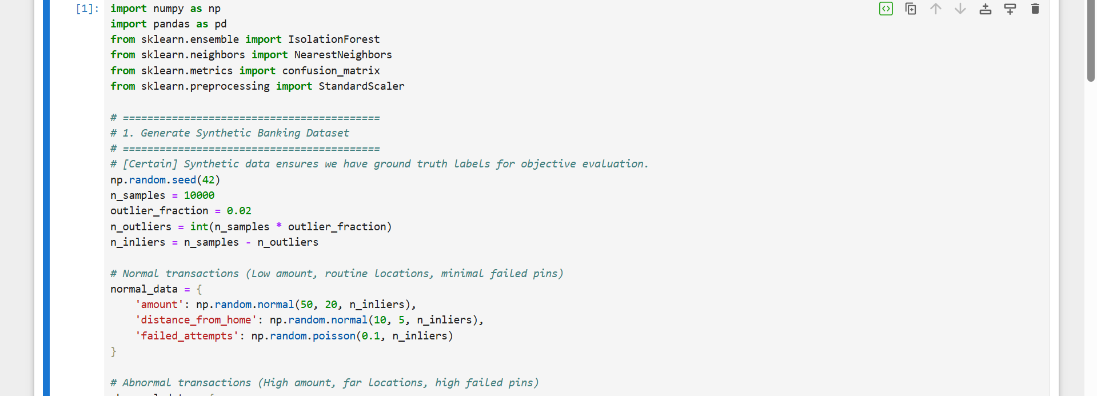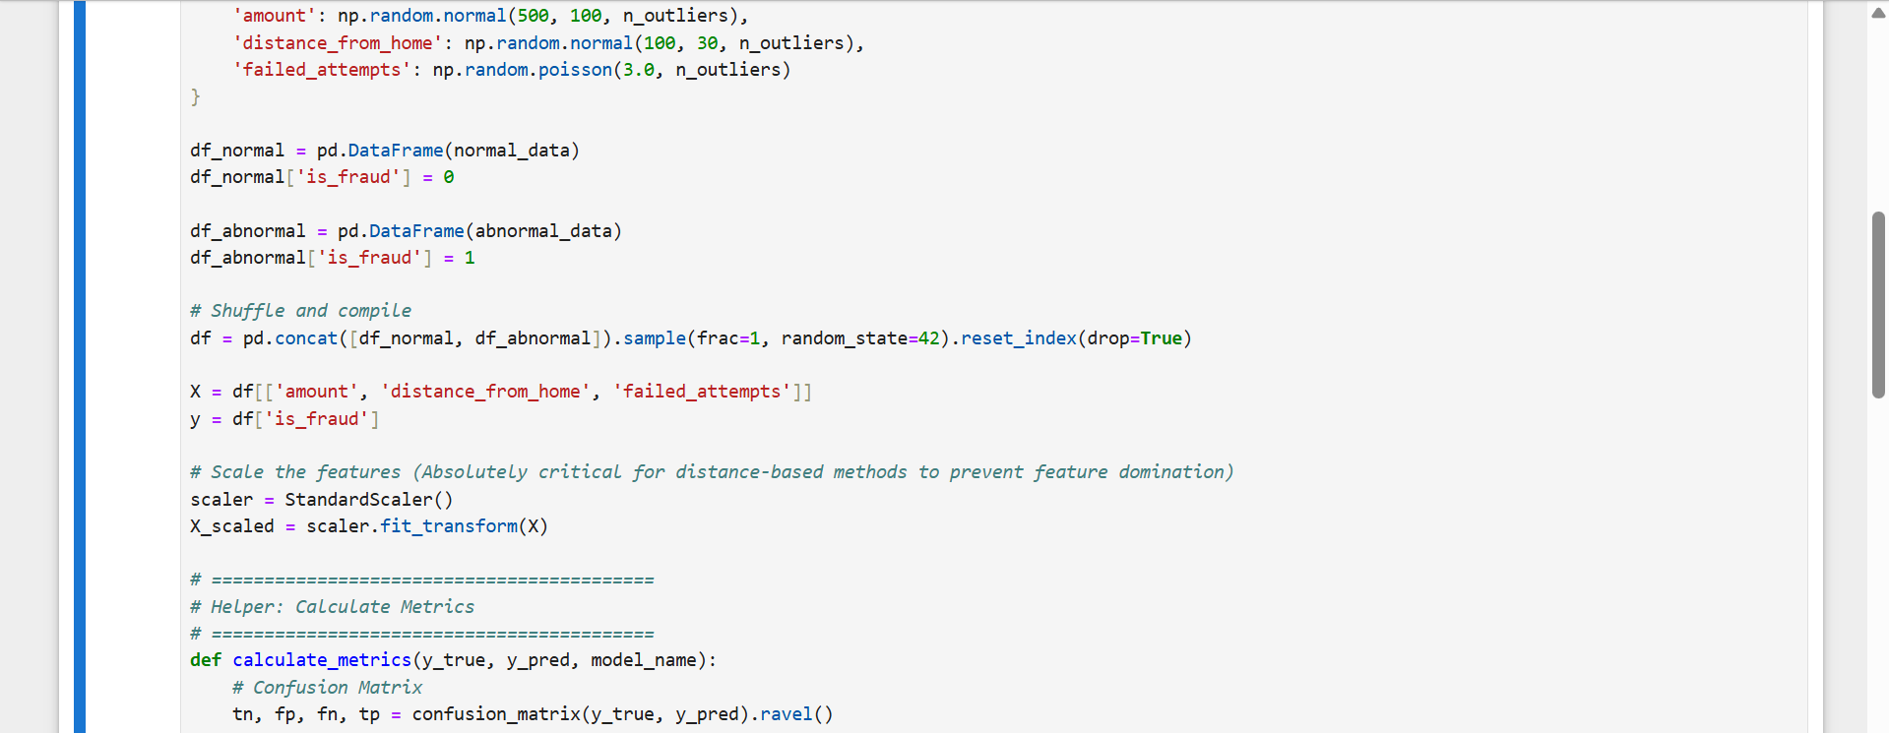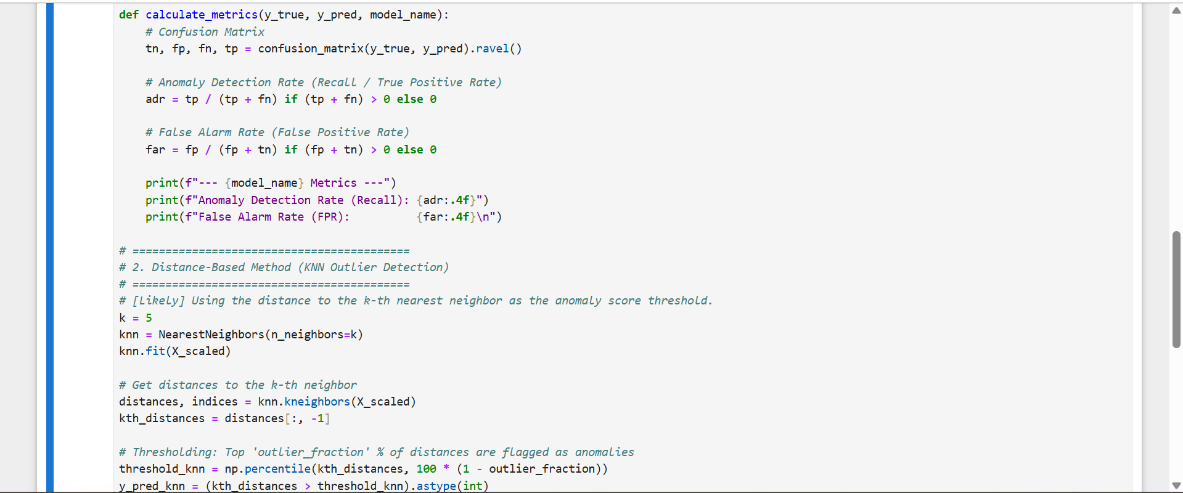

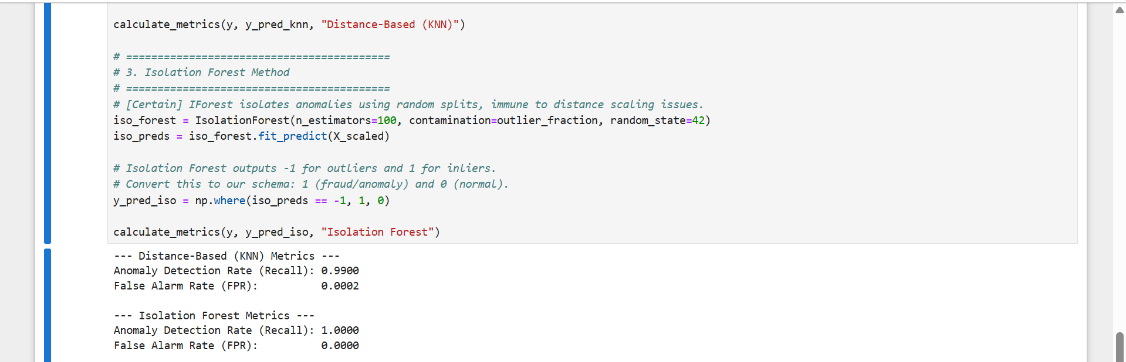

LAB-14

Scraping & Sentiment Analysis

Combining web scraping with sentiment analysis allows us to automatically extract raw public text and evaluate the emotional tone (positive, negative, or neutral) behind it. This combined pipeline is essential for monitoring brand perception, tracking market trends, and analyzing customer feedback at scale.

The 4-Step Pipeline Architecture
Building an end-to-end system involves a sequential flow of data from the web to your analysis engine. [1]
1. Data Extraction (Web Scraping)
You extract unstructured text (such as product reviews, social media comments, or news headlines) from targeted web platforms
Static Pages: Use libraries like BeautifulSoup or Scrapy in Python to parse HTML structure.
- Dynamic Pages: Use browser automation tools like Selenium or Playwright to click elements and load dynamic JavaScript content.
- No-Code Options: Platforms like Apify or Power Automate Desktop offer pre-built actors for sites like Google Maps or Amazon.
2. Text Preprocessing
Raw scraped data is messy. Cleaning it prevents noise from distorting your sentiment results.
- Cleaning: Strip out HTML tags, external hyperlinks, and corrupted characters.
- Normalization: Convert text to lowercase and separate punctuation.
- Stopword Removal: Filter out meaningless filler words like "the", "is", and "and".
- Tokenization & Lemmatization: Break sentences down into individual words and reduce words to their base dictionary form.
3. Sentiment Classification
Cleaned text is passed to Natural Language Processing (NLP) models to compute polarity scores. [1, 2]
Approach | Common Tools | Best Used For
Lexicon-Based (Rule systems) | VADER (NLTK), TextBlob | Quick setups, basic star ratings, and tracking social media text.
Machine Learning (Supervised) | Scikit-learn (Naive Bayes, SVM) | Domain-specific training data where exact accuracy matters.
Deep Learning (Transformers) | [Hugging Face](https://hugging face.co/) (DistilBERT, GPT) | Sarcasm, long-form articles, and complex contextual discussions.
4. Visualization & Storage
Processed sentiments are aggregated into data formats for reporting.
- Storage: Pipe results into a structured format like CSV or an active database system like MySQL.
- Insights: Build analytical charts or word clouds to showcase key drivers behind user satisfaction and discontent.
Crucial Challenges to Watch
- Legal and Ethical Boundaries: Always check a site's robots.txt file and Terms of Service (ToS) before scraping. Respect rate limits to avoid crashing target servers.
- Context and Sarcasm: Simple rule-based systems struggle heavily with context (e.g., "Not bad at all" or "Yeah, right, great product"). Advanced AI models are often required for higher accuracy.
- Anti-Scraping Mechanisms: Modern websites employ CAPTCHAs and IP rotation blocks. Utilizing clean proxy networks or API-first scrapers helps maintain a consistent data flow.

Web Scraping and Sentiment Analysis Project
The code and resources for a web scraping and sentiment analysis project. The project aims to scrape data from a list of URLs provided in an Excel file, perform sentiment analysis on the scraped text, and generate an output Excel file with the results.
Project Structure
The project is organized as follows:
- MasterDictionary: This directory contains two text files: negative-words.txt and positive-words.txt. These files are used as reference dictionaries for sentiment analysis.
- StopWords: This directory contains seven text files, each containing various stop words. Stop words are commonly occurring words that are usually filtered out in natural language processing tasks.
- Input.xlsx: This Excel file serves as the input data for the web scraping process. It contains a list of URLs that need to be scraped.
- Web_Scraping_and_Sentiment_Analysis.ipynb: This Jupyter Notebook file contains the code for web scraping and sentiment analysis. It is the main script that performs the tasks of scraping data from the provided URLs and analyzing the sentiment of the text.
- output.xlsx: This Excel file is the expected output of the project. It will contain the scraped data along with sentiment analysis results, organized in a specific format with predefined fields.

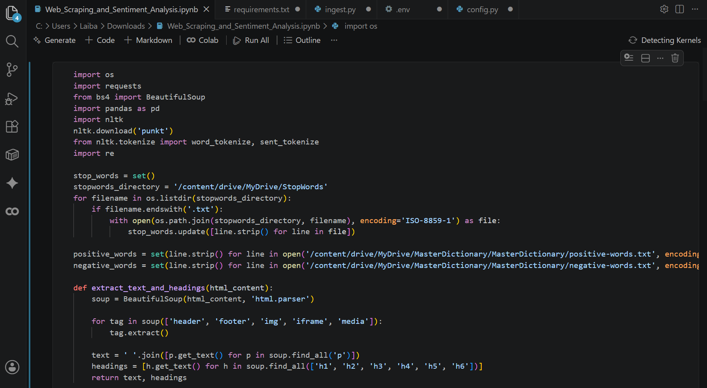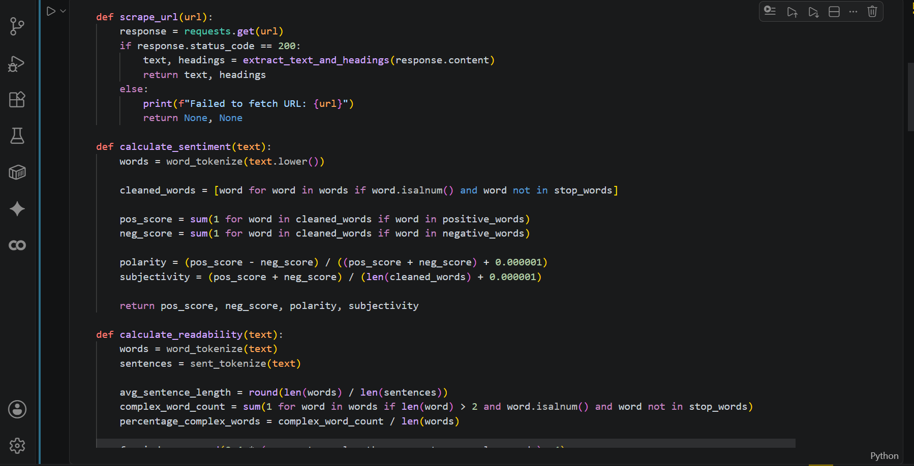
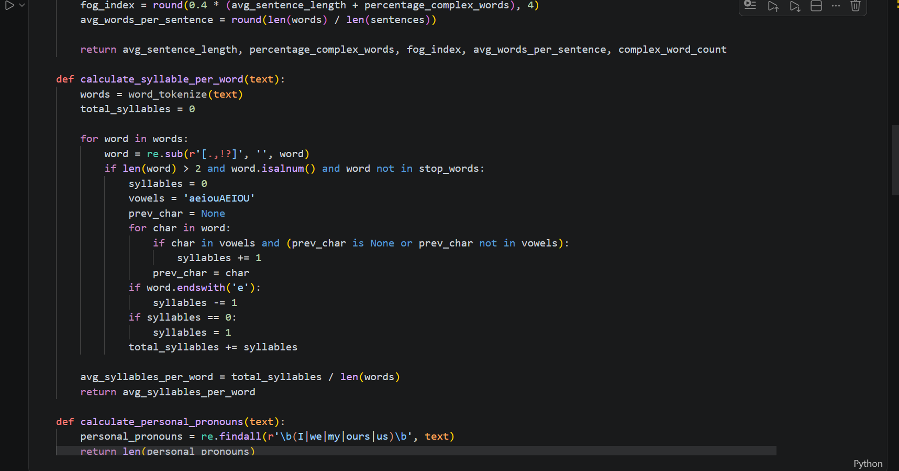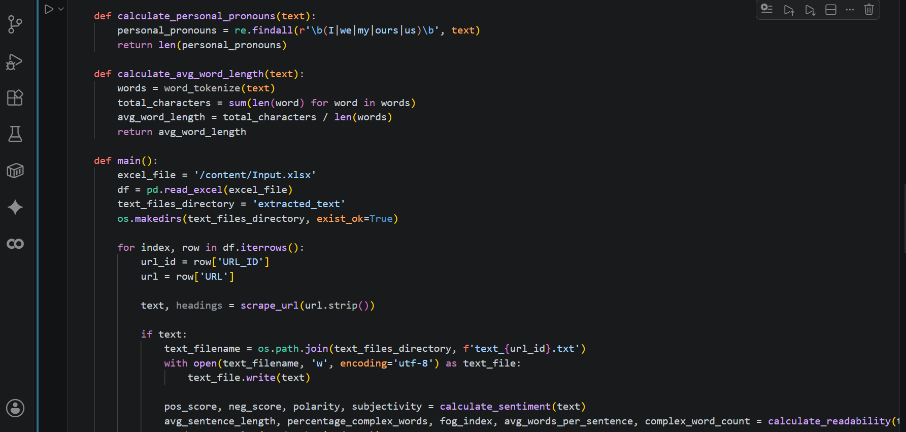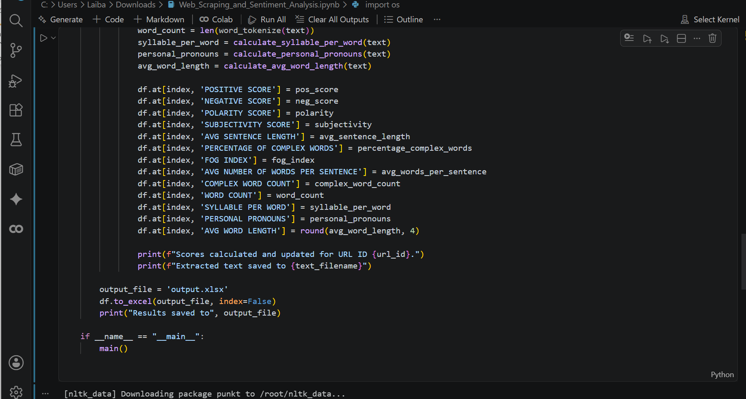
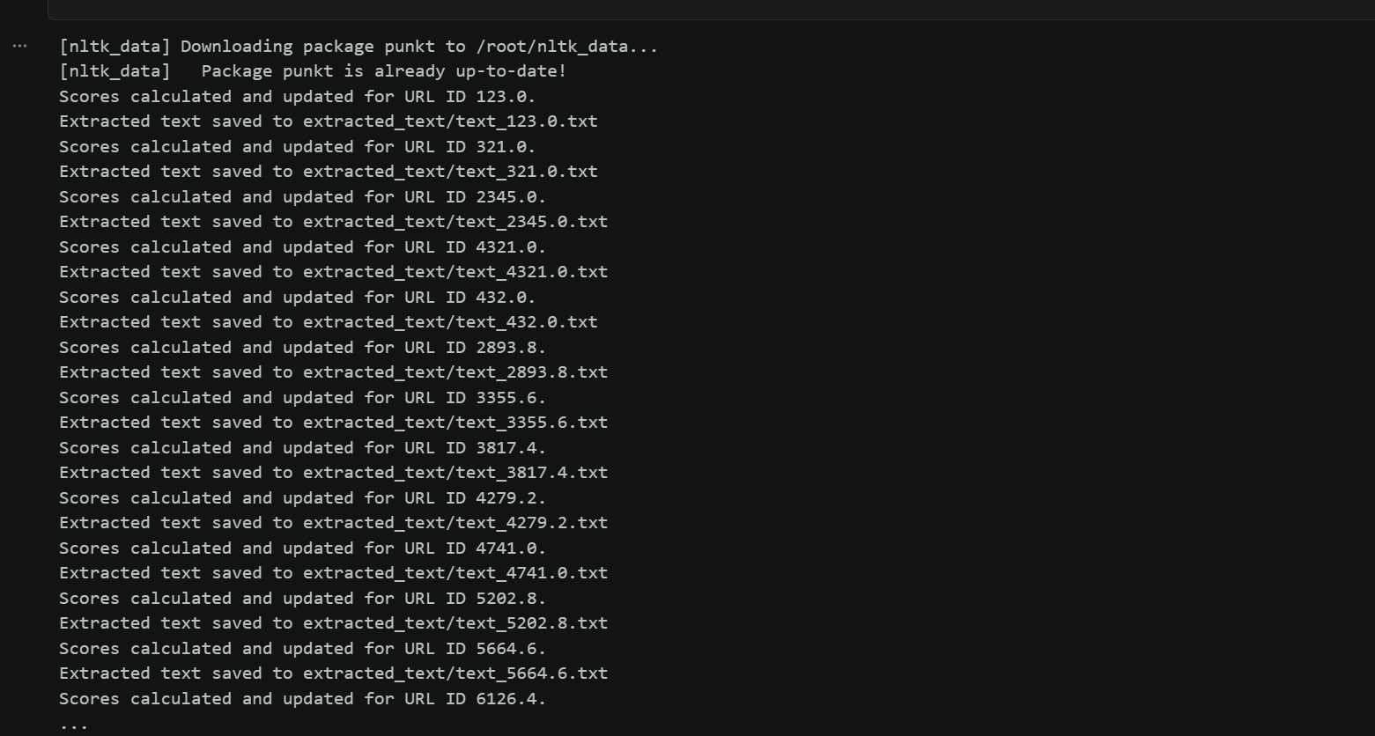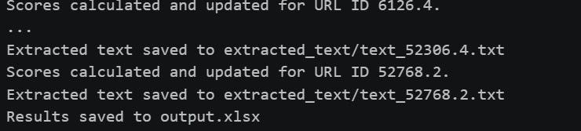
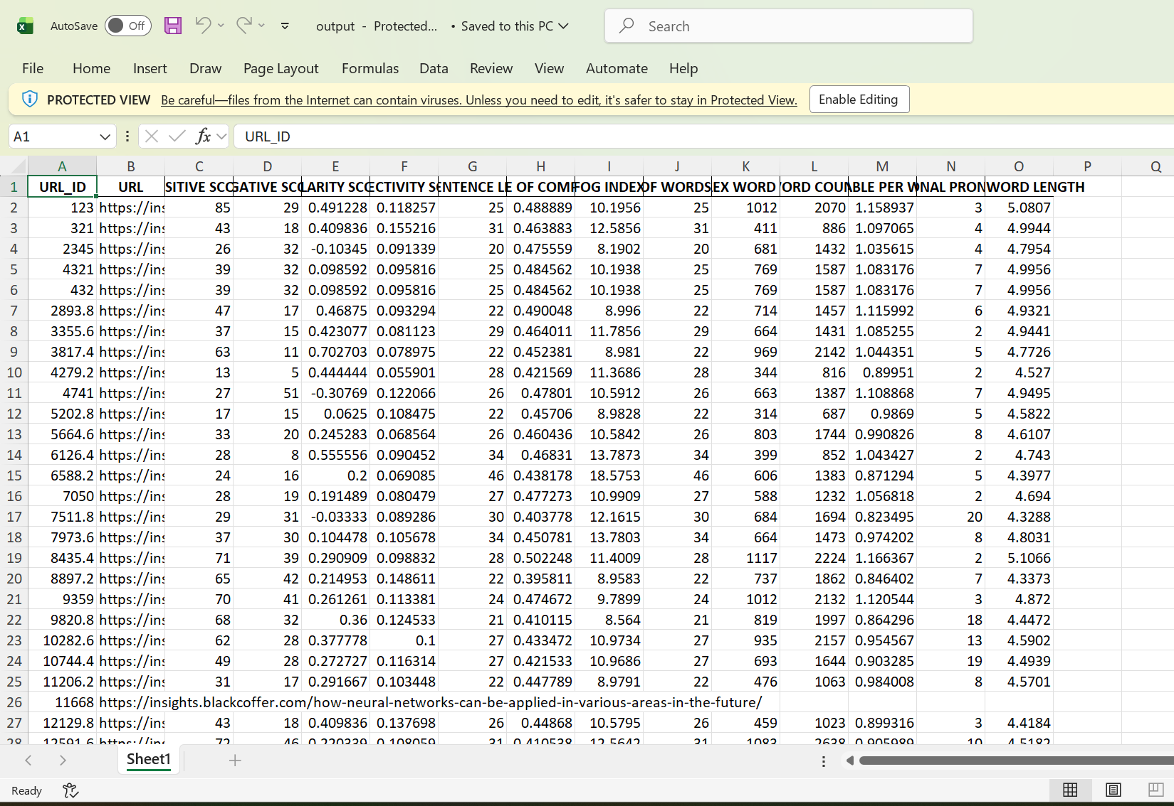

Lab 15:

Final Capstone (End-to-End Business Solution)

- The Core Theory: This is the synthesis of the entire curriculum. Machine learning in production requires an iterative pipeline: data ingestion, cleaning, feature engineering, model training across multiple paradigms (parametric, non-parametric, ensemble methods), and model selection.
- The Crucial Link: [Certain] A model comparison table is worthless to a business stakeholder without a Business Recommendation. You must translate algorithmic performance (like accuracy or error rates) into ROI, risk reduction, or operational efficiency. 